Developing a real-time localhost multiplayer video game

Shaanuka Gunaratne

Centre Number: 12290

Contents

Analysis 6

Introduction 6

Target audience 6

Project Scope 7

Analysis of arcade games 8

Analysis of current system 10

Space Invaders: 10

Analysis of similar systems 12

Duck Game 13

Bug Butcher 15

Opinions from target group 17

Detailed requirements from target audience 22

Problems to tackle with proposed solution 25

Proposed Solution 27

Planning the implementation 27

Advantages of Python 3 27

Disadvantages of Python 3 28

Atom Source Code Editor 29

Main Libraries 30

Prototyping 32

Initial Objectives 35

Final objectives 37

Documented Design 39

High level overview of my program 41

Main game loop 42

Login system 43

Setting up a client-server network 44

Server 44

IP Address and ports 44

Establishing Connection 45

Transferring data 45

Object data instead of string data 45

Serial vs parallel transmission 46

Objects in the main game 47

Class diagram 49

Collision detection 50

Countdown Timer 52

Problems with the timer: 53

Using multi-threading for the timer: 53

Synching the timer between each client: 53

Generating player score 55

Collectable Items 55

Method 1 55

Method 2 57

Power-ups 58

Feedback from target audience 59

Response to feedback 59

Mathematically modelling parabolic motion 59

Creating a WAN server for global client connection 61

Multicasting and broadcasting server to clients 62

Optimisations 64

Sorting High scores using a recursive Merge Sort algorithm 64

Input/Output/Storage 65

Using a Database 66

SQL Commands 67

Encrypting Password 68

Using Multiple Threads to Connect Multiple Clients 69

Data Structures 70

Visual Effects, Sound Effects and UI 72

Sound Effects 72

In-Game Visuals 73

Alpha Compositing 73

Background Animation 74

Designing the Main Menu 76

Creating the menu interface 76

Using a list and pointer to track user input 77

Instructions page 78

High scores page 79

Using a threshold score 79

Main Game 80

Creating and Editing Visuals 81

Login Screen Design 82

Technical Solution 83

Table of contents 83

Client Side Scripts 84

Main Game.py 84

Methods in the game class 86

Player Class 97

Projectile class 104

Map class 105

Collectable item class 106

Client-side Network Class 108

Game Menu screens 109

Highscore Class 118

Timer Class 122

Text Input class 123

Login system 125

Server Side 131

External libraries and files used 131

Broadcasting server 132

Main Server routine 133

Algorithms for testing and additional features 136

Using the Pygame environment 136

Server Class 145

Finding the Audio frequency of sound files 148

Using alpha compositing to blend colours with sprites 148

Testing 149

White Box Testing 149

Black Box Testing 156

Target audience testing and feedback: 157

Github commits 158

Evaluation 173

General Objectives 173

Objective 1 173

Objective 2 173

Objective 3 174

Objective 4 174

Objective 5 174

Specific Objectives 175

Login system 175

Main Menu 175

Server Menu 175

Main Game 176

Game Server 178

Images and sprites 179

Additional objectives 179

User feedback 179

Analysis 180

Bibliography 181

# Analysis

## Introduction

I very much enjoyed playing video games as a child. I’ve played many franchises and spent long hours on campaigns, however I’m now an A-level student and like many of my peers, cannot find the time to play long hours due to studying commitments. This has made me turn to smaller games such as arcade games with simple objectives and minimal complexity.

From Pacman to Dig Dug there are a vast number of arcade titles available for me to enjoy in my free time. I enjoy playing these games a lot and I play with my school friends. However, one thing that most of us agree on is that these old arcade games we have come to love have many missing or outdated features when compared to games of the current generation.

As this is the case, I’ve decided to implement my own modern 2D arcade-style video game that my friends and I can enjoy playing. This will mean incorporating new features of current games such as online communication and better visual effects. I believe this should make the gameplay more enjoyable when playing these types of smaller games.

### Target audience

My game will be mainly aimed at teenagers but it’s suitable for all age groups including children and adults. There will be a focus on the casual gamer as the concept of the game is simple and will be designed for short gameplay sessions.

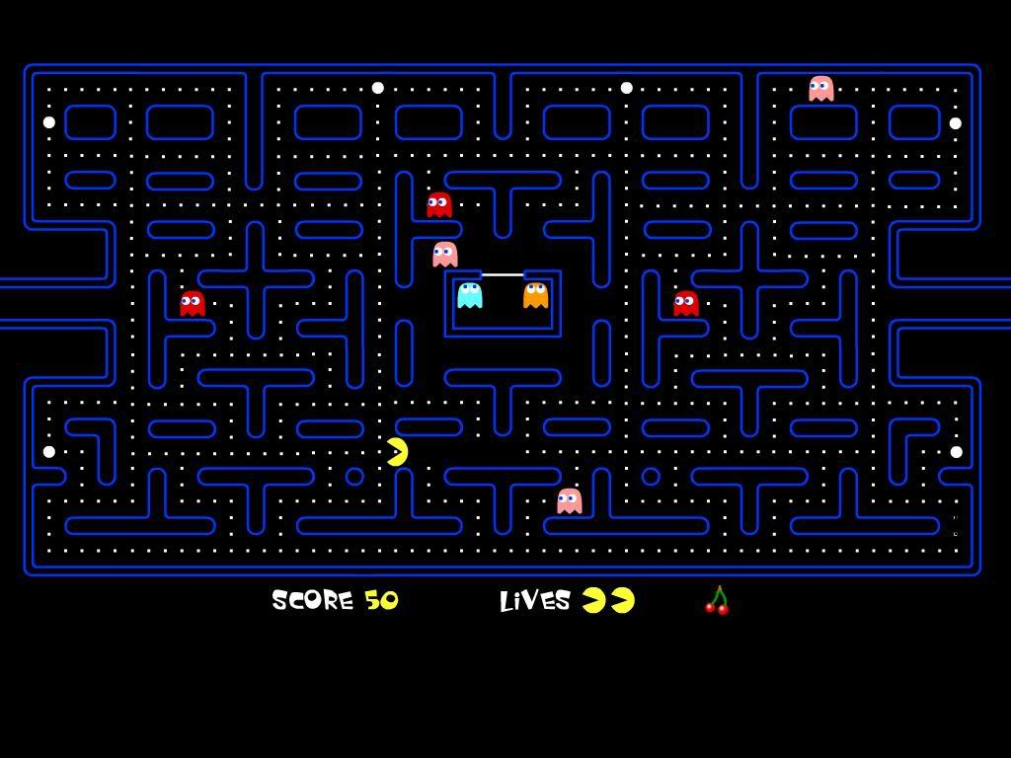

Pacman is a classic example of an arcade game. Released in 1980, it is the highest grossing arcade game to date. [1]

### Project Scope

The project will be completed throughout the course of several months. This table will give me an idea of the time each section will take.

|  |  |  |  |
| --- | --- | --- | --- |
| # | Section | Task | Duration |
|  | Analysis |  |  |
| 1 |  | Research and analyse video games in general | 3 days |
| 2 |  | Research arcade games | 2 days |
| 3 |  | Analyse the current system and outline the problems | 2 days |
| 4 |  | Find other existing systems and analyse them | 1 week |
| 5 |  | Set up a survey and get opinions from target audience | 2 days |
| 6 |  | Setting up a meeting and discussing problem with client | 3 days |
| 8 |  | Creating a new solution | 1 week |
| 9 |  | Finding problems to tackle with proposed solution | 3 days |
| 10 |  | Finding methods of implementing the solution | 1 week |
| 11 |  | Finding the best programming language and libraries to use | 3 days |
| 12 |  | Prototyping and testing the libraries and language | 2 weeks |
| 13 |  | Setting objectives to complete | 1 day |
|  | Documented Design |  |  |
| 14 |  | Splitting the problem into parts | 1 day |
| 15 |  | Designing a high-level overview of the structure of each part of the program using flowcharts | 2 weeks |
| 16 |  | Research into client server networks | 5 days |
| 17 |  | Setting up and testing a client server network | 3 days |
| 18 |  | Finding a method of increasing efficiency when sending data across the network | 1 week |
| 19 |  | Learning to use an object-oriented approach | 1 week |
| 20 |  | Figuring out how classes communicate with each other and constructing a class diagram to represent it | 1 week |
| 21 |  | Creating a collision detection algorithm | 3 days |
|  |  | Designing a countdown timer | 3 days |
|  |  | Generating the players score | 1 day |
|  |  | Creating collectable items | 5 days |
|  |  | How collectable items are going to be synchronised | 1 week |
|  |  | Powerups for collectable items | 2 days |
|  |  | Getting feedback from target audience | 1 day |
|  |  | Improving whole design depending on feedback | 2 weeks |
|  |  | Learning to store data on a database | 1 week |
|  |  | Deciding the most appropriate data structures to use | 3 days |
|  |  | Creating sound and visual effects | 2 weeks |
|  |  | Designing a login system | 1 week |
|  |  | Designing a user interface | 1 week |
|  |  | Potential client-server errors and fixes | 1 week |
|  | Technical Solution |  |  |
|  |  | Implementing all the above | 6 months |
|  | Testing |  |  |
|  |  | Creating white box and black box tests cases | 1 week |
|  |  | Recording and carrying out tests | 3 days |
|  | Evaluation |  |  |
|  |  | Getting user feedback and evaluating the project as a whole | 3 days |

## Analysis of arcade games

A classic arcade game I enjoyed playing since my childhood is Dig Dug. This is a 2D single-player maze game where a player is placed in an underground map with a weapon and numerous AI opponents. The aim of the game is to dig your way around the map and eliminate all opponents. You can use the weapon given to you or the objects around you (e.g. falling rocks) as weapons. Completing the goal will make you progress into harder levels with faster pace and more enemies.

Dig Dug was a very popular game when it was released due to its simplistic gameplay but also being very tactical at the same time as it tested the player’s ability to make decisions quickly.



High-score system being implemented for added competitiveness

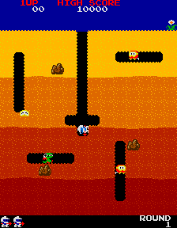

AI enemies can move in any direction including diagonally, however their pattern of movement is very similar throughout each round and can become repetitive for the player.

Objects around the map can be strategically used to benefit the player.

High contrast colours make the game ‘funkier’ and appealing to younger players and retro game lovers even now.

First level of the game[2]

**Problems:**

This game was released 1982 so there are some features that the game lacks compared to newer games that have been released in the current decade.

This includes the graphical quality of the game. Although very colourful, there are only a small number of bits encoded in each pixel, which reduces the colour depth.

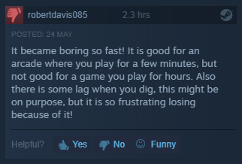Another issue is to do with the limited objectives and functionality within the game. Although the game has many levels that get harder as the player progresses, they are still very similar. This recurring aspect may make the game less interesting especially when thinking about a long-term player base.

Number of hours played before the review.

A review taken from the Steam website where the game can be purchased for the PC platform.

This is proven by several reviews of the game which state that although it’s a good arcade game, it becomes ‘boring’ after continuous play.

As seen, the reviewer on the screenshot[3] had only played the game for 2.3 hours before realising that the gameplay was becoming tedious. This may be due to the fact that this game was originally created to be played at an arcade for a short duration. This is the reason why the PC port has had a lower amount of success compared to the original that was released for arcade machines.

## Analysis of current system

As mentioned previously when it comes to arcade games, I particularly like shoot em ups. There’s a vast array of unique games in this genre, but my favourite is the game ‘Space Invaders’.

### Space Invaders:

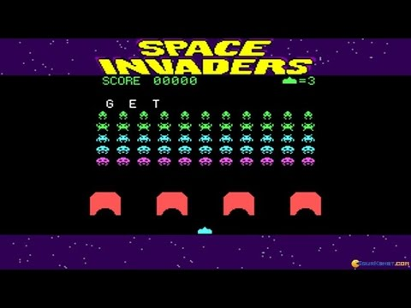Space invaders is a classic shooter game released in 1978.The game has an easy to grasp concept where a player controls a laser canon in the horizontal plane and their goal is to shoot aliens that are loaded into the arena. Defeating all the enemy aliens results in a larger wave of aliens spawning as the player progressed to the next round. This will repeat until the player is defeated and they will be given a score depending on how well they performed. This game is iconic as it paved the way for the shoot em up subgenre of games.

Limited life system because the game is infinite.

Gameplay of a version of Space invaders[4]

Simple movement controls in the x-axis making the game easy to pick up for all age groups.

Simple geometric shapes make rendering easier on almost any supported system.

**Positives:**

* Simple controls and objective made it appropriate for a range of age groups as it is easy to learn and good for small gameplay sessions.
* Very colourful visuals made it more appealing, especially for younger audiences.
* The sound effects were revolutionary. It provided players with direct feedback to their actions and interacted emotionally with the player using music.
* Not very graphically demanding, so it can run on many systems at a high frame rate which is beneficial in a fast-paced game.
* The game generates a score depending on the player’s performance. It also saves high-scores, therefore adding a competitive aspect to the single-player game.

**Negatives:**

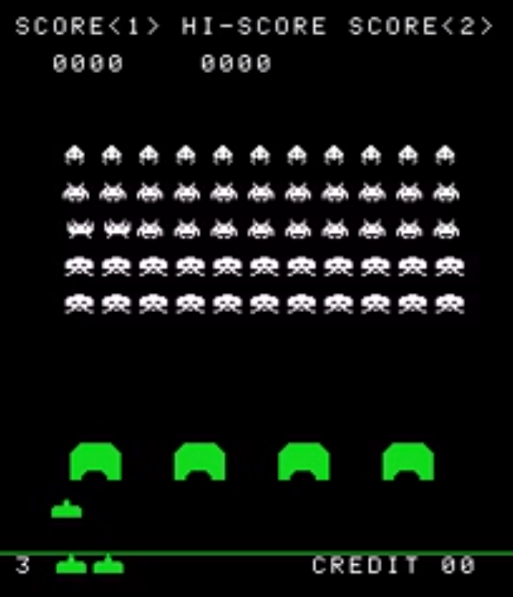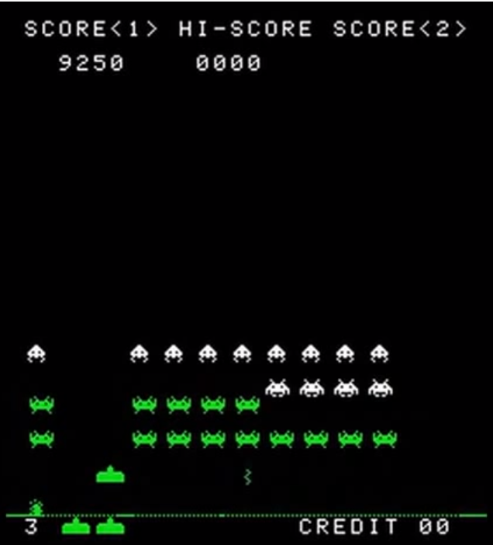Similar to Dig Dug, this game lacks features that modern systems have implemented (e.g. online multiplayer/co-op modes or advanced AI (Artificial Intelligence) enemies that make tactical decisions) to keep players interested in the game. The game’s repetitive structure has a negative impact on its replay value.

These screenshots[5] above are taken from the same gameplay session. The one on the left is from the start of the game with a score of 0, and the other is at a score of 9250 which is a relatively high score. It’s apparent that there aren’t many visual differences between the two. As discussed above, this lack of variety during gameplay reduces the replay value and may result in players losing interest in the game.

# Analysis of similar systems

Flow Diagram of Current Solution

**Key**

Flowline

Decision

Process

Start/End

Subroutine

Input/output

yes

no

I’ve constructed a flowchart of Space Invaders so that I could better understand the mechanics and logic behind the game. This will be helpful during the implementation of my solution due to it having similar aspects to this game.

I analysed several modern 2D arcade-like games. Using thorough research, online reviews and experience playing some of these games, I found 2 games released in this decade that have used an arcade-style approach but still managed to have modern features that made them successful amongst many other games of the current generation.

### Duck Game

Duck game is a fully functional real-time multiplayer arena shooter. You are given a character in the form of a duck which you can customise to your liking. Then you connect to either a LAN or WAN server and compete against other players. The basic controls are simple and consist of directional movement and the trigger key for shooting a weapon. However, there are special functions that can be executed (special character moves) with specific key combinations.

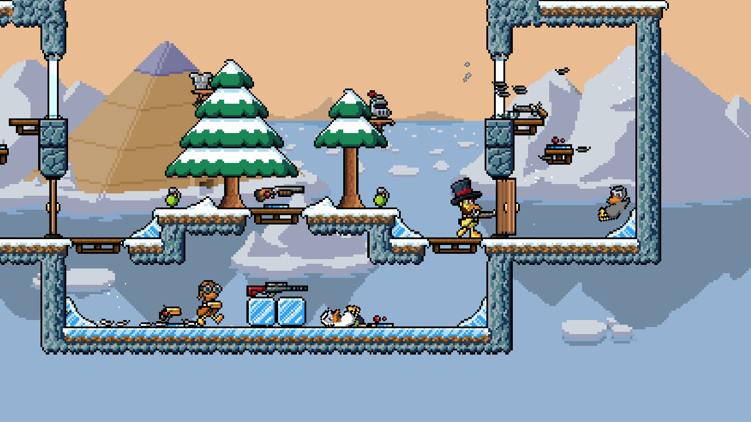

Screenshot of a multiplayer round in the game[6]

Multiple random collectable items scattered around the arena. This reduces repetitiveness in each game, as there could be a number of various weapons or other consumables in different rounds.

Bright, high-contrast graphics. Increases the appeal especially to a younger audience.

The aim of the game is to eliminate all the other players on the map. This follows a classic 2D arcade-style approach, where there is no storyline or complex progression system, but instead there’s a vibrant and funky game style, with larger arenas through the implementation of a scrolling background. After analysing the game, I realised there were also some drawbacks that come with this arcade shooter.

|  |  |
| --- | --- |
| Positives | Negatives |
| A fully functional LAN and WAN real-time multiplayer battle system, so players can compete with one another which adds a competitive element to the game. | Only a maximum of 4 players in an arena. However, this can be a measure to reduce latency since multiple players can put a toll on the server. |
| Includes multiple arenas, a variety of weapons and special moves. Since the game is not reliant on a narrative, these features keep the game fresh for longer as it adds more depth and excitement to the game. | Instructions manual is limited to only the basic controls. Using different weapons requires different key combinations. This may make the game more exciting as you have to figure out the combinations yourself, but it may also disadvantage inexperienced players. |
| Makes use of a scrolling background to increase the size of the arena without scaling the images to be smaller. | Some potential users may not find the 2D style of graphics appealing as many modern games have more realistic and demanding graphics. |
| Most modern systems should be able to run the game at a high frame rate since the 2D visuals are not very demanding on hardware. | The number of multiplayer sessions available may vary depending on the time. This is due to the lack of private matches and the game not having a large online community. |

I realised I would need to find a method of avoiding any similar drawbacks when developing my proposed solution. There are also some positive features about these products that I would like to implement in my own solution.

**Features that can be implemented in proposed solution:**

* Continuously changing animations depending on player actions. A data structure such as a queue can be used to implement sequences of animations in a specific order.
* Collectable items around the map (e.g. health packs, power-ups). This should add more variety to the gameplay.
* Have an Instructions page detailing the functions of each key combination.
* Bright arcade-style 2D graphics as it would be more appealing for the target audience (arcade gamers).

## Bug Butcher

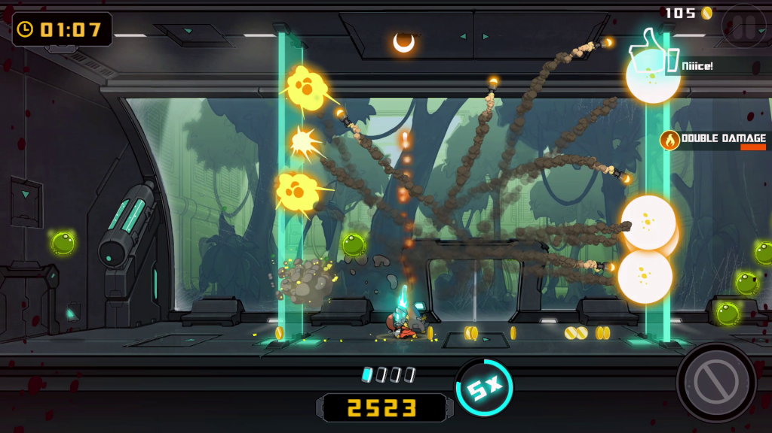Bug Butcher is a 2D single player/co-op shoot em up game where the player’s main goal is to destroy waves of mutant bugs that are above them. This game incorporates a unique style of gameplay where the player is continuously attacked from above instead of side-on. In addition to that, there’s no point accurate aiming system because the player automatically shoots projectiles vertically up, meaning that the user only has to worry about the position of the player. This makes for simple and unique gameplay.

Continuous player feedback on progress and achievements increases their confidence to continue playing.

Bright flashy visuals to draw the attention of the player.

As seen in this image, the player is firing multiple projectiles through the vertical plane. This unique feature alongside the bright visual effects creates an exciting environment for the player.

This game also features a co-op mode which allows a maximum of 2 players to play in the same arena. However, it is an offline local co-op therefore the other player will require another peripheral device, or they will have to share a keyboard when playing this mode.

|  |  |
| --- | --- |
| Positives | Negatives |
| Very bright and colourful visuals make the game feel more vibrant and exciting. | No online co-op mode, so the player will have to share peripherals or connect multiple controllers to play. |
| Dynamic sound effects add pace to the game and can make kills and combo moves feel more satisfying. | Some players may not find the unorthodox orientation of having to focus on enemies in a vertical plane appealing. |
| Continuous player and game feedback and interaction will keep the player more focused on the game and will give them confidence to continue playing. | Cannot add friends or see their profiles in the game as it does not have an online component. This makes the game less competitive compared to games with this feature. |
| Simple, fun gameplay mechanics and animation enhances the arcade style of the game and will appeal to arcade enthusiasts. | Users may be limited to playing only the single player mode if they do not have access to another peripheral device (e.g. an extra controller). |

Finite State Machine of control scheme

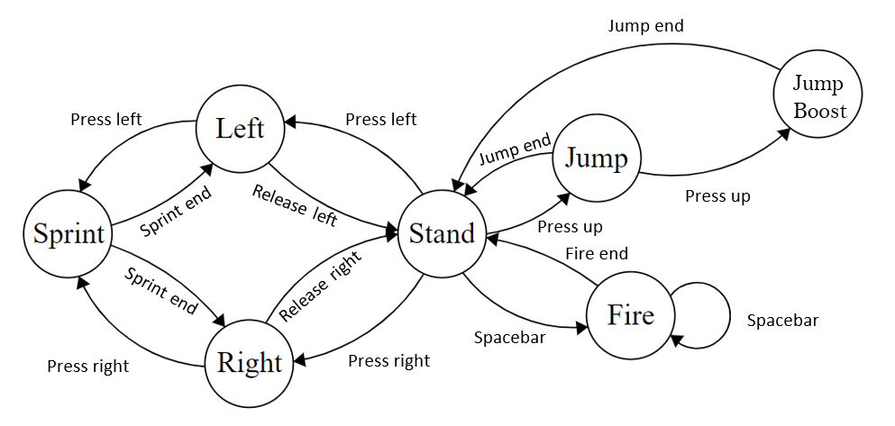

The controls in the two similar systems are very simple and easy to learn. I constructed a finite state diagram by analysing the control scheme for Bug Butcher, in which the same set of controls are used throughout the whole game. This expresses the simplicity of the game and hence why many arcade gamers may find it appealing as it’s very good for short gameplay sessions, where the player doesn’t need to worry about any complicated elements such as a large set of moves and controls.

A similar layout to the above can be used within my implementation to make the game more user-friendly and easier to learn for all age groups.

From the analysis of this game, these are some features I found that I could include in my solution to make it better.

**Features that can be implemented in proposed solution:**

* Make a simple control scheme so it’s easier for players of all age groups to play without confusion.
* Online multiplayer such as a LAN or WAN connection so users can play against and challenge their friends.
* A locally stored high-scores table with a point system for extra competitiveness that can increase the replay value of the game.
* Dynamic sound effects that change depending on the events occurring in the game for added tension and excitement especially near the end of a round.
* Funky arcade-style animations and gameplay mechanics.

## Opinions from target group

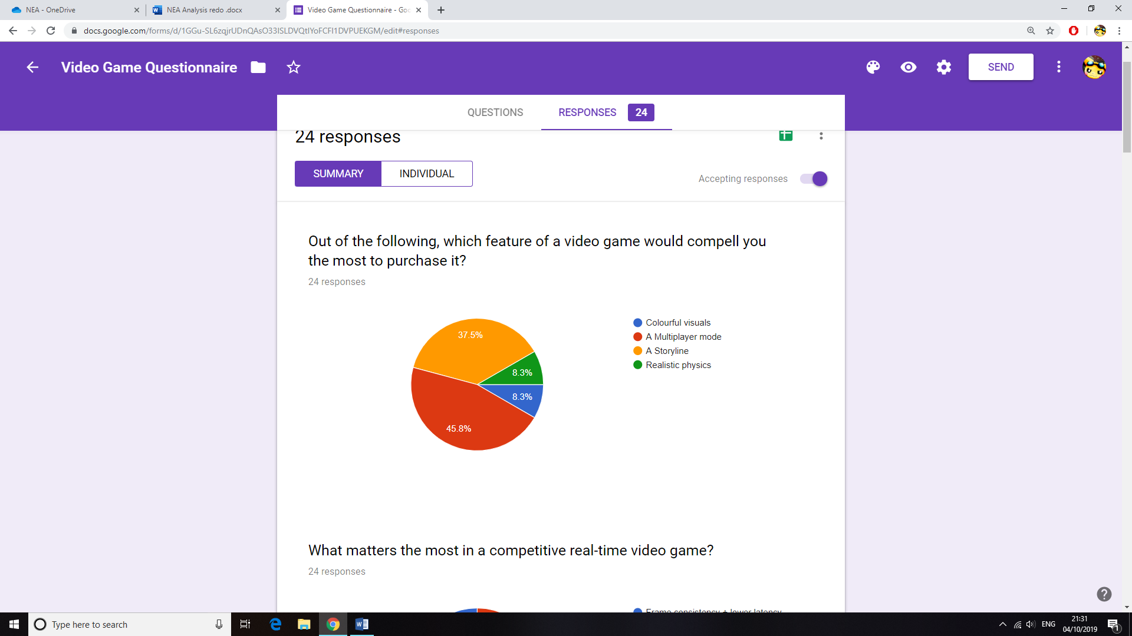I conducted an online survey for my peers in my computer science class who mostly have had experience playing different types of video games. These responses allowed me to gain more ideas and showed me what aspects of the game I should focus on during development.

Like the similar systems I analysed, I thought of creating a multiplayer mode for my game as it is a predominant feature of many games released in recent years. This is clearly shown by the pie chart (above) generated from my survey. The main point of interest seems to be in the multiplayer mode, followed by the storyline of the game. Although it is very clear that a storyline is important when developing a lot of games, it does not apply to mine since my project is for more casual players with less time on their hands to invest in a continuous storyline.

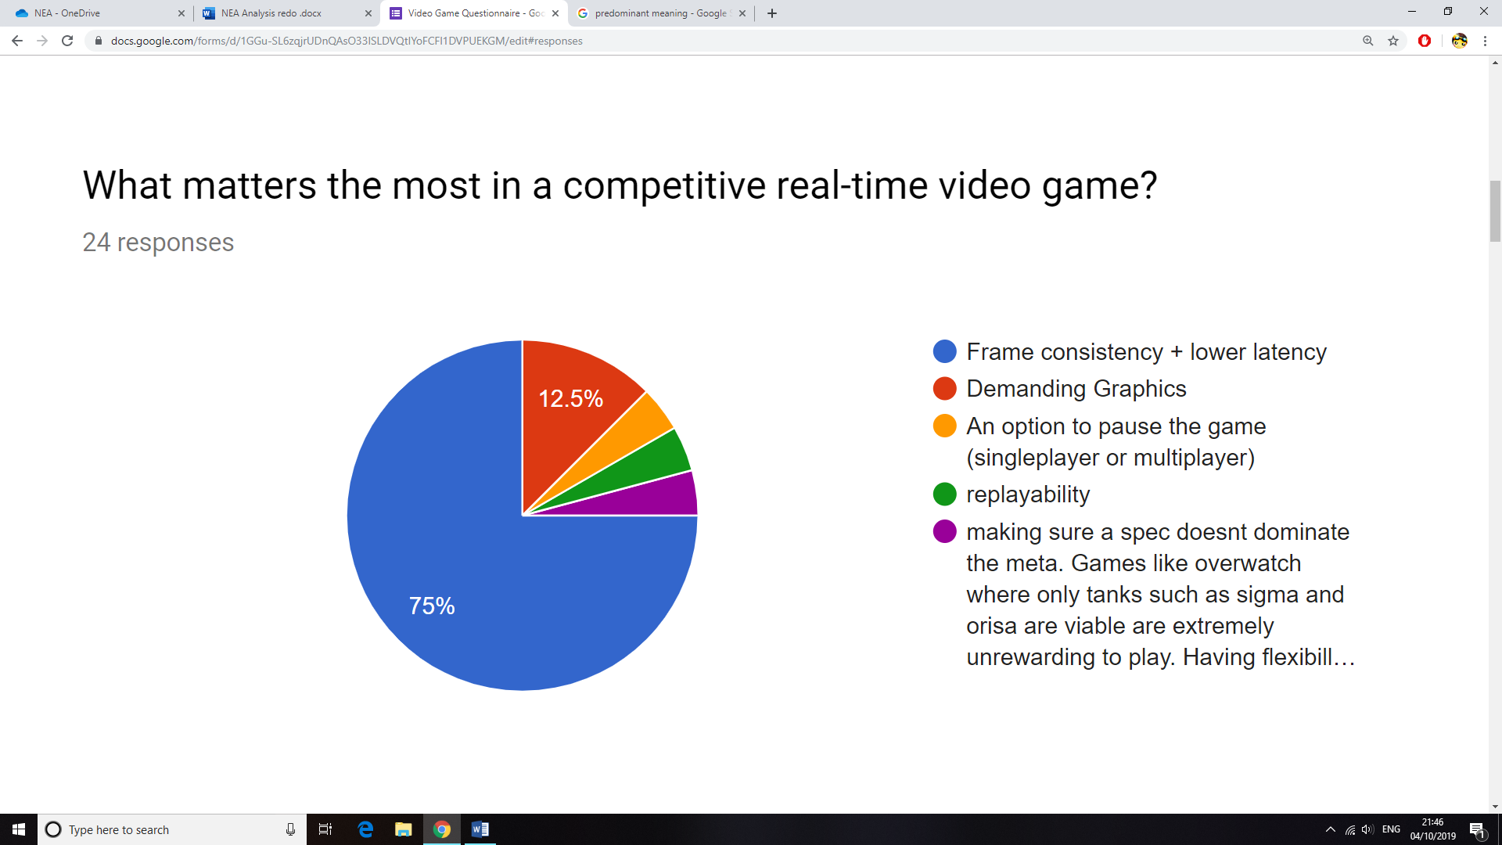

One problem I will need to test and prevent is latency within the game. Since I’ve decided to program a multiplayer game, I will need to make sure the network and server side of the game are stable. This will mean implementing measures (e.g. slowing down the game to reduce the effect of lag) to make sure the game will run with minimal latency.

If latency is not an issue, then another problem is framerate inconsistency during gameplay. This can be particularly annoying especially in a competitive scenario since the pace of the game will change due to frame drops. I will have to test the game on my system and several other systems to find a stable framerate to cap the game at. Furthermore, I will have to optimise my algorithms to a low time complexity, hence reducing the use of hardware resources.

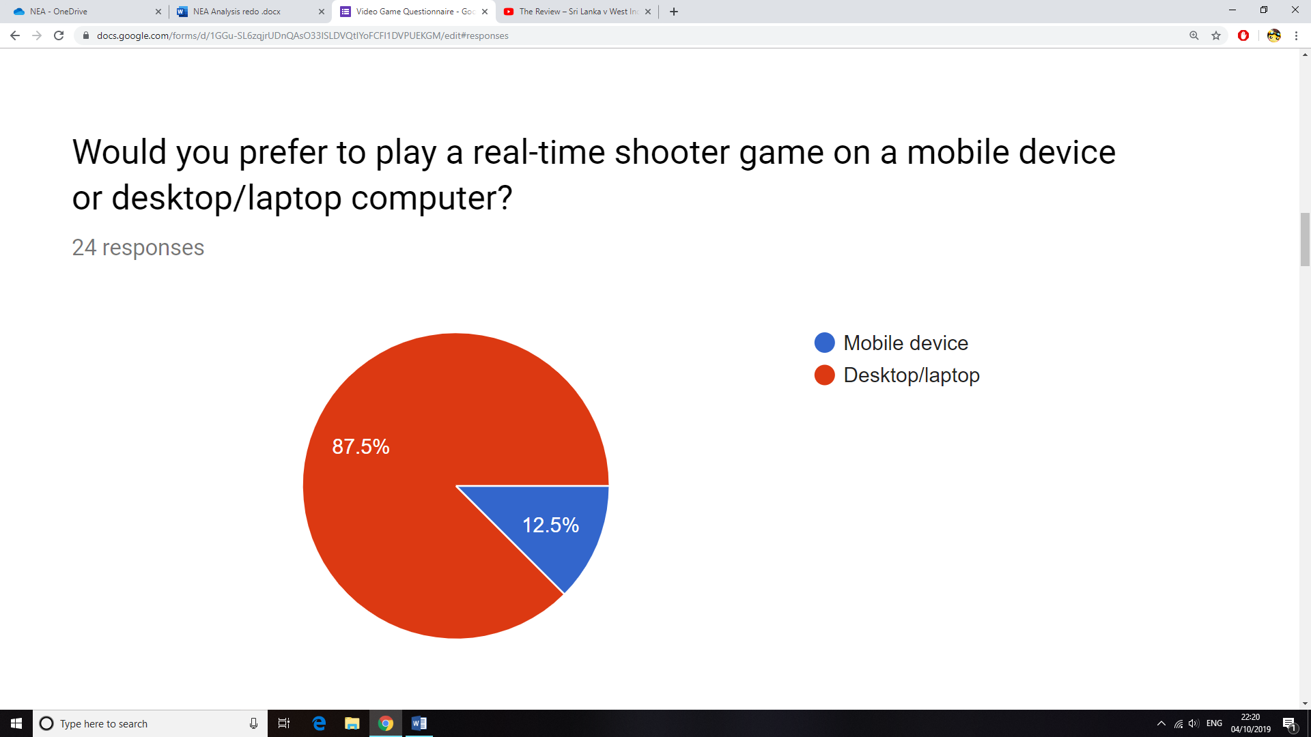

The majority of votes were towards desktop or laptop computers, because they allow for a larger display with a more flexible control scheme due to external peripheral controls. Although there are many mobile arcade games, a lot of gamers (as seen in the chart) will prefer to play a real-time competitive game on their desktop computers, hence I will create my game for a desktop/laptop computer.

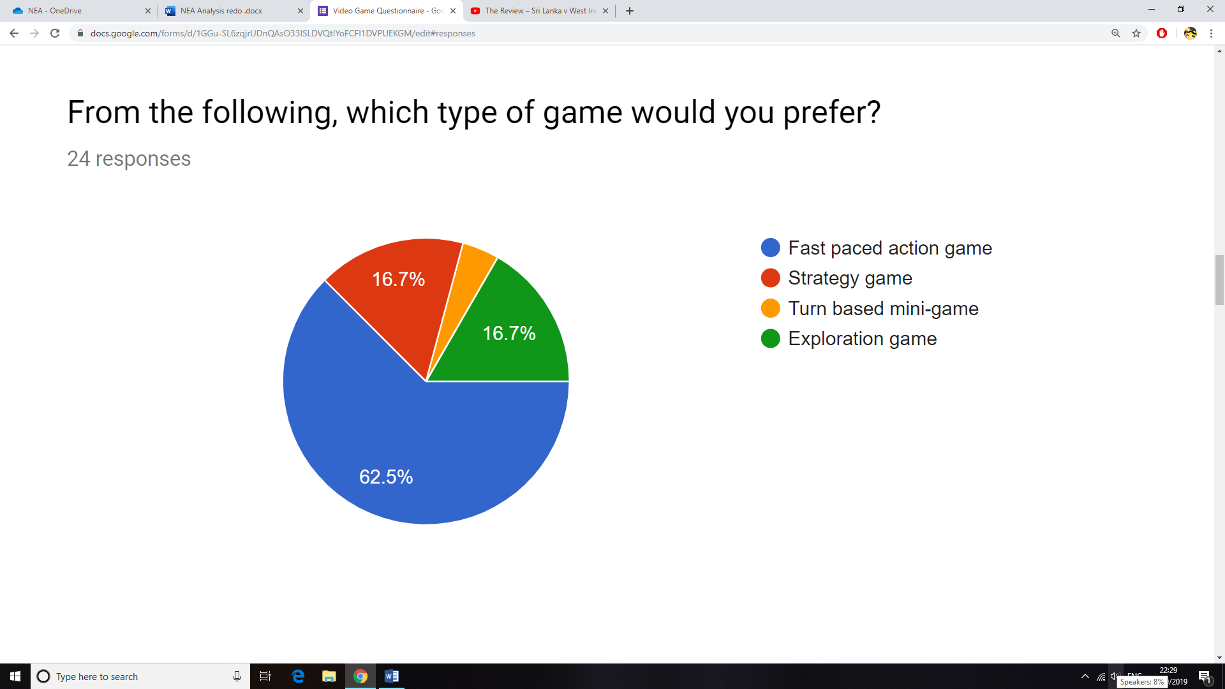

The majority has selected action games as their preferred genre from the options above. I will need to implement features to make my shooter game fast paced, possibly with the use of SFX and other methods such as randomly appearing collectable items which should increase variety and uncertainty of winning the game.

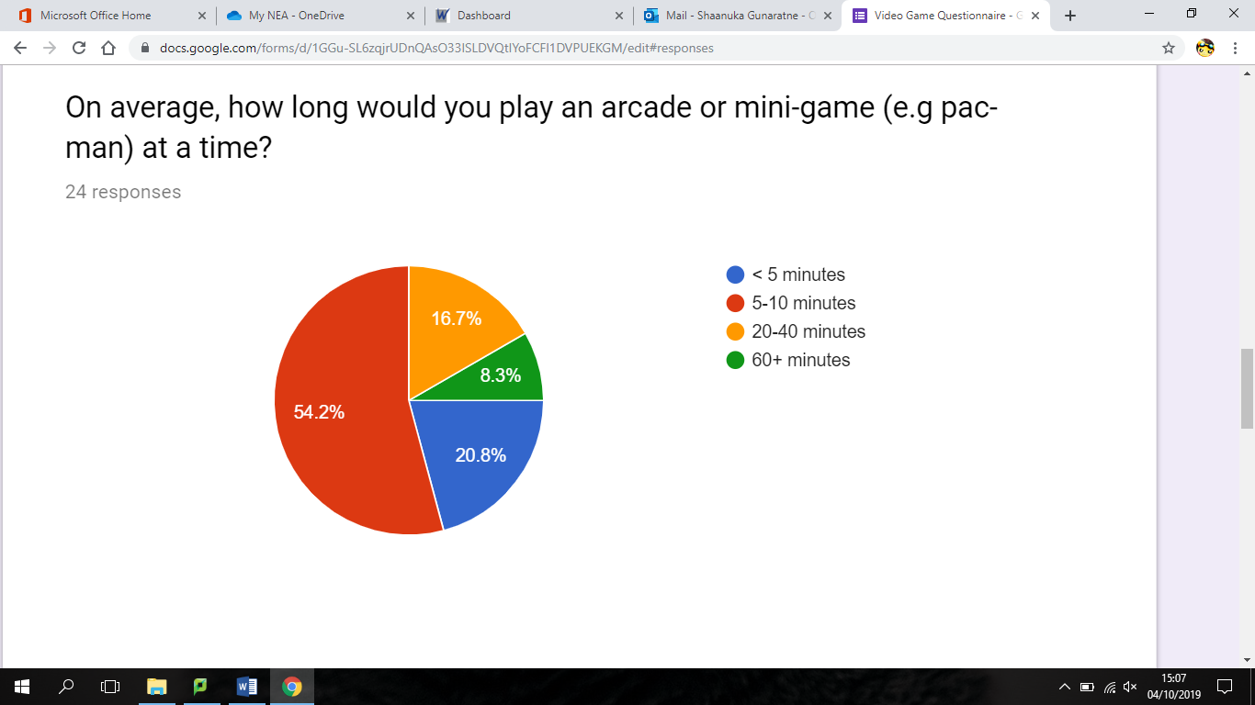

Arcade games are mostly played in small intervals. From the survey, it’s clear that a player would usually play such a game for 5 to 10 minutes at a time. For my implementation, I could add a countdown timer for each match that can be altered by the player, therefore the user would know how long they will be playing for. This feature would be very useful in a multiplayer scenario where it would not be ideal to allow the player to pause the game, therefore adding a controllable time limitation would make it more convenient for the user.

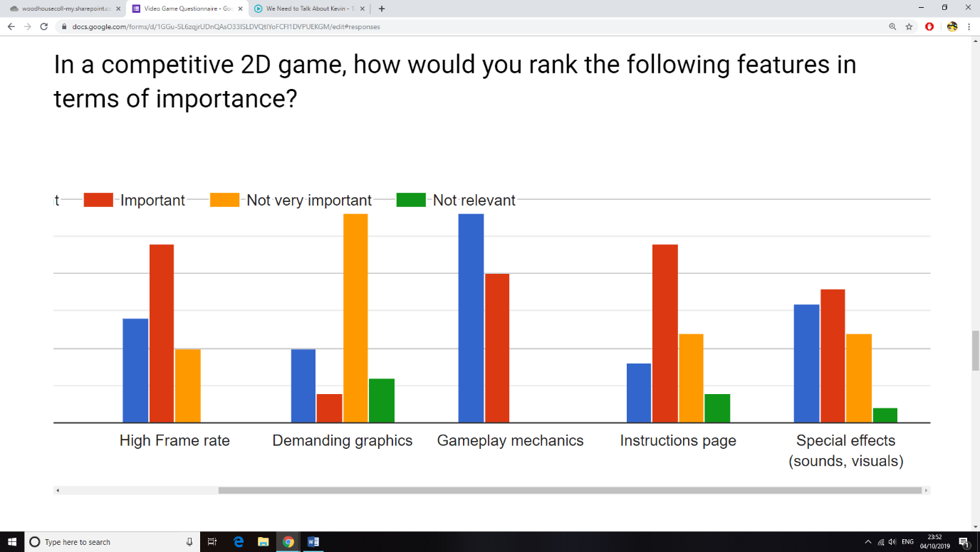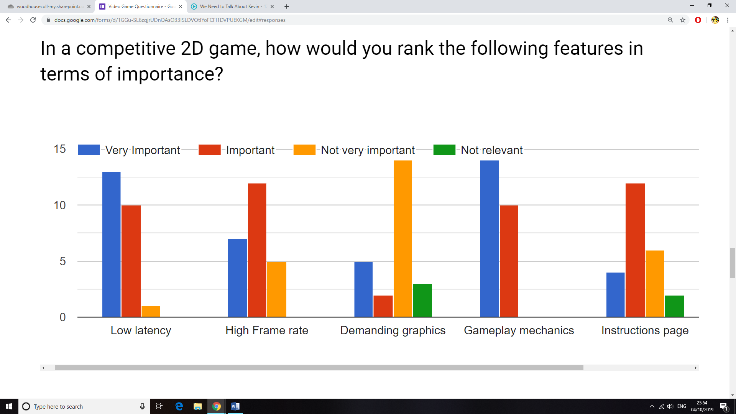

It was crucial that I knew which parts of the project to focus on during development. From the rankings of features I gathered from my survey; I’ve established a hierarchical order of features that are most important in my game.

**Gameplay mechanics** understandably having the most votes suggests that my audience would like me to focus on the core elements of gameplay. This means I will need to refine certain aspects of the game such as the ability to jump and fall due to gravity, the effect of collisions between sprites or projectiles and sprites, and the other similar functions.

**Low latency** and **high frame rate** are again voted as important due to their effect on consistent playability of the game. There will need to be measures taken to prevent frame inconsistencies and latency, which I have discussed above.

**Special effects** have also been noted as important. This may be due to the fact that both the visual and sound effects work together in most games to control the pace of the game. There are some mixed views in the rating for this feature, therefore I will need to talk to one of my peers to get further details.

**An instructions page** has also been deemed of importance. In oppose to an in-game tutorial during the first minutes of gameplay, many gamers do like to have a detailed instructions page so that they can re-visit it if any information if forgotten. I will make sure to add this to my final version of the game.

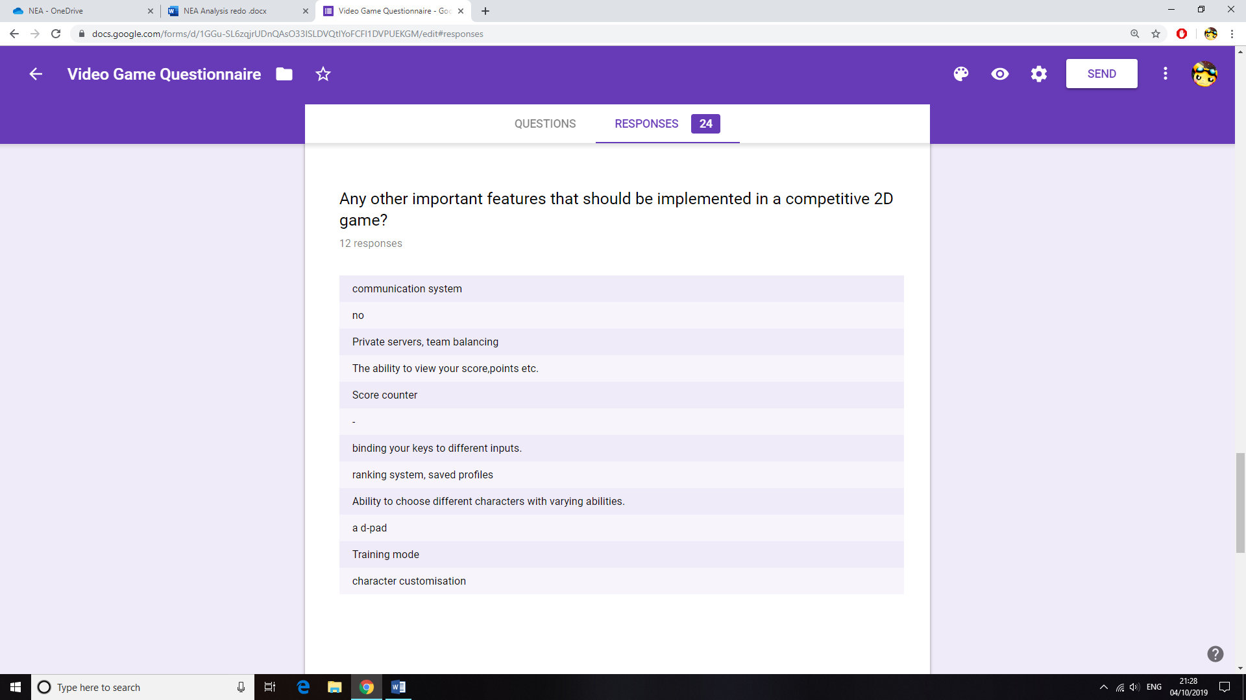Finally, **demanding graphics** has not been a popular choice, therefore I will not focus on this aspect of the game as it’s clear that most players care more about the gameplay mechanics when it comes to playing a fast-paced action game.

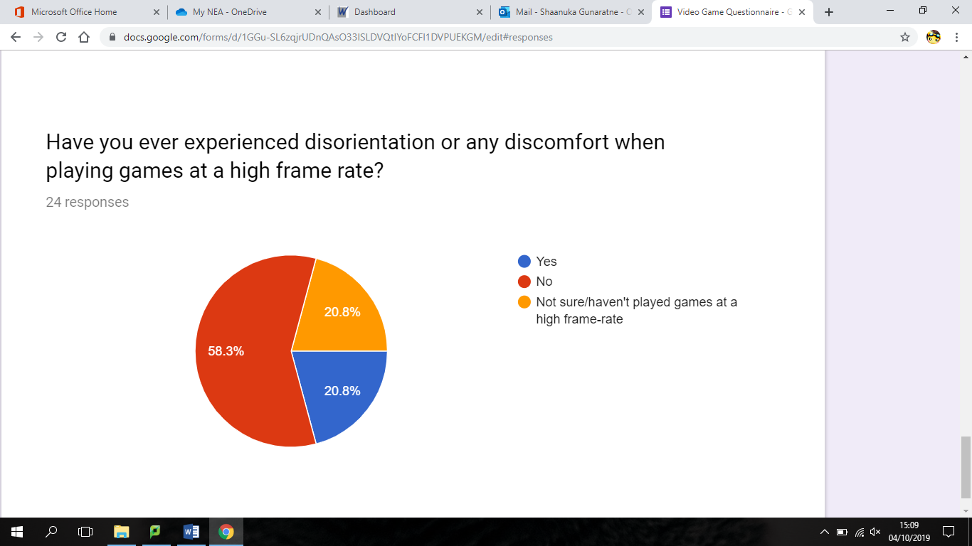From the responses I got for the additional features that could be implemented into my solution, many suggested the addition of a point system and the ability to save profiles. I have already considered creating a scoring system, but I can increase the competitiveness with a system that stores the points such as a highscores table for each player. This can be done via a login system so that a certain player can be identified and their scores can be tallied and stored.

Finally, It has come to my attention that some users do feel motion sickness and are prone to headaches when playing certain types of games[7]. As seen in the chart above, several peers of mine admitted to this. However, from research I have conducted I’ve learnt that the main issue is in first person shooter games. This will not be as much of a problem with my game as it will be in a 2D side-view perspective. However, I will need to cap the game at a suitable framerate so that the user would feel comfortable when playing for longer durations.

## Detailed requirements from target audience

After conducting the survey, I have decided to create a competitive multiplayer shooter game. My final goal is to make an arcade shooter game with features from modern titles of similar genres. To gather more information for my project I contacted one of my peers, David, who is an avid action gamer. I told him the specifics of my project and asked several questions that would help me with my project.

1. **Are there any features in a competitive multiplayer action game that specifically stand compared to other video games?**

*“To me the main thing that differentiates a multiplayer action game from any other game is its competitive nature. I enjoy playing a lot of multiplayer games such as ‘Street Fighter’ and ‘CSGO’. The main reason being the fact that I can play with my friends and compete in fast paced matches. I also like the ranking system in CSGO where prestige is gained from each successful match. But the main focus when playing is the point system and trying to get to the top of the leader board in each game.”*

It’s clear from David’s response that I should focus on the competitive aspect of the game. One of his main points being a leader board and point system increasing the competitiveness of the match. This was also requested on my initial survey, so I think it will be a good idea to implement either a high-score table or a player leader-board in my solution so that the players can gauge their performance and compare it whilst playing against each other.

1. **Do you think there will be a benefit of adding a login system and providing a player with their own account?**

*“Most modern games I’ve played allowed me to make my own account. It adds to the competitive aspect of the game since you can save your high scores and achievements. However, I wouldn’t mind the lack of a login system for smaller titles because I won’t invest as much time playing them.”*

A popular request from my survey was a high-score system. For this to work, I thought of creating a login system for each player so that their scores can be saved individually. From David’s response, I realise that making a login system would add to my game in terms of extra functionality. If I’m to make the scoring system, I’ll need to find a format to store player high scores and login details either using a CSV file format or database. However, CSV files can be easily be read and modified, leaving the login details and high-scores prone to tampering. Such issues can be avoided with the use of a database. This method allows the access rights to the data to be modified so that they cannot be accessed by an unauthorised user.

1. **On the survey, the majority of the class voted against high-resolution graphics. I am assuming it may be because of hardware requirements and issues with frame consistency. What do you think of this?**

*“I love playing graphic intensive games like ‘The Witcher 3’ and ‘Forza Horizon 4’, but neither of these are fast-paced action shooters. For me even with the recommended hardware requirements to run a graphically intensive game, when playing it at a faster pace the graphical quality is less noticeable as my main focus will be on the current events in the game whilst trying to complete the objective. Another reason that it will be less important is the fact that your game is more casual and for smaller gameplay sessions, therefore I don’t think the visuals should be very demanding.”*

Since I am creating this game for a casual player, I understand David’s response saying that there is no need for high-end graphics. I think I should shift my focus to the mechanics of the game and making sure that the multiplayer functionality is stable instead of opting for high resolution textures and enhancing…

1. **If the graphics should not be a concern, what are your thoughts on visual and sound effects during specific moments in the game?**

*“The SFX are definitely a bonus and adds to the pace of the game, especially for increasing the tension such as in a 1v1 situation. For me, these effects add an extra touch to make a game seem complete. If you take Pacman for example, the game has a fairly basic goal and the visuals are bright and colourful but not nearly at the standard that graphics are at right now. The only things that still stands out to me from that game is the sound effects; the change in music from when your Pac-man is chasing the ghosts, compared to when he is being chased by them adds to the tension and makes the game a lot more exciting in my opinion.”*

From his reply, I can understand that sound effects and certain visual effects can also be used to change the pace of the game. The basic sound effects of my shooter game will consist of sounds such as shots being fired, getting hit by a projectile, and the sounds for player movement. I will need to add special sound effects that change depending on the events of a game. For example, if one player is low on health, I could increase the pace of the music output for that specific client, therefore the sound effects will be different for each player. For this to be possible I will need to create an automated sound effect function that can identify each player and their attributes and provide the relevant output accordingly.

1. **Finally, what components would you personally like the final program to consist of?**

***“****For me, I would like it if the final product has 3 main components. A player should be introduced to a main menu screen at start-up. If you decide to add a login screen, then the menu should be loaded after the player logs in. Then he or she should have the option to either play the game or quit. Another feature I see in many games in an instructions page. I would expect this in the main menu alongside the play and quit options. If you are deciding to create an online multiplayer either with a WAN or LAN network, you should allow the user to set up or join a server. Finally, the main focus of the program should be the game itself, such as its performance and mechanics .”*

As an experienced arcade gamer, David’s listed out the main components of the game that he would like me to focus on when programming my solution, those being the main menu, the server and the main game itself. From this decomposition, I think I should separate these components into independent subroutines and work on them individually on separate files during my implementation stage, as they are separate components of the final game and it will allow me to focus on each of them one at a time.

## Problems to tackle with proposed solution

Before starting the development process, there are several potential problems that will need to be considered so that measures can be implemented to tackle them.

**Synchronised frames for both clients:**

My multiplayer system will run on a LAN based system so there should be a lower amount of latency compared to when connecting to a WAN server. However, there can still be network slowdowns present, therefore I will need to control the pace of the game and make sure the frame rate of the output is compatible with the networking speeds so video that video output is consistent and synchronised between the client computers.

**Securing user information:**

As a result of adding a high-scores table and saving the player’s best scores, a login system is to be implemented. The user’s authentication details and high-scores will need to stored securely to prevent account theft or tampering with the scores. This is not a huge issue as the game is not designed for a player that will invest long hours on it and is mostly for quick and fun sessions. However, if measures are to be implemented, the data should be stored in a database format with a certain type of encryption or hashing algorithm for the authentication details.

**Time constraint:**

There will be a time limit for developing this project alongside the fact that I have other academic commitments and extracurricular activities that are ongoing throughout the year. This means I will have to prioritise the main aspect of the game such as the real-time multiplayer battle system, compared to other aspects such as the database for the user details. Although I’m going to focus on the main aspects of the game, I will try my best to implement all of the features in my final game.

**Hardware and software constraints:**

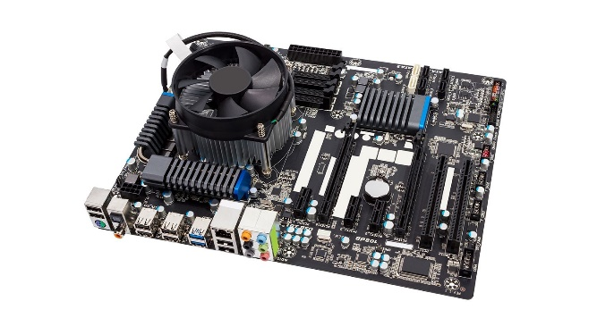I have chosen not to make the graphics very demanding for my game and will also try to make my algorithms efficient (lower time complexity) so that they do not take up a significant proportion of hardware resources. Most modern computer systems should be able to run the game, but I will benchmark it on my own system to test its performance. These are the basic specifications for my current computer system:

**Intel core i3 7100 CPU**

**Integrated Intel HD Graphics 620**

**8GB DDR4 RAM**

**64-bit Windows 10 Home Operating System**

Additionally, I’ve decided to program the game on Python using the Pygame library. Python is an interpreted language, so a Python interpreter with a reference to Pygame will need to be installed on the computer system before running the game.

**Knowledge constraint:**

This is the first time I am developing a video game using an external network and games library, so it will take a moderate amount of time to learn to use and incorporate these libraries and their syntax within my program. Furthermore, I will be implementing a client-server model for multiplayer which will need planning as data transfer between clients can be implemented in many ways.

I will create a few prototypes to familiarise myself with the game engine before I start to implement my final project.

## Proposed Solution

From the analysis on video games that I conducted; I have planned to create a real-time multiplayer arena shooter running on a local area network.

The player will have to option to login or create and account when the program is opened. Then they’ll be welcomed by a main menu screen which will include an option to view the high scores, instructions, quit or play the game. Then they can either chose to create or join a server, where they will connect with another player on the same network playing the game.

The game will start and a countdown will be displayed at the top of the screen. There will be platforms and collectable items around the map. The players will each have a blaster and the aim of the game will be to eliminate the other player. This is a simple objective and it’s similar to the retro gaming style of the current solution (Space Invaders). Every hit taken will reduce the player’s health. The collectible items on the arena will provide the players with random resources and powerups. The last player to survive, or the player with the most health after the time runs out will win. The users’ high-scores will be stored in a database and they will be required to login at the start of the game.

## Planning the implementation

I’ve decided to use the Python 3 programming language for the implementation for several reasons, one of them is the fact that it’s the programming language I am most familiar with. This choice should allow me to spend more time solving logical problems within my program rather than learning the syntax. The other factors affecting my decision are listed below.

### Advantages of Python 3

* Python is a very popular programming language that comes with a lot of online resources. By 2019, it was used by more than 32% of the programming community.[8] Owing to this fact, there is a large community of Python programmers providing a lot of helpful resources that I could use to solve problems within my program and to make it better.
* Python’s syntax is known for its closer resemblance to modern English compared to other programming languages like C. It is the same for the libraries such as Pygame and Socket which I am not very familiar with as of now. This should make it easier for me to learn and memorise new commands that I will need when programming my solution.
* Python also has a very compact syntax compared to many other languages[9]. Due to this fact, the development time for my project should be lower when using Python in comparison to languages with a less compact syntax as it will take longer to write the source code.

### Disadvantages of Python 3

Python is an interpreted programming language. This means that it uses an interpreter as its translator to translate the high-level source code into machine code. Unlike compilers, interpreters translate source code line by line every time the program is run, whereas compilers translate the whole program at once into a single executable file that is independent of the source code. This causes several limitations for the program.

* One limitation is that a version of Python 3 will need to be installed on the client’s computer and the source code will need to be present for them to run the program. This is because the interpreter needs to translate from the source every time the program is run.
* The previous point raises a vulnerability as the source code will need to be distributed for the program to work. This will allow the original code to be modified by the user. This is may be a problem as the users can modify the source code for unfair advantages.
* Finally, the fact that Python is interpreted may cause performance issues as interpreters are known to be limited in terms of performance as a result of the line by line translation process during the running of the program. It will be vital for me to optimise the game and not make it too demanding for the system to reduce any performance issues as a result of this.



### Atom Source Code Editor

I decided to use Atom, a free source-code editor to develop my program as it has several advantages over IDLE (the default development environment that comes with Python).

Atom allows multiple files to be loaded into one window with multiple tabs. This will be helpful when comparing code from multiple files and will allow me to have every file in my project to be opened simultaneously in one window, making it faster to edit code.

Furthermore, Atom provides the user access to thousands of packages made by its community, providing various functions such as multiple debuggers to choose from. This is extremely useful due to features such as debugging allowing a programmer to troubleshoot their program and to detect any errors within a given region. I think this would be useful for me since I am creating an abstract environment for my game, which will include multiple variables and data structures that I’ll need to keep track of. Debugging will allow me to assess each component of my code to make sure everything is consistent and allow me to spot any logic errors in my program.

Atom also allows the integration of a Github account. Github is a platform for software developers that allows them to manage their code. I can link my Github repository onto atom so that my code will automatically be updated and saved.

It also has small features that will save time and make the development process easier, such as auto-correcting syntax with suggested inputs and an auto-save feature which saves changes periodically and when terminated. This makes it more reliable and more developer friendly compared to IDLE

### Image result for pygame logoMain Libraries

**Pygame**

I’ve decided to use the Pygame library as my main graphical user interface and game engine for developing my program. There were other choices that I researched such as Blender, Pyglet and Panda 3D, but Pygame has several advantages over other game engines available on Python 3.

Pygame has a very large community with a lot of support such as active forums and tutorials compared to other engines with similar performance. This will make it easier to learn the syntax I will need for my program to work and will allow me to use the library to its full potential.

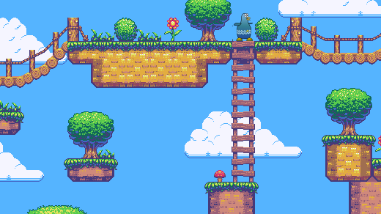Unlike some of the engines mentioned such as Blender and Panda 3D, Pygame provides the programmer with a simple 2D environment where 2D images can easily be imported from many file types without the need to worry about a 3rd dimension. My game will run on 2D graphics; this will advantageous since I plan to focus more on the logic of the game and less on demanding visuals.

Pygame is known for its support of arcade style graphics as seen above[10]

Pygame is also supported on multiple platforms such as Windows, Linux, Mac OS and many other operating systems. This is a significant advantage not only because I can program the solution on multiple operating systems, but mainly the fact that my software can be distributed to my peers and it will most likely work on their systems.

On the other hand, there are some drawbacks to using Pygame that I will have to be aware of. Pygame is not considered a high-performance game engine. This is partially due to the fact that it’s not hardware accelerated; hence it lacks optimisation compared to some other game engines. I’ll need to make sure there aren’t a lot of sprites and that a large proportion of video memory is not used in the final version of the game.

**Sockets**

The socket library allows information to be exchanged between devices across a network. With streaming sockets, data can be transferred to a device continuously and at any time whilst the program is running.

Using the sockets library, I can create a central server for the clients to connect to. This is called a client to server network. The server will dictate the transmission of data to the two clients when the game has begun[11]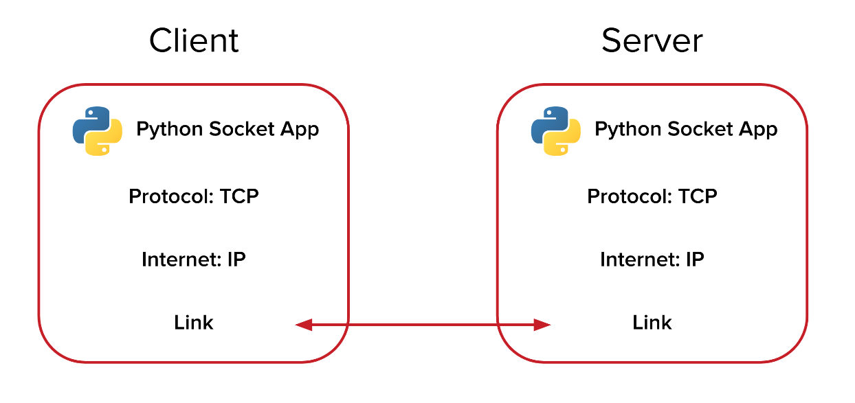

I’m using sockets because it allows me to implement a communication line between two devices on a network. Most importantly, it causes low network traffic. Since I’m running a real-time multiplayer game, lower network traffic should reduce the latency between the client and server, therefore increasing the performance and smoothness of the game.

However, Socket based communications will only send raw data to and from the server, so I will need to implement a mechanism for re-collecting the data and processing it back into information. Although this will work for small amounts of raw data, there will be a lot of different data such as player coordinates, projectile coordinates, character move-sets and items on the arena and implementing such a mechanism for each one of these data types will be inefficient.

## Prototyping

I wanted to test sending and receiving data using the socket library, therefore I set up a client-server network and sent data between 2 clients and a server.

These are the libraries that I used for my server. The socket library for data transfer across a network and the thread library which allows multiple functions to run simultaneously. This will be useful when more than one client is connected to the server.

import socket

from _thread import *

server = "192.168.1.01"

I used port 1010 as it’s normally open and will be available to use for my program.

port = 1010

s = socket.socket(socket.AF_INET, socket.SOCK_STREAM)

try:

s.bind((server, port))

except socket.error as e:

str(e)

s.listen(2)

I sent location data of sprite objects from 2 clients to a server that I set up. The integers within the tuple data structure must be converted into string format before being sent across the network, which is what the create_position () subroutine does.

print("Waiting for a connection, Server Started")

def create_position(tup):

return str(tup[0]) + "," + str(tup[1])

position = [(0,0),(50,50)]

def receive_position(str):

This subroutine takes the string data that has been received from the client and converts it into a tuple data type so that the integer values can be used by the server.

str = str.split(",")

return int(str[0]), int(str[1])

def threaded_connection(conn, player):

conn.send(str.encode(create_position(position[player])))

I’m using a separate thread so that the server can continue to wait for incoming connections from other clients (while loop) whilst sending and receiving data from a client that is already connected.

reply = ""

while True:

try:

location_data = receive_position(conn.recv(2048).decode())

position[player] = location_data

Number of bits received at a time

if not location_data:

print("Disconnected")

break

else:

if player == 1:

reply = pos[0]

else:

reply = pos[1]

print("Received: ", location_data)

print("Sending : ", reply)

conn.sendall(str.encode(create_position(reply)))

except:

Data must be encoded and converted into bits before transferring them using sockets.

break

print("Connection lost")

conn.close()

**Problems with the prototype:**

As mentioned before, the information that is sent between the client and server network will need to be converted into raw data. This can be seen in my prototype where the data was converted from string to tuple and encoded before sending. The data will then have to be decoded at the clients end and be reconverted into useful information. Several subroutines had to be created to implement this way of communication, and more will be needed when more data types (e.g. projectile data and other player variables) have to be transferred. This will make the source code very repetitive and will be time consuming.

**The Pickle library and Object-Oriented Programming**

One efficient method of implementing multiple data transmissions is by using an object-oriented approach. Instead of transferring individual data elements, I could transfer object data. Due to the encapsulation of attributes that is available with OOP, a class for players can be created, and instantiating player objects would allow the client to send all of the player’s attributes (not just coordinates) at once. This will save a lot of time and reduce complications within the source code. It will also make it easier to debug the program and test the transfer of data since whole objects can be tested at once instead of testing variables individually.

For this to be possible, the object data will still need to be converted into byte data as it’s a requirement for transmission with sockets. The pickle library in Python will allow me to do this using the ‘pickle.dumps()’ function, which can be used to convert data types including objects into a byte-stream for transmission

## Initial Objectives

* Create a login system that works with a database to create or verify an account.
* A main menu with the following options: Start, Instructions, High-Scores and Quit.
* An instructions page with an introduction detailing the objective of the game and a list of all the controls and their purposes in-game.
* High-scores page that displays all the high-scores from all stored accounts in the player database.
* If the Start button is selected, it will take the player to the server menu.
* A server that will maintain and synchronise the game with both clients and allow the clients to exchange data with each other.
* A main game subroutine where the players will be loaded into the arena.

**Main game:**

* Basic control scheme for movement and corresponding sprite animations.
* Gravity that keeps the players from hovering mid-air.
* The arena will be designed with platforms to both assist and hinder player movement.
* Background animation to make the game more visually appealing.
* Each player should have weapons that shoot projectiles that travel at a constant velocity until they collide or move beyond the map.
* A synchronised countdown that will start at the beginning of the match.
* Music and sound effects depending on the scenario in the game.
* A health and damage system.
* Random collectable items should appear at a random time and should provide the player with different powerups when picked up (e.g. increased speed).
* A system that determines the winner of a round. Either when a player dies, or time runs out.
* An endgame display showing the winner of a round.
* A high-score comparison function that should determine whether a player’s score is their highest, if so, it should be stored in the player database.

**Server**

* Allow a maximum of 2 players to connect to the server but optimise the game so that it will be easy to add improvements such as allowing for more than 2 clients to connect and play the game. This will also make the game easier to update and add new features.
* Should have the host’s IP address stored in a variable.
* A network port should be available for the server to use.
* A command-line interface that provides the user with feedback on the server status while running (e.g. “Waiting for connection”).
* Should continuously send packets of data to the client and detect if a client has disconnected.
* Should convert the raw data received into information to process a response.
* Should have a memory efficient method of sending multiple data types simultaneously between the client and server.

**Sprite design**

* Design 2 character models for player 1 and player 2.
* Design a sprite for the projectile.
* Multiple sprites should be created for animations.

**Possible additions and deductions:**

There’s a time limit for completing this project, so at the end I may either have extra time or lack time to complete some features of the program.

**Extra features:** I will optimise my code so that if I have time remaining on the project, I can make improvements such as support for more than 2 clients in a game round, and multiple animations for player actions.

**Limiting features:** I will prioritise making the main game work, then the performance optimisations, then the player database and finally user interface and additional visual effects.

After designing the structure of the program, I took feedback from my target audience and implemented new objectives to better my game. The feedback and changes have been documented in the documented design section. These are the updated set of objectives for my final program.

## Final objectives

**Login System**

* Gives users the option to login or create a new account.
* Database records checked for identical details when creating new account. If not, new details inserted into player table.
* Player database checked for login detail validity. If invalid, error returned to user. If valid, main game menu loaded

**Main Menu**

* User given the options Join Game, Host Game, Instructions, High-Scores and Quit.
* An instructions page with an introduction detailing the objective of the game and a list of all controls and their purposes in-game.
* High-scores window loads in a separate window on Tkinter and displays all the high-scores from all stored accounts in the player database.
* Quit will close all instances of the game and terminate all services
* Host Game will take the server name and time limit of the game as input. Then it will broadcast the server on a separate thread and return the user to the main menu.
* Join Game will open the server menu.

**Server Menu:**

* Client will listen for broadcasting messages from servers. If received, the server name and address will be stored, and all server names will be displayed to the user.
* Servers listed and keyboard input will allow the user to scroll up and down the list of servers.
* If a server is selected, the main game will be loaded.

**Main game:**

* Waiting screen for user until both players are connected and loaded.
* Basic up, down, left, right control scheme for movement and corresponding sprite animations.
* Gravitational acceleration that keeps the players from hovering in mid-air.
* Jumping acceleration and deceleration modelled with parabolic motion equation.
* The arena will be designed with platforms to both assist and hinder player movement.
* Live background animations to make the game more visually appealing.
* Action music playing from the start of the game.
* Pace of music increases with time.
* Each player given blasters that shoot projectiles travelling at a constant velocity until they collide or move beyond the arena boundaries.
* A synchronised countdown that will start at the beginning of the match.
* Additional sound effects such as blaster fire.
* A health and damage system.
* A scoring system
* Random collectable items should appear at a random time and should provide the player with different powerups when picked up (e.g. increased speed).
* A system that determines the winner of a round. Either when a player dies or time runs out.
* An endgame screen showing the winner of a round.
* A high-score comparison function that should determine whether a player’s score is their highest, if so, it should be stored in the player database.

**Server**

* Broadcasts name to all devices on the network using the broadcast domain.
* Use an open port for UDP transmission to clients.
* Listen for connections from clients.
* Terminate broadcast when 2 clients have connected.
* Start new thread for each new client.
* Uses serial communication to transmit data.
* Optimise to make new features and updates easier to implement (e.g. adding new elements to dictionary, allowing more than 2 players to connect).
* A command-line interface that provides the user with feedback on the server status while running (e.g. “Waiting for connection”).
* Use pickle to serialise object data before being transmitted.
* Serial transmission used.
* Send collectable item data in a 2D list array.
* Instantiate and run a timer instance and continuously update the time elapsed for both clients.
* Use pickle to convert received serialised data back into its original format and update the server’s data on clients.
* Act as an interface and manage communication between clients
* Close server when match has ended.

**Images and sprites**

* Obtain 2 character models for player 1 and player 2.
* Obtain a sprite for the projectile.
* Multiple sprites should be created for movement animations.
* Background gifs separated into a list of images
* Use an arcade style font for all text
* Create an instructions page externally and convert it to an image format

# Image result for design iconDocumented Design

Description of how each part of the program will run. This is the initial version before client feedback or problems encountered that would have changed the structure of the program.

**Login system:**

* Player will be invited with a login screen that requests account details.
* There will be an option to create a new account.
* All details will be checked or added to the players table in the database.

**Game Menu:**

* After login, the player will be directed to the main menu with the following options: Start, Instructions, High-Scores and Quit.
* Clicking ‘instructions’ will open a page with an introduction detailing the objective of the game and a list of the controls and their purposes.
* If the ‘High-scores’ option is chosen, the player will be taken to a page which displays all the high-scores from all stored accounts in the player database.
* If the user choses the Quit option, the program will terminate.
* If the Start button is selected, it will take the player to the server menu.
* Within the server menu the player will be prompted to either run the server file which hosts a server or enter the IP address of the server that they want to connect to.
* If the player choses to run their own server, there will be a button that connects them to their own server without needing to type their IP address.
* If an IP address is entered, the program will search for local server associated with it. If not found, a message will be displayed to the user notifying that there is no server present. They will have the option to go back to the game menu and create a server.
* If a server has been found or created, the main game subroutine will run and the player will be loaded into the arena with their default player sprite.

**Main game:**

* The players will have basic movement controls such as left, right and jump, with the corresponding character animations.
* An integer constant will be created that simulates gravity within the game.
* If another player connects, the default sprite for player 2 will be loaded into the game. A maximum of 2 players can connect to the server.
* The arena will be designed with walls and floors to both assist and hinder player movement.
* A message in large font saying ‘Begin’ will indicate the start of the battle, where the players will be able to shoot projectiles by pressing the spacebar key.
* The projectiles should move in the horizontal axis at a constant speed. If they collide with an object, they will be removed from the player’s projectile list and will not stop rendering.
* A countdown timer will start at the beginning of the match.
* Music and sound effects will be present and will change depending on the events in the game.
* The players will each have a health attribute which will decrease whenever they get shot.
* A player is eliminated when their health value reaches 0. If so, the other player will win the match and a victory message will be displayed.
* If the time runs out, the player with the most health will win. If they both have the same health, the match will be a tie.
* Both players will then be redirected to the main menu, and the sever will terminate.

**Server**

* Will act as an interface between the 2 clients and control certain aspects of the game.
* Will instantiate the player objects and update the data for both clients simultaneously.
* Will provide feedback to the user on its status (e.g. ‘Connection Lost’).

## High level overview of my program

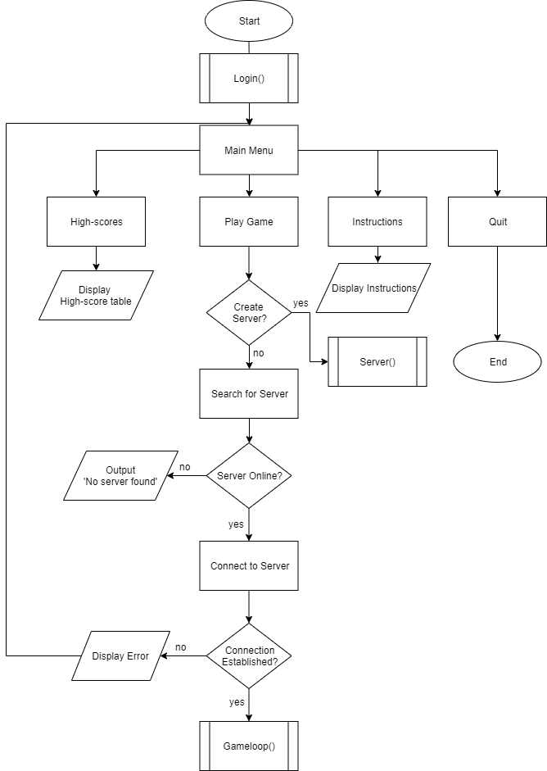The following flowcharts represent the logic behind my program. These will help me to decompose the project into smaller individual problems, making it easier to solve.

## Main game loop

## Login system

This allows users to create a new account and login to the game. The user’s authentication details will be stored in a table on a local database. The structure of the login system is detailed below with the use of a flowchart:

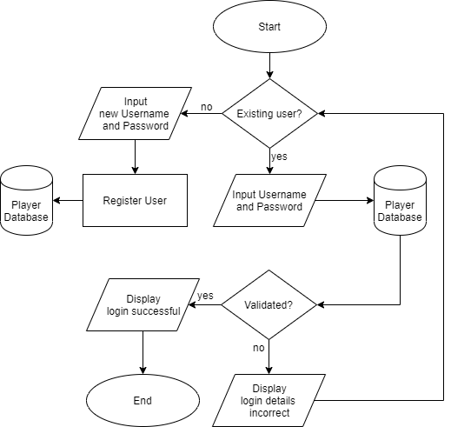

## Setting up a client-server network

As mentioned in my analysis, I have decided to use the sockets library to set up a client-server network. A client-server network allows a user’s computer (client) to connect to a server and exchange data with it.

### Server

The central server controls the flow of data from client to client. This will be a LAN server that’s in charge of connecting 2 local clients together and processing their inputs. It will then send a valid output to both the clients through packet switching using the sockets library.

### IP Address and ports

To setup a server, first I will need to identify my computer’s private IP address, specifically my IPV4 address that I’ll use to host the server. This is a unique set of values that will identify a device on a network. For other clients to join my server, they will need the IP address of the computer that the server is running on. I’ll be using IP version 4 (IPV4) as it is the most common version right now.

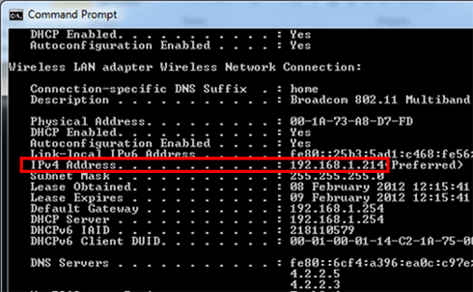

The IP address and other network information can be accessed using the ‘ipconfig’ command in the Windows command prompt as displayed in the image above[12]

For the communication line to work between the client and the server, I will need to use an unused port so that the client can connect to the host IP. A port is a number that allows a client from another computer to connect to a service hosted by a specific IP address. Ports are used in several protocols such as HTTP and FTP. I will need to use a free port on my router that is not used by other services.

A port that is usually free to use is port **1010**, therefore I will use this port to test my server.

### Establishing Connection

The **listen ()** function will be used so the server listens on the selected port for an incoming connection. When a known connection is detected, the function will create a new socket called a child socket and will establish a connection.

### Transferring data

When transferring raw data between client and server, the socket library usually requires the data to be in a certain format so that it can be converted into bits for packet switching. As seen in my prototype in the analysis section, I had to convert position data into a string an encode it.

def create_position(tup):

return str(tup[0]) + "," + str(tup[1])

position = [(0,0),(50,50)]

def receive_position(str):

str = str.split(",")

return int(str[0]), int(str[1])

This process will become very tedious and will make the program inefficient in terms of storage when numerous other variables are also processed using this method.

### Object data instead of string data

One solution to this problem is to use object data. The Object-Oriented Programming paradigm will allow me to create objects such as players and projectiles that will each have attributes such as player’s position instead of independent variables. These attributes have a relationship with the object so when I send an object though the network, it will contain all its attributes and I won’t have to send them separately. This will also make it easier to debug the program as I won’t have to test a multitude of variables.

**Using Pickle to send object data**

I’ll need to use the pickle library in Python to send object data through the network. Pickle will let me convert the object data directly into a byte stream, where they can be sent through the network using sockets.

Pickle.dumps() – this function will convert the data into a byte stream and it will be ready for transfer.

Pickle.loads() – this function converts the byte stream back into the original data so that it can be read from the other side (server or client).

### Serial vs parallel transmission

There are multiple objects and variables in the game that need to be transmitted from server to client. Sending each of these elements separately at the same time via parallel transmission is one option to consider. However, through testing I’ve encountered errors using this method due to latency causing some packets of data to be transmitted later than the others. This is a problem in a real-time game as data needs to be updated constantly. A solution to this would be to use a buffer to store the received data temporarily until all of it has been received. However, this can also cause inconsistencies and lag within the game. The easiest method would be is to use serial transmission by storing all the necessary data in a data structure and transferring it all at once.

I decided to use a dictionary to store the relevant objects and variables for each client, then store both in a list structure so that it can be indexed to provide each client with the corrent player data.

**Server side:**

all_data = [{

'player1':Player(x,y,[sprite_1,sprite_2,sprite_3,1,direction),

'projectiles':[],

This method will also make it easier to further develop the game and add extra features. For example, adding another player by storing a ‘player3’ dictionary in the list.

'collectables':Collectable_items(x,y,type)

}, {

'player2': Player(x2,y2,[sprite2_1,sprite2_2,sprite2_3],2,direction),

'projectiles':[],

'collectables':Collectable_items(x,y,type)

}]

The server will send the list of dictionaries to the client.

Send_to_client(pickle.dumps(all_data))

**Client side:**

The client will receive the list and can chose the object that it needs. This line on the client side stores the first dictionary in the containing the player1 and projectile instances, into the player1 variable.

Player1 = pickle.loads(data_from_server[0])

## Objects in the main game

There are multiple classes within my game. The classes in my main game contain objects that have dynamic attributes some depend on each other. The game will run on a main game class, which will contain all the necessary attributes. This class will be connected to all the objects within the game. These are the objects that link to the main game:

**Player object**

The player object will be one of the objects that it sent from the client to the server in order to replay information of the actions taken by the player. They will contain the following attributes:

* Y_position- player’s position coordinate in the y-axis.
* X_position- player’s position coordinate in the x-axis.
* Player – player identification (e.g. Player 2).
* Speed- speed that player moves when moving in the x and y directions.
* Sprites – a list of the names of sprite images that are loaded and displayed depending on the actions performed by the player.
* Direction – Direction that the player is facing.
* Projectiles – List with bullet objects that are added whenever the player shoots
* Projectile_limit – Maximum amount of shots allowed to be fired at a time.
* Health – Player’s health value.
* Score – The player’s score.
* Collectibles – list of collectible items that the character has picked up.
* Death Animation – list of sprites for the animation when a player is destroyed.
* Collision up/down/left/right – Boolean value that indicates whether the player has collided with an object on the map.

**Projectile object**

The projectiles in the game are fired using the blasters given to each player. If a player comes into contact with the other player’s projectile, they will lose health. The projectile object will have the following attributes:

* Y_position - projectile's position within the y-axis.
* X_position – projectile's position within the x-axis.
* Player – Identifies which player the projectile belongs to (used for score system).
* Speed – The projectile’s speed after being fired (constant).
* Image – The imported image for the projectile.
* Direction – direction projectile’s being fired at.
* Hitbox – A square-shaped model of the projectile that’s used to determine collisions.
* Collided – Indicated whether projectile has collided.
* Remove – Indicates whether projectile should be removed or not.

**Collectable Item objects:**

These are multiple objects randomly placed around the map that will provide a player with a special ability (e.g. More than 100% health, increased fire-rate and the ability to heal). They are collected by the player automatically if the player moves to their position. These objects will have their own class and will have the following attributes:

* ItemType – Integer that indicates the type of item.
* X-position – x coordinate on the display.
* Y-position – y coordinate on the display.
* Sprite – the name of the sprite image that will be displayed.
* Life – Item will de-spawn when this reaches 0.
* Correct_location – Boolean value that’s controlled by a method inside the function that makes sure the item is spawned in an appropriate location (e.g. not inside a wall).

**Immovable objects:**

These include walls, floors, platforms and other geometric objects the map. The player will not be able to pass through these objects and they will have the following attributes:

* X – coordinate of object in the x-axis.
* Y – coordinate of object in the y-axis.
* Height – height of the shape.
* Width – width of the shape.
* Hitbox – Pygame rectangle object created to check for collisions.
* Image – Name of the image file displayed to represent object.

## Class diagram

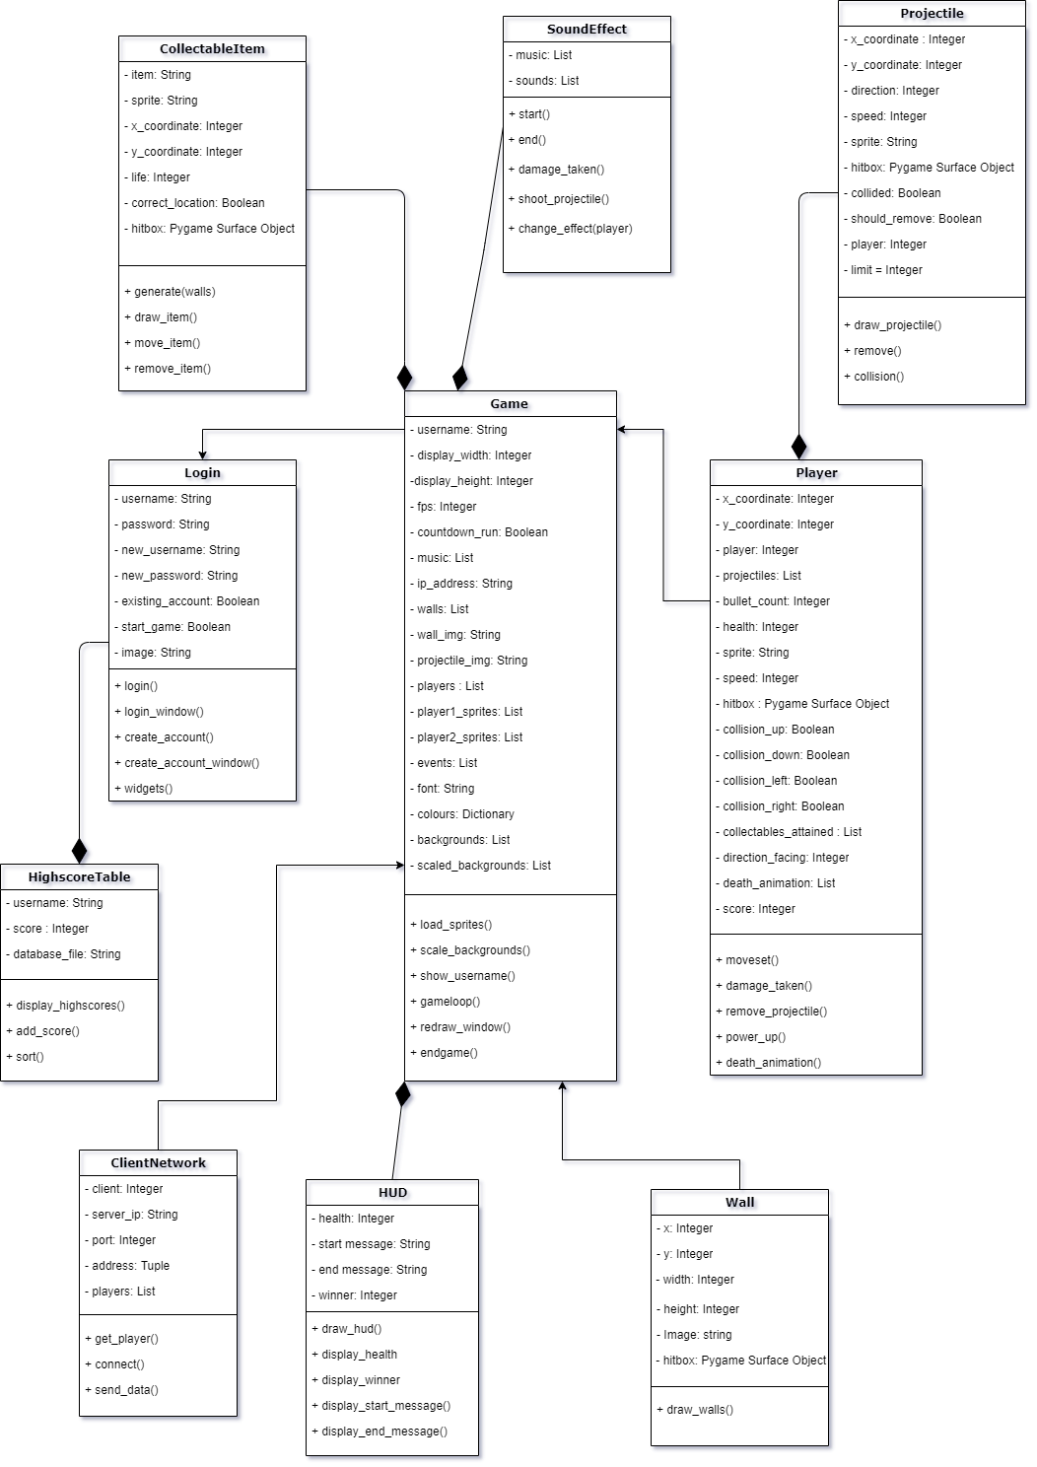This represents my initial design for the class structure of my game.

## Collision detection

Collision detection is another aspect that is essential for other parts of the game to work, such as health reduction, number of projectiles displayed and the scoring system. Collision detection will be used to identify when and where a projectile has collided in order to remove it and deduct player health if necessary. It will also be used to detect the player’s collisions with objects on the map, such as walls and the other player.

All player and projectile objects will have a sprite associated with them. However, abstraction can be used to make collision detection faster and easier to implement. The players and projectiles can be modelled into simple geometric shapes such as squares and rectangular hitboxes.

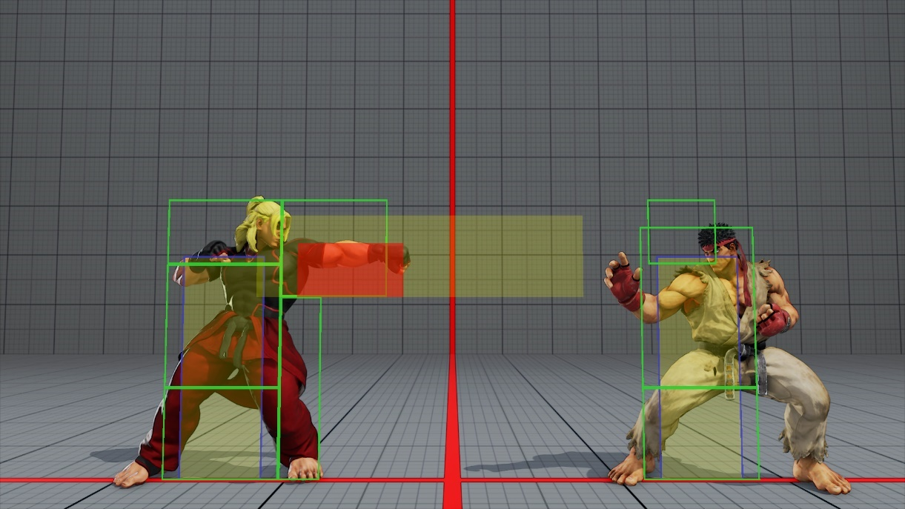

Hitboxes are a popular method of collision detection due to their simplicity. This is used in many games such as the Street Fighter games as seen in the image above.

By doing this, it will be easier to program the detection by assigning ranges to the hitboxes depending on their width and height. Then an algorithm such as the one below can be used to detect the collisions:

Player.hitbox 🡨 (x,ysprite_width,sprite_height)

Projectile.hitbox🡨(projx,projy,proj_sprite_width,proj_width_height)

Def collide(rect_one,rect_two)

If rect_two.x-rect_two.width/2 < rect_one.x < rect_two.x + rect_two.width/2

or rect_two.y - rect_two.heigth/2 < rect_one.y < rect_two.y + rect_two.height/2 Then

return True

else

return False

if collide(projectile.hitbox, player.hitbox) Then

projectile.collided🡨True

For collisions with walls, the algorithm is more complex because rather than the game detecting the collision and simply removing the and object as with the projectiles, the function should also stop the player from advancing once they have collided with the object. This means that there will need to be collision variable for each direction that the player is facing and two more to verify if the player has collided with a wall on top or below them.

collision_left🡨False

collision_right🡨False

collision_up🡨False

collision_down🡨False

if collision(wall.hitbox,player.hitbox):

if player.direction == left and collision_left == False Then

collision_left🡨True

if player.direction == right and collision_right == False Then

collision_right 🡨True

if (wall.y+wall.height/2)<(player.y-player.height/2) and collision_up==False Then

collision_up 🡨 True

if (wall.y-wall.height/2)>(player.y+player.height/2) and collision_up==False Then

collision_down 🡨 True

else

collision_left🡨False

collision_right🡨False

collision_up🡨False

collision_down🡨False

## Countdown Timer

The timer for my game will determine when a round will end. At first, I tried implementing a local timer that runs on the client side and is independent of the server:

**Initial timer routine**

class Timer

private time

private has_started

private end

private font

Public Procedure show_time (player2, Display)

Colour = White

The timer starts when player 2 is loaded into the game. When player 2 is loaded into the game, they will drop vertically down from their original position due to gravity in the game. This comparison statement will detect the moment when player 2 moves from their original position and initiated the countdown.

If has_started = False

if player2.x <> 100

has_started = True

If has_started = True

if time<1

Display (font, "Game Over")

start=False

Else

timer = Display (font, time)

time = time -(1/60)

Timer is decremented by 1/60 each time it’s called in the while loop because the game runs at 60fps, so it will decrement by 1 each second, therefore emulating real time.

if time<1

end=True

### Problems with the timer:

The timer function shown above is local to the client, hence there’s no method of synching the timer on both clients to make sure the output is the same for both clients. Factors such as random frame drops can affect the rate of change of time since it’s proportional to the frame rate of the game. This can cause the time output to vary as a round progresses…

### Using multi-threading for the timer:

One method of fixing this issue was to use a separate CPU thread to execute the timer in parallel to the running game so that it won’t be affected by any frame drops from the main game itself. However, after testing this I realised that multithreading causes performance issues due to Python’s GIL (Global Interpreter Lock), which prevents multiple threads from executing Python bytecodes at once. By conducting further research[13] I found that running a function on one thread is much faster when it comes to more demanding programs such as my game due to this restriction.

### Synching the timer between each client:

A better method would be to run the timer on the server side and synchronise the time value with both clients by passing the value using sockets. This will make sure that the time value is the same for both clients. Calling the timer on the server side will also allow me to start it when the second player has connected, instead of the previous method where the timer started when the player moves from their initial position.

This is the class definition for the timer:

class Timer(object):

def __init__(self):

self.start_time = None

self.stop_time = None

def start(self):

self.start_time = time.time()

The calculations for finding the time elapsed have been decomposed into several functions. The functions start () and stop() both retrieve the current time from the OS and assign the values to their corresponding attribute.

def stop(self):

self.stop_time = time.time()

def time_elapsed(self):

if not self.has_started():

return 0

return int(time.time() - self.start_time)

Time elapsed calculates the number of seconds elapsed by subtracting the starting time from the current time and returns an integer from the result.

def has_started(self):

return self.start_time() != None

**Server-side:**

timer = Timer ()

all_data = [{ 'player':Player(0,0,["sprite1.png","right.png","left.png"],1,1,0),

"timer": timer,

}, {

'player': Player (100,100, ["sprite2.png","player2right.png","player2left.png"],2,2,0),

"timer": timer,

}]

As seen above, I have instantiated a new ‘timer’ object from the class defined previously. Then I added it to the ‘all_data’ dictionary for both players. This means that both clients will receive the ‘timer’ object and it will be updated centrally by the server.

if not data_received_from_client:

print("Client Disconnected")

total_connections -= 1

break

else:

all_data[0]['timer'] = timer

all_data[1]['timer'] = timer

if total_connections == 2:

if not timerHasStarted:

timer.start()

timerHasStarted = True

Finally, this function will continuously check for data received from each client. Whenever a client connects, the value of ‘total_connections’ is incremented, and then decremented when disconnected. I’ve set the timer to start when there are 2 clients connected as that is when the round should begin.

## Generating player score

For there to be a high-scores table, the player should have different scores that depend on multiple events occurring within the game. This will include, the amount of damage dealt by the player, the collection and usage of collectable items and the difference between each player’s health at the end of the game. A real time score-count will be displayed at the top of the game screen…

…

## Collectable Items

There will be multiple collectable items that randomly spawn on the map. They will each have a lifetime in which they will spawn for and then disappear. If the player moves to its position, it’s automatically picked up and provides the player with power-ups such as additional health, faster movement and invisibility.

Heart: Health

Potion: Invisibility

Orb: Super speed



### Method 1

I wanted the collectable items to appear in the map spontaneously in a random location, but the spawn times and locations had to be the same for both clients. This meant that the items must be instantiated and given a random location by the server before being sent to both clients.

This method is shown by the pseudocode below.

Spawn_chance is the chance that an item will spawn during the game.

Itemlist = []

Spawn_chance = 2

While True

Using a random integer generator, a value is generated. If the value is smaller than the spawn_chance, it will generate a collectable item.

Using probability allows me to change the average number of collectables spawning in a game whilst still keeping it random.

Spawn_value = RandomInteger(0,100)

If Spawn_value < Spawn_chance Then

Item = Collectable()

Item.generate()

Itemlist.append(Item)

Item.life = Item.life-1

If Item.life <0 or item.collided = True Then

An item will have a random value for life, which will continually decrement. If life is 0 or the player collides with the item, it’s removed.

Remove item from Itemlist

all_data = {player:playerdata,timer:time,collectables:Itemlist}

Send all_data to Clients

**Generate item method:**

The generate method makes sure the location is random and that the item does not spawn inside a wall. A list containing all the wall objects is passed as an argument and the method will repeat recursively if the item’s location is within a wall.

Public Procedure generate(self,walls)

self.type = RandomInteger(1,3)

self.x = RandomInteger(0,width)

self.y = RandomInteger (0,height)

self.hitbox = PygameRectangleObject(self.x,self.y,25,25)

self.wrong_position_count = 0

for wall in walls

if self.hitbox collides(wall) Then

self.wrong_position_count = +=1

if self.wrong_position_count>0 Then

generate(walls)

#### *Problems encountered with method:*

The main issue with this method is that the server continuously sends and updates the list of collectable items on the client side. This means that any changes to the items made on the client side will be overwritten by the server. When the player picks up an item, the item is removed from the list on the client side, however the sever keeps updating the list in order spawn more items, and as a side-effect it adds the already collected item back to the list. This caused the item to stay spawned until its lifetime reached 0.

To fix this problem, the processing of the item had to be moved to the client side. This meant that the items will be generated on the client side. However, this caused synchronisation issues as the item locations and lifetimes were different for each client.

### Method 2

To fix this problem, I instantiated the items on the client side, then used a 2D array to send the items’ attributes to the client, where the client will then create their own collectable item objects and take the values from the array to be their attributes. This way the client will replicate the objects received from the server and the client will have full control of these objects from their side, preventing the server from overriding them.

The array will look be similar to the one below. Note: Python 3.0 does not natively support the use of arrays, therefore a list will be used during development. A list will also be easier to manage as it’s dynamic, so it’s length will change depending on the number of items randomly generated.

[ [ item.x, item.y, item.spawn_time, item.life, item.type], [item.x, item.y…], [item.x, item.y… ] ]

#### *Synchronising spawn times:*

As detailed previously, the countdown timer object is continuously in synch with the clients and is running on the server. Each item will be given a ‘spawn time’. If the spawn time is equal to the time on the timer, the item will spawn. Since the timer for both clients is already synchronised, the items will spawn at the same time for both clients.

This is method is represented by the pseudocode below:

The server generates the collectables items and adds them to an array. A new attribute ‘time’ is added and generated randomly. This is to reference the time elapsed from the ‘timer’ object. Each item has its own array with its attributes stored. Each array is added to the main 2D array which is sent to both clients.

**Server Side:**

collectable_data = []

for number in range 0 to RandomInteger(10,20)

item = Collectable()

item.generate(walls)

collectable_data.append([item.x,item.y,item.time,item.life,item.type])

Send {player:playerdata,timer:time,collectables:Itemlist} to Clients

**Client Side:**

Collectable_list = []

Collectable_data = received(data.collectables)

For data in collectable_data

The clients receive the data from the list (x, y, spawn time, life and type). It uses this data to re-create the collectable item object on the client side. As seen on the left, ‘item’ is instantiated and its attributes are provided by the received array of data.

item = Collectable()

item.x = data[0]

item.y = data[1]

item.time = data[2]

item.life = data[3]

item.type = data[4]

Add item to collectable list

If item.hitbox collides(player.hitbox) Then

Remove item from Collectable_list

### Power-ups

The player will store the items in a list attribute and will have a usage timer. When used, the usage timer will start and be incremented in the game loop. The item is removed from the list and when the usage time reaches a certain value, the item will be removed from the list and the power-up will stop.

**Speed** – When the player picks up a speed orb, their speed attribute is changed to equal another attribute called ‘super_speed’, which is a higher value. This value will now be the player’s speed until the usage time of the orb runs out. The speed wasn’t incremented as this will cause the speed to increase every time an orb Is picked up to the point where the player’s speed increase may cause a disadvantage, hence ‘super_speed’ is a constant.

**Invisibility** – When the player uses a potion, their sprite will stop displaying until the item’s use time has run out. The player will still be able to see their username which is situated above their player sprite, but the other player will not, hence the invisible player’s location will be completely hidden. The Boolean attribute *‘visible’* will be given to them. When the item is picked up it will become false, and true when the usage time expires.

**Health –** Picking up the heart will increment the player’s heath by 50 health points. I may change this value when testing my game to make sure the health increment doesn’t disadvantage the other player.

## Feedback from target audience

After discussing my current development plan with several of my peers, I received feedback on the game mechanics and connection to the server. They were pleased with the features and functionality of the game such as the power-ups and the high score system, but also noted the lack of UI elements such as showing the player the servers that are currently running and available to join, instead of the user having to manually enter their specific IP addresses.

I was also questioned on the mechanics of the game because some features such as support platforms were not necessary if the player could move freely in the air without being pulled back to the ground. Although I have defined a value for gravitational pull that pulls the player down to the ground, it can easily be counteracted by holding the jump key which causes the player to continuously move up.

## Response to feedback

I have designed several solutions to rectify the inconsistencies in my game as requested by several members of my target audience.

### Mathematically modelling parabolic motion

Currently, the gravitational constant is used as a constant value for the player’s velocity when moving vertically down and the jump key continuously keeps the player moving upwards when held. In reality, an object would accelerate towards the ground rather than move at a constant speed unless it’s in flight. Its upwards velocity would constantly decrease up-to a point where it will change direction and fall towards the ground. This motion can be modelled to the shape of a parabola.

A parabola is a curve that’s mapped by a quadratic function. For the motion of an object under gravity, the SUVAT equation ‘ s = ut + ½ at2 ‘ can be used as the function for the curve, where ‘s’ is the displacement of the object, ‘u’ the initial speed, ‘a’ the acceleration and ‘t’ the time taken for the object to reach a specific displacement.

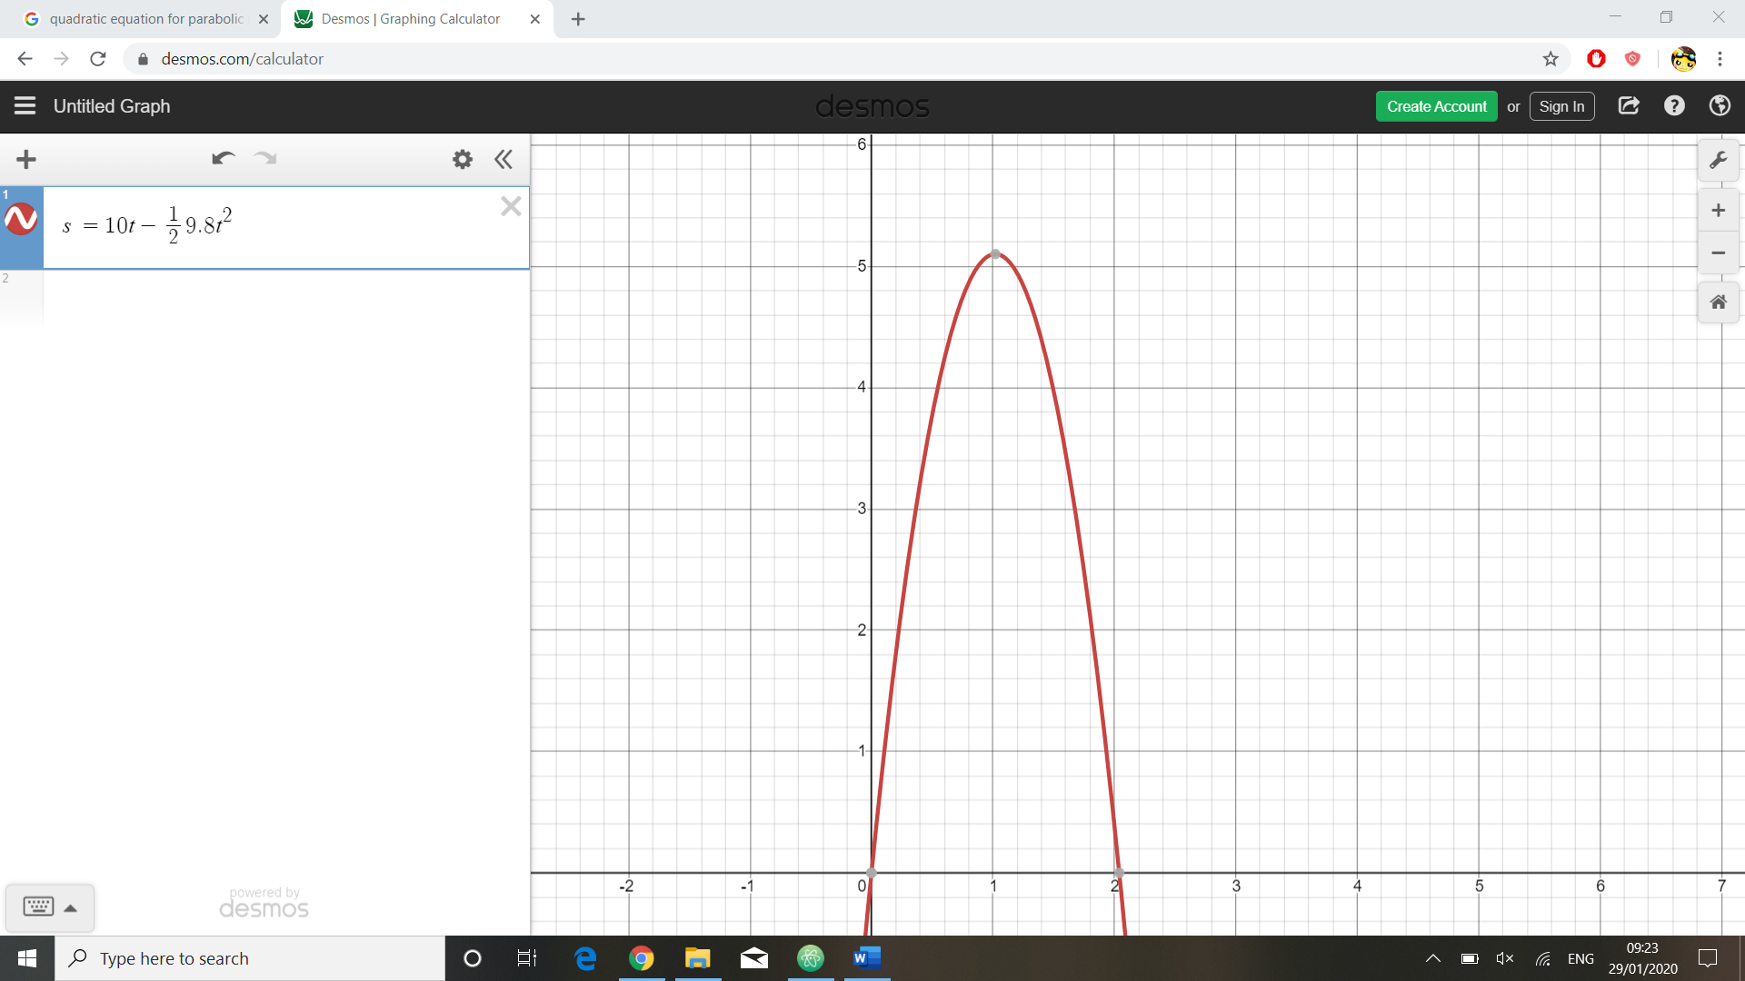

I used Desmos an online graph plotter for this illustration.

As seen in the image above, when the quadratic function ‘s = ut + ½ at2 ’ is applied, a parabolic path is traced. This will make the game more realistic and the players can make use of the floating platforms for more tactical play such as gaining high ground. In the image, the value of 10 is used for the initial velocity and -9.8 for acceleration as that is the approximate value for gravitational acceleration.

To make this type of motion possible, the player should only be able to jump once before falling down. A Boolean variable such as ‘can_jump’ should control if the player is allowed to jump or not. The player’s y coordinate attribute should be equated to the function since that is their vertical displacement.

Player.y = (player.vertical_speed * time) + ½ (game.gravity * time**2)

### Creating a WAN server for global client connection

One way of solving the server issue was to host a WAN server that connects all players and manages matches individually. I modified my server code and hosted it using Amazon LightSail. Using SSH to run it on a virtual server it was successful as seen in the screenshots below.

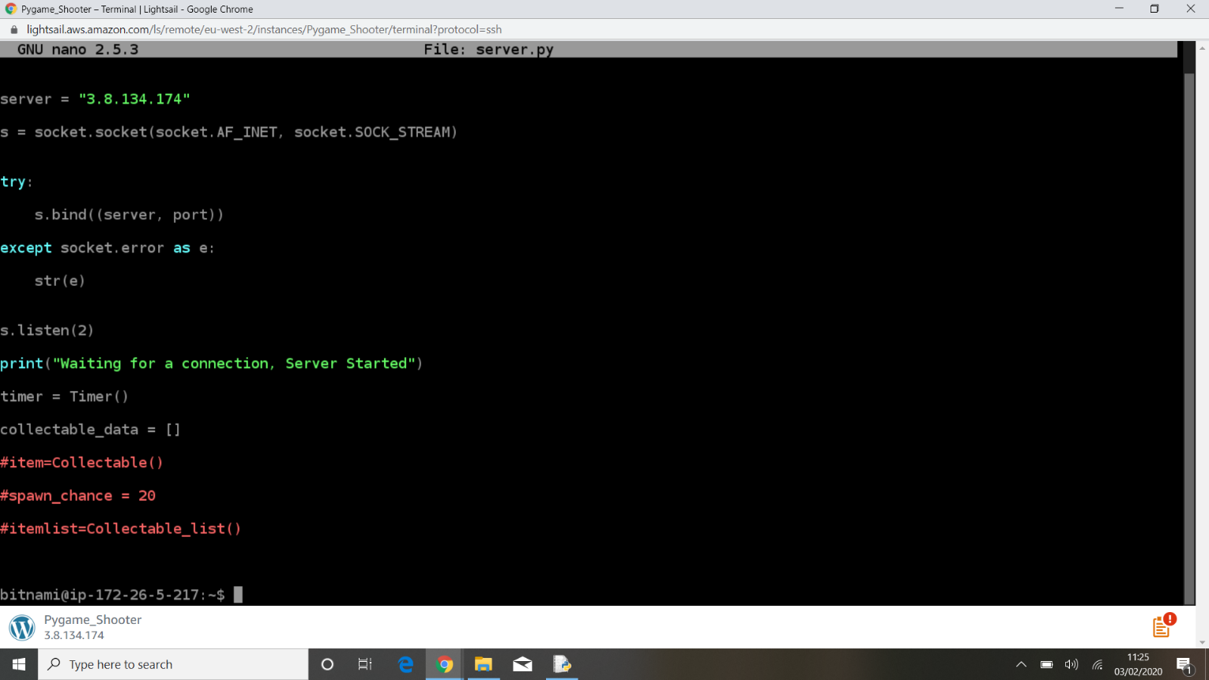

A screenshot of my server being hosted on an Amazon aws virtual server.

Although the server was running successfully, the ports that it was using were not open, meaning that clients could not connect to the server. Several ports that are usually open were tested but none were successful. It was evident that the issue was from their service as the use of know ports was restricted, therefore I returned to the local-host method with LAN servers rather than WAN.

### Multicasting and broadcasting server to clients

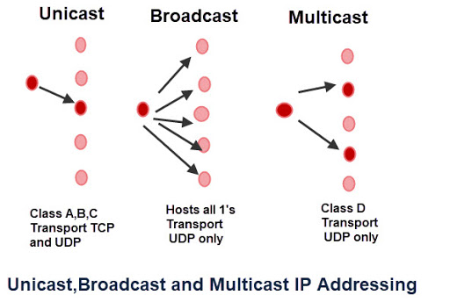Returning to my original method of having a local server, I needed an in-game feature to create and transmit the servers’ availability to all clients. There are 2 possible methods for implementing this, either using multicasting or broadcasting.

As seen in the image above, multicasting will use private UDP transmission to send data to a specific set of clients and the clients would all connect to one specific IP address and port number to receive the data. I tested this method first because it will allow me to choose which devices on the network the data will be transmitted to, allowing more control of the data. However, when testing this method, I realised that devices transmitting from 2 different network channels (i.e. 2.4GHz and 5GHz) will not be able to communicate. The only method that is compatible with all devices on a network regardless of the network channel is broadcasting.

Broadcasting will send data to all devices connected to the network at the time of transmission. Although this method provides less control of the data, there’s better chance of all clients receiving the data, hence being able to view all available servers at that given time.

The server will continuously transmit its availability until 2 clients connect, where it will then halt broadcasting it’s availability as the maximum number of players would have been reached.

A server page will be created to display all available servers on the local network.

Below are flowcharts constructed to show the processes on the broadcasting and receiving sides of the message:

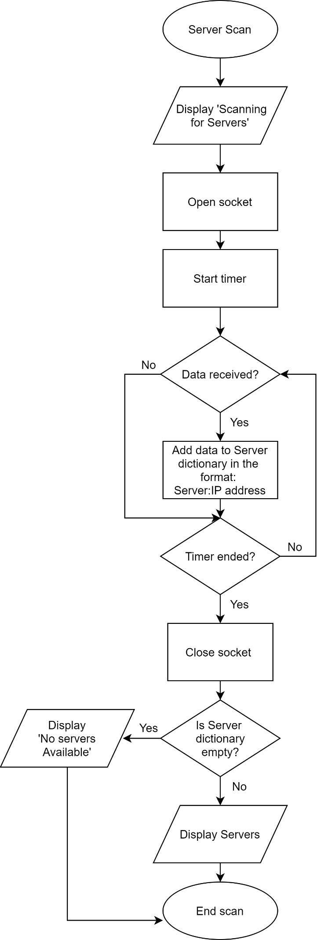**Server-Side (Broadcast)**  **Client Side (Receive)**

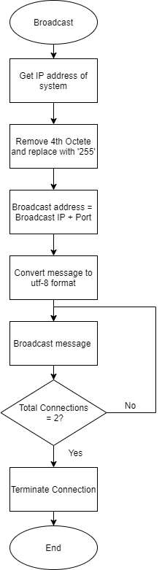

Close socket

## Optimisations

### Sorting High scores using a recursive Merge Sort algorithm

The high-scores list will need to be in order of highest to lowest scores with the players’ usernames beside their score. I’ve decided to use a recursive merge sort algorithm to sort the high scores. The merge sort algorithm has an O(nlogn) time complexity during execution. This makes it efficient especially if the dataset increases with more player accounts. Furthermore, it reduces dependence on the database since the sorting occurs before displaying the data and therefore will not result in problems during storage or retrieval.

I’m going to use a list to sort the scores and a dictionary to pair the scores with the correct usernames. The algorithm is represented by the pseudocode below:

Function merge_sort(score_list)

if length(score_list) <=1

return score_list

middle = length(score_list)/2

left = merge_sort(score_list[0 to mid])

right = self.merge_sort(score_list[mid+1 to EndofList])

return self.merge(left,right)

Function merge(left,right)

A standard merge sort algorithm will sort the scores in ascending order. The comparison statement is reversed here (left > right) as the scores will be in descending order with the highest scoring player displayed first.

final_list = []

left_pointer = 0

right_pointer = 0

While left_pointer<length(left)and right_pointer < length(right)

if left[left_pointer] > right[right_pointer] Then

final_list.append(left[left_pointer])

left_pointer = left_pointer + 1

else

final_list.append(right[right_pointer])

right_pointer = right_pointer + 1

for index 0 to left pointer

final_list.append(left[index])

for index 0 to right pointer

final_list.append(right[index])

return final_list

## Input/Output/Storage

I’ve constructed a table showing how the game will handle different inputs by the user.

|  |  |  |  |
| --- | --- | --- | --- |
| **Input** | **Process** | **Storage** | **Output** |
| Create account-  New account details | -Verify format  -Check if they already exist  -Encrypt password | Username and encrypted password | Account created/unsuccessful message with the reason |
| Login –  Existing account details | Encrypt password and  check database for matching data | None | Login successful/details incorrect |
| Instructions | Load Instructions subroutine | None | Display instructions page |
| HighScores | Retrieve username and high scores from all accounts on the database file. | None | Display high-score table for all local accounts |
| Play game | -Load server menu  -Scan for broadcasting servers | None | Display discovered servers |
| Select game server | Run main game subroutine | Update high scores on player table | -Display map, sprites and text |
| Host game | Load input textbox | None | Enter server name |
| Server name | -Run server routine on a separate thread  -Broadcast server name to entire network | None | Server status |
| Movement controls  (in-game input) | Change player coordinates and update sprite attribute | None | Update sprite |
| Fire key  (in-game input) | -Load projectile image  -increment projectile’s x coordinate | None | Display projectile |
| Quit | End all processes and close game window | None | None |

## Using a Database

The database for my program only has one table, therefore it doesn’t require normalisation. The main purpose is to store an individual player’s account details and high score locally so that they can be viewed by the user.

**Data Dictionary:**

I will need to store the following data for each player in my local database.

|  |  |  |  |  |  |
| --- | --- | --- | --- | --- | --- |
| Data item | Data type | Data size | Description | Example | Validation |
| Username | VARCHAR | 20 | The name the user wishes to identify as within the game. | Player21 | Not null and 3< Length <20 |
| Encrypted  Password | CHAR | 20 | Password of the user that’s encrypted for security | $53hbr35 | Not null and 5<length <20 |
| High score | INT | 5 | The player’s high-score which will be compared and updated between matches. | 02984 | none |

### SQL Commands

As a developer, I will need to know the following SQL commands to control and maintain my database:

**CREATE –** creates a new table in the database. I will use this to create a table that will store the user’s details:

*CREATE TABLE Player (*

*Username VARCHAR (20) PRIMARY KEY,*

*EncryptedPassword VARCHAR (20),*

*HighScore INT*

*);*

**SELECT-** This will allow the user to view specific details such as high-scores without displaying other records that are not necessary:

*SELECT Username, Highscore*

*FROM Player*

**INSERT-** This will be used to store details for new accounts. For example:

*INSERT INTO Player*

*VALUES (3042, ‘legend27’, ‘3efje43fs’, 2899);*

**UPDATE –** Used to modify existing values such as the previous high-score after it’s been exceeded:

*UPDATE Player*

*SET HighScore = new_highscore*

*WHERE UserID = current_userID;*

I will need to integrate these SQL statements into the main program so that the database can be queried automatically. E.g. checking and updating the high scores after every game.

## Encrypting Password

My program will encrypt the account passwords before they’re stored on the database so that it’s hidden from anyone that reads the data directly from the database file.

There are several types of encryption that I could use, but since this is a local database it will not affect any outside users’ data, so there is less need for the most secure algorithms available. Because of this I decided to base my encryption on the Caesar Cipher algorithm.

This process is shown in the pseudocode below.

Function encrypt (password,shifts)

encrypted_ascii 🡨 []

encrypted_string 🡨 ""

For character in password

encrypted_ascii.append (char_to_code(character)-shifts)

EndFor

For num in encrypted_ascii

encrypted_string🡨 encrypted_string + code_to_char(num)

EndFor

Return encrypted_string

Function decrypt (encrypted_string,shifts)

decrypted_acii 🡨 [ ]

decrypted_string 🡨 " "

For character in enctryped_string

decrypted_ascii.append(char_to_code(character))

EndFor

For num in decrypted_ascii

decrypted_string 🡨 decrypted_string + code_to_char(num)

EndFor

Return decrypted_string

The encrypt function will take the user’s input when creating an account and will process it, returning an encrypted string. This will be stored as a database record.

When the user tries to login, the program will retrieve the encrypted string and the decrypt function will return the original password. This can be compared to the user’s input to verify their login details.

The shift for the cipher cannot be larger than 32 because that’s the lowest possible ASCII value. If the shift value is larger than the input character, the generated ASCII value would be negative and its conversion to a string would not work since ASCII values cannot be negative.

## Using Multiple Threads to Connect Multiple Clients

Multi-threading allows multiple problems to be processed in parallel to each other. This will be helpful for the server side of my network as it will be dealing with more than one client.

The Threading library can be used to implement this on Python 3. This pseudocode represents how threading will be used to connect multiple clients (players) to the server.

While True

If client connected Then

Start_new_thread(threaded_client (connection,player))

The server will listen for incoming connections and start a new thread for each one. This way the game can support many clients simultaneously without wait time in-between.

Function threaded_client(connection,player)

While True

Alldata🡨data received from client

If data received = none Then

Display(‘disconnected’)

Break

Else

If player=1 Then

send (pickle.dumps(alldata[0]))

Else

send (pickle.dumps(alldata[1]))

## Data Structures

I’ll be using multiple data structures within my program for different purposes.

**Dictionaries** – A dictionary is used to store all the data that is used in the game for each player. This is initially stored in the server, then it’s also sent to the client. Using a dictionary is memory efficient because all the player data can be sent at once, and the client can choose which data to use once it’s received. This will also make it easier to add and remove features in the game, because values in a dictionary aren’t stored in a specific order, meaning that there’s no indexing of data. So adding more data to this structure will not change how the previous data is accessed (no indexing so references will not change), hence it won’t affect the rest of the game.

**Linked lists –**This is a dynamic data structure, hence it’s perfect for storing data such as projectiles that are generated by keyboard input. Every time the player presses the fire key, a projectile object will be added to the list. The list is dynamic, so it will take up less memory when the player hasn’t generated any projectiles. The projectiles will be removed from the list when they collide or move beyond the map, hence saving more main memory.

**2D Arrays –** 2D arrays can be used to send larger amounts of data between server and client. This is useful for sending collectable item attributes. The server will generate a random amount of collectable item objects. Each will have attributes such as item type, lifetime and spawn timestamp. Each of set of attributes can be stored in separate arrays within one main array so that they can be sent to the client and indexed. A 2D arrays is multi-dimensional hence it will be perfect for these nested arrays.

**Queue –** A queue data structure can be used for pre-made animations such as the death animation of a player. Each image of the animation can be stored in an array and displayed and removed in a ‘First in First Out’ order. This is more memory efficient than just looping through a list because the animations such as the player’s death cannot be changed with user input, therefore the image references can be added and removed from the list as they won’t be required later.

**Files –** Files are very important in my game as there will be several that are imported and used in several parts of the program. These include the database file for user details, image files for player sprites and game animations, and TTF files for different fonts. My program will also be separated into several files such as the 4 main menu options, a file containing all the main game classes, the server and a networking file used by the client to communicate with the server. These will all be imported into the main game file which will work as an interface to control which parts of the game are to be accessed by the user.

## Visual Effects, Sound Effects and UI

### Sound Effects

Fast paced action music will be outputted throughout the runtime of the game. One of the objectives for my program is to change the pace of the music in real-time. To do this, the original frequency of the sound file will need to be taken. The wav library in Python will allow me to obtain this value. Then Pygame’s music mixer function will allow me to change the frequency of the music. Increasing the frequency will increase the pitch of the sound and will provide the illusion of increased pace.

However, chanding the music’s frequency will mean re-initialising the the mixer function and the file will have to be reloaded for the changed to occur. Performing this continously can cause slowdown during gameplay.

I’ve attempted using a new thread to run the music operations separately. However I’ve used threading multiple times for other functions in my game which caused a memory error when trying to start a new thread.

Because of this, my new implementation is a method inside the main game class that automatically increases the frequency of the sound file each time the value of the timer halves. The new frequencies will be stored in a list and indexed sequencially every time the timer value halves. This step by step change of frequency rather than continously loading and processing the sound file would be more efficient in terms of memory and processing power.

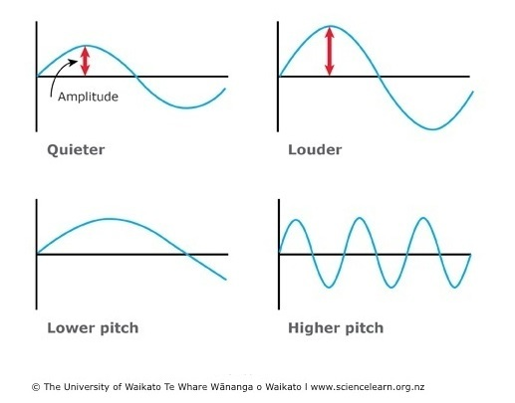

As seen in the image[14] above, highser frequency waves have a higher number of wavelengths per second, hence higher pitch sound is produced.

### In-Game Visuals

Alongside the sound effects, I added several visual effects to make the game more immersive for the player.

### Alpha Compositing

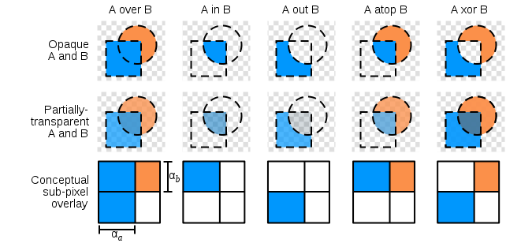When a player picks up an invisible potion item, their image will stop rendering on the second player display, however the user will still need to see their character as the item’s purpose is to cause a disadvantage to the opponent and not the player that uses it. Alpha channel transparency is a good method of blending the player’s pixels with that of the background, providing a translucent image and letting the user know that their player is invisible to the opponent.

As seen above[15], the image will retail a portion of its original pixels and will be combined with that of the background image to a certain extent to provide the perception of a translucent image.

### Background Animation

I decided to have dynamic animated background rather than a static image to add visual appeal and make it more immersive. 

I chose this gif file for my animated main menu screen. However, Pygame doesn’t have built in support for displaying animated gifs, so it’ll have to be done manually.

Splitting frames:

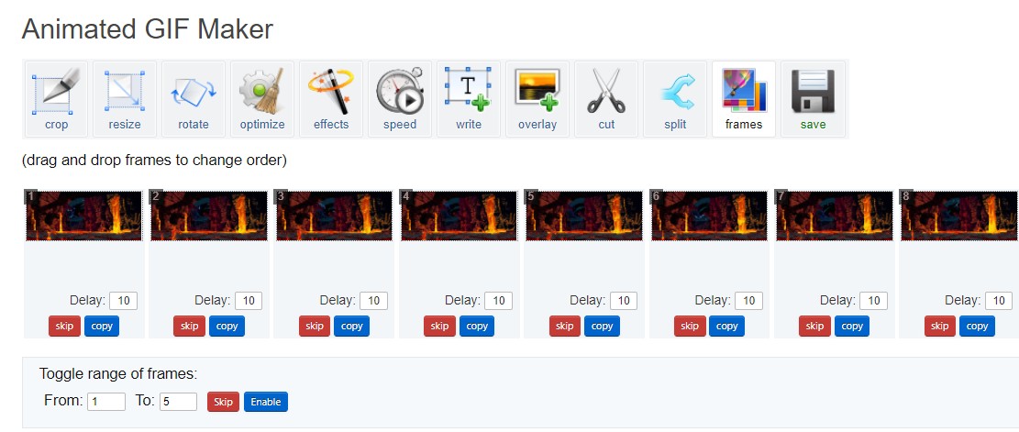One method of doing it is to split the frames from the animated image and import them individually to a list in my main menu subroutine. Then I can loop through the list and display each image consecutively as an animation. I can also control the framerate of the display to change the speed of the animation.

Individual frames from gif

I used an online tool[16] to split the gif into separate frames. The file I chose contained 8 frames.

**Looping through the frames:**

backgrounds 🡨[background1, background2, background3, background4, background5, background6]

The list ‘backgrounds’ will store the background images that are scaled to the appropriate resolution.

Within the loop, the counter will be incremented and used as an index to loop through the list. It’s also used to track which image in the list is being displayed to prevent an ‘index out of range’ error.

counter 🡨 0

While True

If counter>6 THEN

counter🡨0

Else

counter🡨counter+1

EndIf

Counter = Counter + 5/framerate

Display backgrounds[int(counter)] (x=0, y=0)

Counter value is incremented by a fraction that depends on the frame rate of the game. This allows the framerate output of the background to be separate to the framerate of the game. This means the animation speed can be changed without affecting the framerate of the main game.

EndWhile

## Designing the Main Menu

The main menu screen with have 5 options: Join Game, Host Match, Instructions, High Scores and Quit. The main game will only use keyboard peripheral inputs, so I thought would be appropriate to make the main menu also operate using keyboard inputs.

The main menu screen will also consist of frame by frame animation like that of the background animation for more visual appeal.

### Creating the menu interface

Before creating the animated background, I will need to design the main menu interface. It’s important to make the main menu screen look good as it’s the first part of the program that the user will see after they log in.

The ‘arcade classic’ font for the text as it’s aimed toward arcade gamers.

Selected option will be in a different colour so that the user can see which option they are choosing.

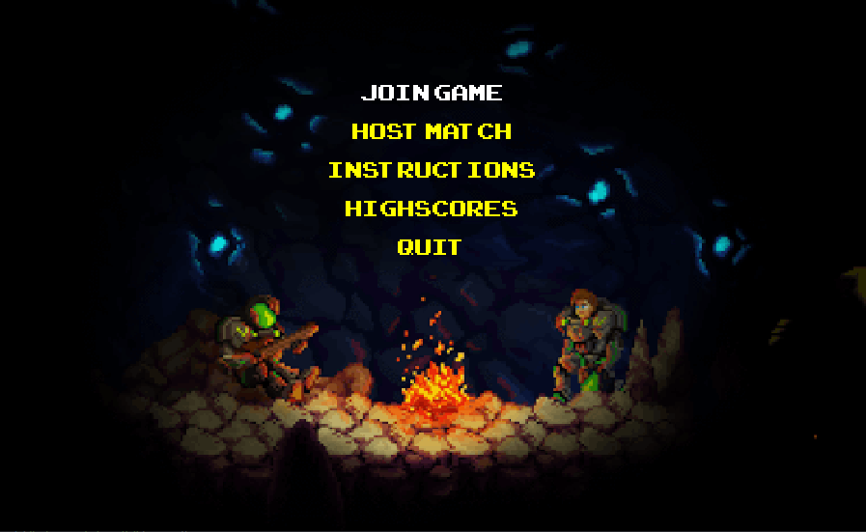

Five vertically stacked options that will take the user to different parts of the game.

Animated background that’s relevant to the shooter genre of the game.

### Using a list and pointer to track user input

There will be 4 options vertically listed: start, instructions, high-scores and quit. The user will use the arrow keys to navigate through the options. I devised a method to efficiently track the user’s choice of either options through their peripheral inputs.

Tracker🡨['join','create','instructions','highscores','quit']

Pointer🡨 0

I used a list containing the options and a pointer that tracks the output shown to the user.

For selected in window

If selected = Keypress Then

If selected = Up_key Then

selected ='start'

If pointer>0 Then

pointer = pointer - 1

selected = tracker[pointer]

If selected = Down_key Then

if pointer < 4 Then

pointer🡨 pointer+1

selected🡨tracker[pointer]

If selected = Enter_key Then

if selected = 'quit':

quit()

Else If selected = 'join' Then

server_screen()

Else If selected == 'create' Then

create_server()

Else If selected = 'instructions' Then

instructions_page()

Else If selected = 'highscores' Then

high_scores()

EndIf

EndFor

When the user clicks either the up or down arrow key, the pointer will be incremented or decremented up to a limit and will reference an index on the list. The strings in the list will be passed into a text processing function, which will output the corresponding text in the correct font.

## Instructions page

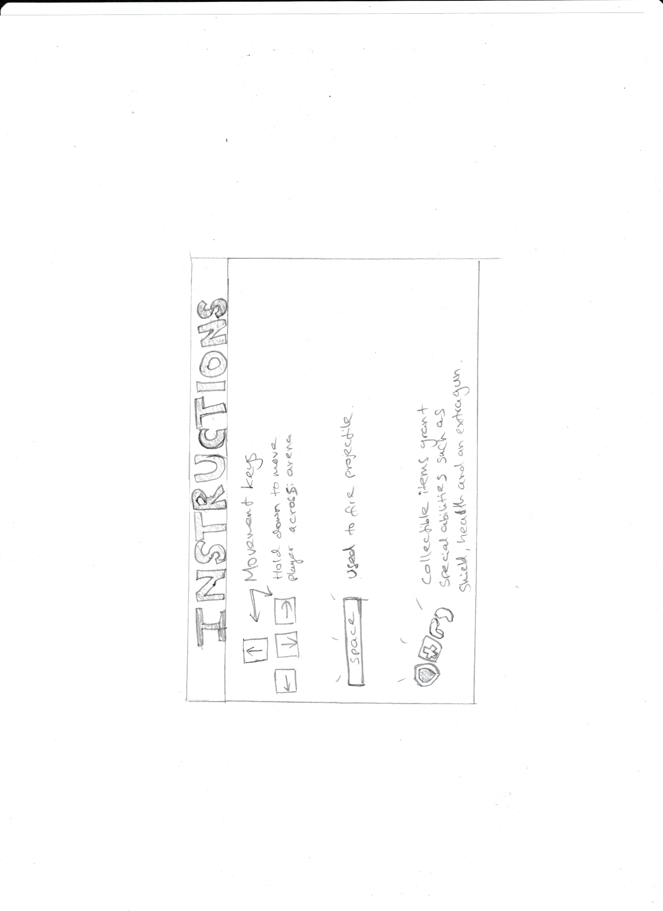The instructions page will have a funky arcade style design with arcade fonts and bright colourful images.

Large colourful text (in arcade font) with a bright background to showcase the casual nature of the game.

Images detailing the controls for the player and the features of other objects such as collectable items that are found around the map.

The instructions page is a guide for the player which will display the objective of the game, different controls in-game and their effects.

## High scores page

The high scores page will display a table with all the usernames and scores from all the accounts that have been created. This will be created using the Tkinter library on Python 3.0 as it’s a good option for small graphical tasks. When selected in-game, a separate Tkinter window will run with the use of multi-threading and it will display the high scores. The table will be in descending order of score and will look like the following:

|  |  |
| --- | --- |
| Username | High score |
| TheLegend27 | 8989 |
| Terminator249 | 3241 |
| JusticeWarrior569 | 242 |
| DarthTyrant | 241 |
| Noobmaster68 | 62 |

Although this table looks manageable, it will grow larger with more accounts, therefore I will need to limit the number of scores displayed so that it doesn’t become too large to display.

### Using a threshold score

One way of fixing the problem mentioned above is to introduce a threshold score. First there will need to be a maximum value that will limit the number of scores that are viewed by the user. The records will be arranged in descending order of score and the maximum number of highest scores will be displayed. The lowest score from here will be stored in the main game as the threshold score. If the player beats the threshold score and is not in the high scores list, the threshold score will be replaced by the new high-score and the table will be ordered again in descending order of score.

This method will be of use if the user has multiple accounts or allows others to log in and play the game on their system. However, due to time restrictions and the fact that this feature is not as important compared to optimising and developing the main game, it won’t be prioritised.

Update: This method is not necessary anymore as I discovered the Tkinter window used for displaying the scores could be stretched and it will automatically display more scores as the window is being stretched. It also automatically displayed a set number of scores in descending order therefore the threshold score will not have to be calculated.

### Main Game

This is how to main game will look like when the players have successfully been loaded in. I’ve drawn the main features in the foreground of the display, but I will also have a background image of the map.

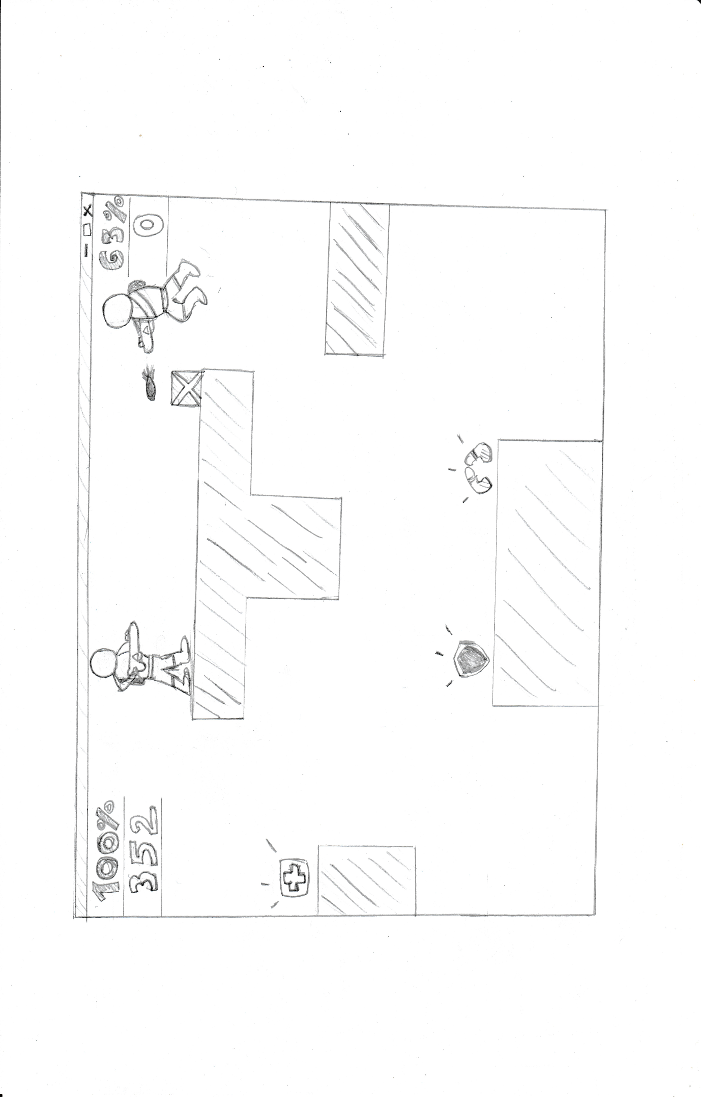

Health percentage and score of player 1 1

Projectile being fired.

Rectangular platforms around the map allow for more strategic gameplay such as using it for cover or elevation.

Collectable items such as health packs and speed orbs for powerups

### Creating and Editing Visuals

I decided to use Adobe Photoshop CC 2019 to edit and create the visuals of my game.

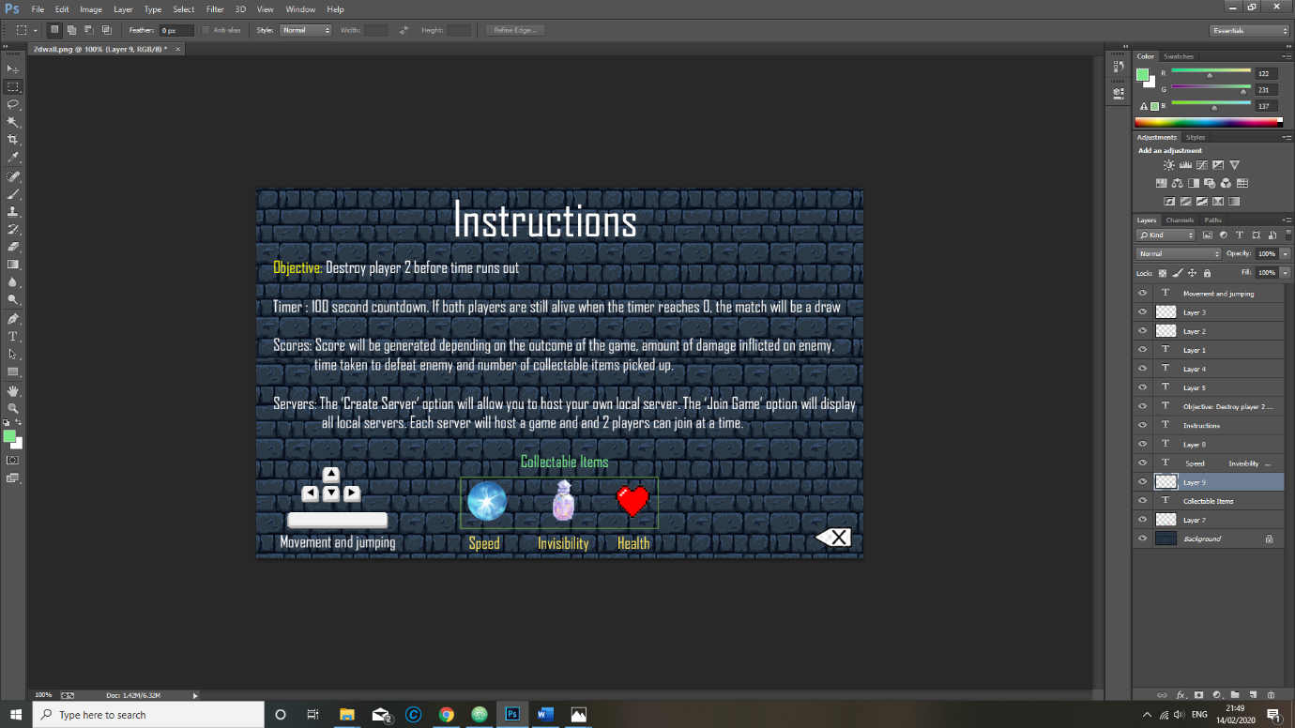

This will be used to create and edit backgrounds, information pages, sprites and other visual assets.

## Login Screen Design

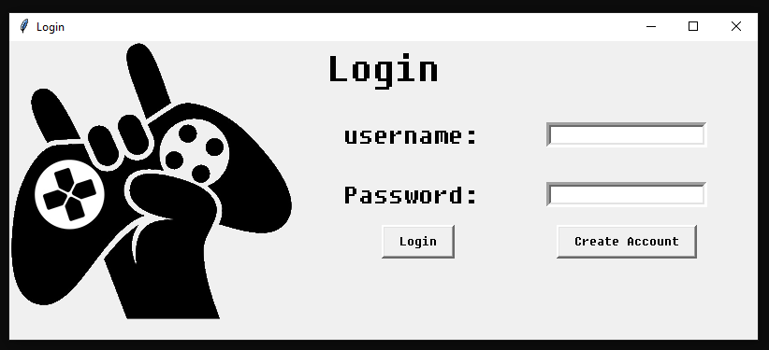As seen below, I’ve designed a login screen with 2 authentication fields, an option to create a new account and the login button on the left. This will be the first window that will open when the game is run. If the user details are verified, the main menu will be loaded

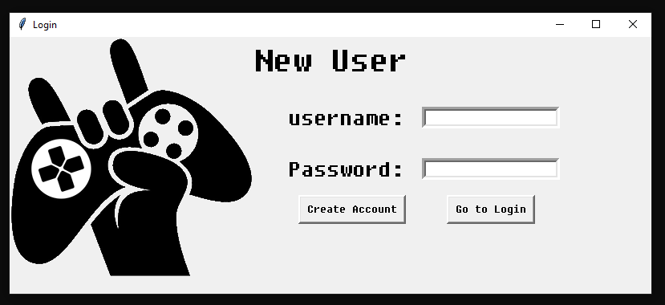This window will open if the user choses to create a new account. The user will enter their new authentication details and if successful, they will be returned to the login screen.

Option to return to login screen (in case of accidental clicks).

If the details do not exists in the database already, they will be stored and account creation will be successful

# Technical Solution

### Table of contents

|  |  |  |
| --- | --- | --- |
| Method | Group | Evidence |
| Complex user-defined use of Object-Orientated Programming model | A | Pg 84- 127 |
| Complex client-server model | A | Client side: pg 84 – 130  Sever side: pg 131 - 135 |
| Complex mathematical model | A | Pg 99-100 |
| List and Pointer Operations | A | Pg 112-114 |
| Recursive Merge Sort Algorithm | A | Pg 119 |
| Other List operations | A | Many list structures throughout whole solution |
| Simple data model in database | B | Pg 125- 127 |
| Multi-Dimensional Arrays | B | Pg 94, 134 |
| Dictionaries | B | Pg 114, 134, 144, 145, 119 |
| Mathematical Calculation algorithms | B | Pg 96, 117 |
| Simple Mathematical calculations | C | Pg 91,106, 112, 123 |

## Client Side Scripts

### Main Game.py

The main game class contains all the attributes that are needed for hosting a match. A game is instantiated from the main menu algorithm where the player’s username and game server’s IP address is passed in as arguments.

class Game():

def __init__(self, username, ip):

self.client = False

self.time_addition = 0

self.time_elapsed = 0

self.username = username

self.width = 1300

self.height = 700

self.display = pygame.display.set_mode((self.width, self.height))

self.backgrounds = [

pygame.image.load("sprites/Background anime/frame0.gif"),

pygame.image.load("sprites/Background anime/frame1.gif"),

pygame.image.load("sprites/Background anime/frame2.gif"),

pygame.image.load("sprites/Background anime/frame3.gif"),

pygame.image.load("sprites/Background anime/frame4.gif"),

pygame.image.load("sprites/Background anime/frame5.gif"),

pygame.image.load("sprites/Background anime/frame6.gif"),

pygame.image.load("sprites/Background anime/frame7.gif")

]

self.scaled_backgrounds = []

self.waiting_screen = pygame.image.load("Images/waitingscreen1.0.png")

self.clock = pygame.time.Clock()

self.fps = 45

self.music = pygame.mixer.music.load("power_music.wav")

self.ip = ip

self.p2 = None

self.p = None

self.network = None

self.walls = None

self.wall_img = pygame.image.load("wall1.png")

self.proj_img = pygame.image.load("projectile1.png")

self.run = False

self.countdown_time = 100

Countdown time loaded from server but is set as 100 by default if in case of an error

self.playerObj = None

self.secondPlayerObj = None

self.players = None

self.events = None

self.loop_count = 0

self.background_index = 0

self.player1_sprites = ["sprite1.png", "right.png", "left.png"]

self.player2_sprites = [

"sprite2.png", "player2right.png", "player2left.png"

]

self.loaded_player1 = []

self.loaded_player2 = []

self.collectable_list = []

self.arcade_font = pygame.font.Font("Images/arcade.TTF", 12)

self.text_font = pygame.font.Font("Images/arcade.TTF", 28)

self.speed_ball = [

pygame.image.load("Images/SpeedBall/1.gif"),

Multiple images loaded for animations

pygame.image.load("Images/SpeedBall/2.gif"),

pygame.image.load("Images/SpeedBall/3.gif"),

pygame.image.load("Images/SpeedBall/4.gif"),

pygame.image.load("Images/SpeedBall/5.gif"),

pygame.image.load("Images/SpeedBall/6.gif"),

pygame.image.load("Images/SpeedBall/7.gif"),

pygame.image.load("Images/SpeedBall/8.gif"),

pygame.image.load("Images/SpeedBall/9.gif"),

pygame.image.load("Images/SpeedBall/10.gif")

]

self.invis_potion = pygame.image.load("Images/invisiblepotion.png")

self.heart_img = pygame.image.load("Images/heart.png")

self.image_index = 0

self.black = (0, 0, 0)

self.white = (255, 255, 255)

self.yellow = (155, 135, 12)

self.green = (0, 255, 0)

self.blue = (0, 0, 255)

RGB Colour codes

self.light_blue = (173, 216, 230)

self.start_round = False

### Methods in the game class

There are several methods that perform different functions within the game class.

#### Loading sprites:

This method ensures all sprite images are pre-loaded into the main game so they can be displayed afterwards. This increases performance in comparison to loading the images multiple times.

def load_sprites(self):

for i in self.player1_sprites:

image=pygame.image.load(i)

self.loaded_player1.append(image)

for j in self.player2_sprites:

image=pygame.image.load(j)

self.loaded_player2.append(image)

#### Scaling backgroud images:

The display resolution on different devices may vary, hence this operation scales the background images to ensure the images are displayed in proportion to the display size.

def background_scale(self):

for background in self.backgrounds:

self.scaled_backgrounds.append(pygame.transform.scale(background,

(self.width,self.height)))

self.waiting_screen=(pygame.transform.scale(self.waiting_screen,(self.width,self.height)))

#### Displaying player’s username above their player sprite:

This routine displays both players usernames on top of their player sprite to prevent confusion. The username is not displayed to the second player if the first player is invisible.

def show_username(self):

self.playerObj.username=self.username

username = self.arcade_font.render(str(self.username), 0,

self.light_blue)

player2_username=self.arcade_font.render(str(self.secondPlayerObj.usern

ame), 0, self.light_blue)

self.display.blit(username, (self.playerObj.x,self.playerObj.y-

20))

if self.secondPlayerObj.visible==True:

self.display.blit(player2_username,

(self.secondPlayerObj.x,self.secondPlayerObj.y-20))

This displays the player’s username to the other player only if they are not invisible

#### Activating invisibility:

When a player’s visibility attribute becomes false, the alpha transparency method **(pg…)** is called to display a translucent version of their sprite to indicate the player’s use of the ability.

def invisibility(self):

if self.playerObj.visible == False:

self.playerObj.alpha_transparency(

self.display,

self.loaded_player1[self.playerObj.direction],

(self.playerObj.x, self.playerObj.y), 130)

#### Updating game display:

This method contains all the routines that need to updated continuously while a session is running.

def redraw_window(self):

self.display.fill(self.white)

if self.playerObj.player == 1:

score1 = self.text_font.render(

str(self.playerObj.score), 0, self.light_blue)

score2 = self.text_font.render(

str(self.secondPlayerObj.score), 0, self.light_blue)

else:

score1 = self.text_font.render(

str(self.secondPlayerObj.score), 0, self.light_blue)

score2 = self.text_font.render(

str(self.playerObj.score), 0, self.light_blue)

if self.background_index>6:

self.background_index=0

else:

self.background_index+=self.background_rate

index = int(self.background_index)

self.display.blit(self.scaled_backgrounds[index], (0, 0))

The section above indexes a list with several background images and displays them sequentially at a certain rate depending on the ‘background rate’ value. This creates an animated background.

self.display.blit(score1, (20, 50))

self.display.blit(score2, (self.width - 55, 50))

self.playerObj.draw(self)

self.secondPlayerObj.draw(self)

self.backwards_time = (self.countdown_time - (self.time_elapsed))

time = self.text_font.render(str(self.backwards_time), 0, self.white)

self.display.blit(time, (self.width / 2, 20))

self.invisibility()

for wall in self.walls:

wall.draw(self)

self.collectables()

self.playerObj.item_use()

self.playerObj.stop_item_usage()

self.secondPlayerObj.item_use()

self.secondPlayerObj.stop_item_usage()

for bullet in self.playerObj.projectiles:

bullet.draw_bullet(self.display, self.players)

if bullet.collides(self) == True:

if self.timer.has_started == True:

self.playerObj.score += 10

if bullet.should_remove():

self.playerObj.remove_projectile(bullet)

continue

for bullet in self.secondPlayerObj.projectiles:

bullet.draw_bullet(self.display, self.players)

if bullet.collides(self) == True:

if self.timer.has_started == True:

self.secondPlayerObj.score += 10

if bullet.should_remove():

self.secondPlayerObj.remove_projectile(bullet)

continue

These method calls are for managing projectiles in real time. They’re used to create, launch and remove projectiles from the map.

#### Collectable Items:

def collectables(self):

if self.image_index > 8:

self.image_index = 0

self.image_index += 1

Detecting item collisions with players, adding items to the player’s item list and removing them from the map

for item in self.collectable_list:

item.hitbox = pygame.Rect(item.x, item.y, 25, 25)

if item.time < self.time_elapsed:

if item.hitbox.colliderect(self.playerObj.hitbox):

self.playerObj.items.append(item)

self.collectable_list.remove(item)

self.playerObj.score += 20

elif item.hitbox.colliderect(self.secondPlayerObj.hitbox):

self.secondPlayerObj.items.append(item)

self.collectable_list.remove(item)

if item.life > 0:

item.levitate()

if item.type == 1:

item.display(self.display, self.heart_img)

if item.type == 2:

item.display(self.display, self.invis_potion)

if item.type == 3:

item.display_anime(self.display, self.speed_ball,

self.image_index)

item.life -= 1

else:

self.collectable_list.remove(item)

#### Score generator:

Player’s final score is generated depending their health compared to their opponent and the time taken to finish a round.

def score_generator(self):

if self.secondPlayerObj.dead==True:

self.playerObj.score += (100-(self.time_elapsed))*5

health_diff=(self.playerObj.health - self.secondPlayerObj.health)

if health_diff>0:

self.playerObj.score+= (health_diff3)

#### Changing music frequency:

This method changes the output frequency of the game music and increases the pace of the output music each time the time limit halves.

def music_control(self):

if self.loop_count == 1:

pygame.mixer.music.play(-1)

if self.time_elapsed == round(self.countdown_time/2):

print("sped up")

pygame.mixer.quit()

pygame.mixer.init(frequency=self.music_frequencies[1])

music=pygame.mixer.music.load("power_music.wav")

pygame.mixer.music.play(-1)

if self.time_elapsed == round(self.countdown_time/4):

pygame.mixer.quit()

pygame.mixer.init(frequency=music_frequencies[2])

music=pygame.mixer.music.load("power_music.wav")

pygame.mixer.music.play(-1)

List containing different frequency ranges indexed in sequencial order as the time elapsed increases. This increases the pace of the music outputted. The sound file must be loaded each time for the change to take effect.

#### Saving score to database:

Sqlite 3 is used to query the database for the player’s username, check if their current score is higher than their previous, then update their high score record accordingly.

def save_score(self):

with sqlite3.connect('playerdata.db') as db:

cursor = db.cursor()

player_search = ('SELECT * FROM player WHERE username = ?')

cursor.execute(player_search, [(self.username)])

print(cursor.fetchall())

update_score = 'UPDATE player SET highscore = ? WHERE username = ? AND

highscore < ?'

cursor.execute(update_score, [(self.playerObj.score), (self.username),

(self.playerObj.score)])

db.commit()

#### Waiting screen:

The waiting screen is displayed until the second player connects to the server.

def waiting_for_player(self):

self.display.fill((255, 255, 255))

self.display.blit(self.waiting_screen, (0, 0))

self.clock.tick(2)

pygame.display.update()

#### Main Gameloop

This method handles the data received by the server, then instantiates game objects and most of the methods described above.

Exception handling used to check for incoming data from the server. If received, it means that a connection has been established. If not, the ‘error_screen’ method will display the error and return the player to the main menu.

def gameloop(self):

self.load_sprites()

self.background_scale()

self.run = True

try:

self.network = Network(self.ip)

self.p1= self.network.getP()

print(self.p1)

print(self.p1['player'])

self.playerObj = self.p1['player']

self.timer = self.p1['timer']

self.countdown_time = self.p1['timer'][1]

self.collectable_data= self.p1['collectable']

self.playerObj.username=self.username

self.walls = self.p1['walls']

except:

self.error_screen("ERROR CANNOT CONNECT TO SERVER")

Below is the main while loop of the game. The second while loop checks for player 2 data received from the server. If received, the second player has been connected, else the ‘waiting_for_player’ method will be called.

while self.run:

while self.start_round == False:

self.waiting_for_player()

self.p2 = self.network.send(self.p)

Assigns elements from the received dictionary to class attributes

self.timer = self.p2['timer'][0]

self.secondPlayerObj=self.p2['player']

print("initial: ",self.timer.time_elapsed)

if self.timer.time_elapsed !=0:

self.time_addition = 0-self.timer.time_elapsed

self.client = True

Game timer is continuously synched with the clients. There are certain systematic errors with the timer where the value broadcasted changes by a constant value when received by the client. The above identifies any inconsistencies with the timer

if self.timer==None:

continue

else:

if self.timer.started==True:

self.start_round = True

break

self.players=[self.playerObj,self.secondPlayerObj]

self.loop_count+=1

if self.background_index>6:

self.background_index=0

else:

Checks if both connected players are on the same account. Error message displayed if true and both players are disconnected

self.background_index+=0.30

self.p2 = self.network.send(self.p)

self.secondPlayerObj=self.p2['player']

if self.secondPlayerObj.username == self.playerObj.username:

self.run = False

self.error_screen("ERROR PLAYER ACCOUNTS ARE IDENTICAL")

self.timer = self.p2['timer']

Any timer errors are rectified by the attribute ‘time_addition’ which returns the time to its original value

self.time_elapsed = self.timer.time_elapsed

if self.client == True:

self.time_elapsed+=self.time_addition

self.collectable_data= self.p2['collectable']

if self.loop_count == 1:

pygame.mixer.music.play(-1) #continuously plays the game music

for data in self.collectable_data:

item=Collectable()

item.recreate(data[0],data[1],data[2],data[3],data[4])

self.collectable_list.append(item)

The dictionary key ‘collectable’ contains the 2D array with the collectable item data. Collectable item objects are instantiated and the data from the array is assigned to their objects’ attributes.

self.events=pygame.event.get()

for event in self.events:

if event.type == pygame.QUIT:

self.run = False

pygame.quit()

self.playerObj.collisions(self)

self.playerObj.move(self)

self.redraw_window()

self.show_username()

When a player dies or time runs out, the final scores are generated, saved and the user is taken to the endgame screen

if self.playerObj.dead==True or self.secondPlayerObj.dead==True or

self.time_elapsed>self.countdown_time:

self.score_generator()

self.save_score()

self.run=False

self.endgame(self.playerObj.dead, self.playerObj.health,

str(self.playerObj.username), self.secondPlayerObj.dead,

self.secondPlayerObj.health, str(self.secondPlayerObj.username))

#### Endgame screen:

The endgame method will take in the necessary data as parameters and calculate the the winner of the game (or if it’s a tie), then it will display the result for both players before returning them to the main menu.

def endgame(self, player1_dead, player1_health, name1, player2_dead,

player2_health, name2):

count = 0

new_font = pygame.font.Font("Images/arcade.TTF", 80)

player_font = pygame.font.Font("Images/arcade.TTF", 60)

game_over = new_font.render(str("GAME OVER"), 0, self.black)

player1 = player_font.render(str(name1 + " wins!"), 0,

self.yellow)

player2 = player_font.render(str(name2 + " wins!"), 0,

self.green)

tie = player_font.render(str("Match Tied"), 0, self.blue)

player1_wins = False

player2_wins = False

game_tie = False

if player1_dead == True:

player2_wins = True

print("player 2 wins!")

elif player2_dead == True:

player1_wins = True

print("player 1 wins!")

if player1_dead == False and player2_dead == False:

if player1_health > player2_health:

player1_wins = True

If player one player’s health is above the other’s, their username will be displayed as victorious. If their health points are equal, the game will be a tie.

player2_wins = False

if player1_health < player2_health:

player2_wins = True

player1_wins = False

else:

player1_wins = False

player2_wins = False

game_tie = True

while True:

if count == 12:

start_check(self.username)

count += 1

self.display.fill((255, 255, 255))

self.display.blit(game_over, ((width / 2) - (200), (height /

2)))

if player1_wins == True:

self.display.blit(player1, ((self.width / 2) - (200),

(self.height / 2 100)))

if player2_wins == True:

self.display.blit(player2, ((self.width / 2) - (200),

(self.height / 2 + 100)))

if game_tie == True:

self.display.blit(tie, ((self.width / 2) - (200),

(self.height / 2 + 100)))

pygame.mixer.music.stop()

Using calculations to position text in the middle of the screen

self.clock.tick(2)

pygame.display.update()

#### Routine that instantiates and starts the game:

def start_check(player):

List passed as argument from the main menu containing the server IP address and Boolean variable to start the game

message = menu (False)

if message [0] == True:

game = Game (player, message [1])

game.gameloop()

#### Error screen:

If an error occurs, this method is called and the error description is passed as an argument. The game and music is stopped and the error is displayed for several seconds, then it returns the user to the main menu.

def error_screen(self,error):

pygame.mixer.music.stop()

big_font = pygame.font.Font("Images/arcade.TTF", 40)

time = 0

error_message=big_font.render(str(error), 0, self.white)

while True:

if time >=10:

start_check(self.username)

time +=1

self.display.fill(self.black)

self.display.blit(error_message, ((width/2) - (300), (height/2)))

pygame.display.update()

self.clock.tick(2)

### Player Class

This class contains all attributes for each player object and methods for different player abilities.

class Player():

def __init__(self, x, y, sprite, player, direction, score, health):

self.x = x

self.y = y

self.player = player

self.projectiles = []

self.speed = 10

self.gravity = 10

self.sprite = sprite

self.direction = direction #1=right, 2=left

self.health = health

self.display = sprite[direction]

self.dead = False

self.collision_left = False

self.collision_right = False

self.collision_up = False

self.collision_down = False

self.hitbox = pygame.Rect(self.x, self.y, 45, 68)

self.username = None

self.score = score

self.jump = False

self.jump_position = 10

self.jump_speed = 10

self.jump_direction = None

self.free_fall = False

self.counter = 0

self.visible = True

self.items = []

self.speed_power_timer = 0

self.invisibility_timer = 0

self.disconnected == False

#### Redraw window:

This method updates the player class attributes continuously and changes the player sprite displayed accordingly.

def draw(self,game):

colour=(255,255,255)

self.hitbox= pygame.Rect(self.x, self.y, 45, 68)

image=pygame.image.load(self.display)

if self.player==1 and self.visible==True:

game.display.blit(game.loaded_player1[self.direction],(self.x,sel

f.y))

elif self.player==2 and self.visible==True:

game.display.blit(game.loaded_player2[self.direction],(self.x,sel

f.y))

Updates player’s hitbox used for collision detection

rect = pygame.Rect(self.x, self.y, 45, 68)

new_font = pygame.font.Font("Images/arcade.TTF", 28)

health_p1 = new_font.render("HP "+(str(self.health)), 0, game.yellow)

health_p2 = new_font.render("HP "+(str(self.health)), 0, game.green)

if self.player==1:

game.display.blit(health_p1, (30, 20))

elif self.player==2:

game.display.blit(health_p2, (width-110, 20)

#### Move method:

The players movement, collision restrictions and ability to jump is controlled by this method.

def move(self,game):

if self.y>(game.height-100) or self.collision_down == True:

self.free_fall=False

if self.collision_up == True:

self.free_fall=True

Boundary rules used to detect collisions with the edges of the display and stops player from going past them. Ability to jump also controlled by Boolean value to stop player jumping whilst in mid-air

keys = pygame.key.get_pressed()

if self.y<(game.height-80) and self.collision_down==False and

self.jump==False:

if self.gravity > 0:

self.y-=(self.gravity ** 2) * 0.1 * (-1)

self.gravity -= 0.01

else:

self.gravity=10

else:

self.gravity=10

SUVAT equation to model player’s movement path as a parabola when jumping and moving across the screen above the ground. Player will decelerate on their way up and accelerate when falling. This part of the method models the upwards deceleration where ‘self.gravity’ is initially an constant integer so the equations is used to model gravitational acceleration with variable speeds rather than a constant. The equation has been modified and acceleration slowed from that of of the Earth as gravitational acceleration is lower in the game.

projectile_sound=pygame.mixer.Sound("laser.wav")

if keys[pygame.K_LEFT]:

if 0<=self.x and self.collision_left==False:

self.x -= self.speed

self.direction=2

self.display=self.sprite[2]

if keys[pygame.K_RIGHT]:

if self.x<=width-50 and self.collision_right==False:

self.x += self.speed

self.direction=1

self.display=self.sprite[1]

Indexing list of sprite images to change displayed sprite when direction changes

if self.jump==False:

if self.free_fall==False:

if keys[pygame.K_UP]:

self.jump=True

self.free_fall==True

if keys [pygame.K_DOWN]:

if self.y <(height-80) and self.collision_down==False:

self.y += self.speed

else:

if self.jump_speed > -10 and self.collision_up== False and

self.y>0 :

self.jump_direction=1

if self.jump_speed<0:

self.free_fall = True

self.jump_direction=-1

self.y -= ((self.jump_speed ** 2) * 0.1 *

self.jump_direction)+15

self.jump_speed -= 1

When the player has reached the top of their jump, they will accelerate down towards the ground. The acceleration is modelled by the SUVAT equation used on the left.

else:

self.jump=False

self.jump_speed=10

for event in game.events:

if event.type == pygame.KEYDOWN:

if event.key==pygame.K_SPACE:

if len(self.projectiles)<4:

projectile_sound.play()

self.projectiles.append(Projectile(self.x, self.y,

self.direction, 'projectile1.png', self.player))

#### Alpha Transparency:

def alpha_transparency(self,target, source, location, opacity):

x = location[0]

y = location[1]

temp = pygame.Surface((source.get_width(),

source.get_height())).convert()

surface.blit(target, (-x, -y))

Manipulating the Pygame surface to Blend player sprite with the image displayed before them using alpha transparency

temp.blit(source, (0, 0))

temp.set_alpha(opacity)

target.blit(temp, location)

#### Using collectable Item:

Determines what type of item is collected, activates the necessary powerup and removes the item from the player’s itemlist.

def item_use(self):

for item in self.items:

if item.type==1:

self.health+=50

self.items.remove(item)

if item.type==2:

self.visible = False

self.items.remove(item)

if item.type == 3:

self.speed = 18

self.items.remove(item)

#### Stopping usage of item:

Timers used for each powerup to make each one last for 5 seconds. Until the time is reached, the powerup is activated.

def stop_item_usage(self):

if self.visible == False:

self.invisibility_timer+=1

if self.invisibility_timer > 225:

self.visible = True

self.invisibility_timer=0

if self.speed > self.speed:

self.speed_power_timer+=1

if self.speed_power_timer>225:

self.speed = 9

self.speed_power_timer=0

#### Collisions with platforms:

Collision rules have to be set for each direction that the player collides with the platforms (‘wall’ object) and the outcome is also calculated depending on which part of the sprite’s body is in contact with the platforms.

def collision_type(self,right,left,down,up):

This method reduces the need to repeat the collision type statements. Instead amending each of the collision direction attributes each time a collision occurs, the values are passed into the method which makes the changes automatically.

self.collision_right = right

self.collision_left = left

self.collision_down = down

self.collision_up = up

def collisions(self,game):

for wall in game.walls:

if self.hitbox.colliderect(wall.rect):

self.counter=0

if self.direction==1:

self.collision_type(True,False,False,False)

elif self.direction==2:

self.collision_type(False,True,False,False)

The collision direction is updated so the player’s movement is stopped in that direction, but they will still be able to move in other directions

if (wall.y)>(self.y+40) or self.y<(game.height-80):

self.collision_type(False,False,True,False)

if (wall.y)<(self.y+34):

self.collision_type(False,False,False,True)

The player’s position is checked to see which part of their body has collided to determine whether the collision is from above or below. This allows the players to stand on the platforms

else:

self.counter+=1

if self.counter>2:

self.collision_type(False,False,False,False)

#### Damage register:

Reduces player hp when taking damage and checks if player is dead.

def damage_taken(self):

self.health-=5

if self.health<1:

self.dead=True

#### Removing projectile:

def remove_projectile(self,proj):

self.projectiles.remove(proj)

### Projectile class

Projectile class used to model bullets fired from the players’ blasters.

class Projectile(Player):

def __init__(self,x,y,direction,sprite,player):

self.x=x

self.y=y

self.direction=direction

self.speed=35

self.sprite=sprite

self.player=player

self.shouldRemove = False

self.hit_radius=50

self.collided=False

self.hitbox= pygame.Rect(self.x, self.y, 10, 10)

#### Drawing projectile:

Determines the direction fired and continuously updates the location of the projectile after being fired fired and displays it.

def draw_bullet(self, display,players):

self.hitbox=pygame.Rect(self.x, self.y, 10, 10)

proj=pygame.image.load("projectile1.png")

display.blit(proj, (self.x+10, self.y+20))

if self.x<width and self.x>0:

if self.direction==1:

self.x+=self.speed

elif self.direction==2:

self.x-=self.speed

else:

self.shouldRemove = True

for p in players:

p.bullet_count=2

#### Collision check:

Uses hitboxes to determine collisions with players or platforms

def collides(self,game):

self.hitbox=pygame.Rect(self.x, self.y, 10, 10)

for p in game.players:

if self.hitbox.colliderect(p.hitbox) and self.player!=p.player:

self.shouldRemove=True

self.collided =True

p.damage_taken()

if p.player==1:

return True

elif p.player==2:

return True

for wall in game.walls:

if self.hitbox.colliderect(wall.rect):

self.shouldRemove = True

self.collided = True

#### Should Remove method:

def should_remove(self):

return self.shouldRemove

### Map class

Controls immovable objects within the maps such as platforms (‘walls’)

class Map():

def __init__(self, x, y, width, height, image):

self.x = x

self.y = y

self.height = height

self.width = width

self.image = image

self.rect = pygame.Rect(self.x, self.y, 228, 44)

self.img = pygame.image.load("wall1.png")

def draw(self, game):

game.display.blit(self.img, (self.x, self.y))

### Collectable item class

Contains all attributes and methods used when generating and removing collectable items from the map.

class Collectable():

def __init__(self):

self.type = random.randint(1, 3)

self.sprite = None

self.x = random.randint(0, width - 50)

self.y = random.randint(0, height - 50)

self.type = None

self.life = random.randint(300, 2000)

self.hitbox = pygame.Rect(self.x, self.y, 25, 25)

self.correct_position = False

self.status = None

self.frame_counter = 0

self.time = random.randint(0, 100)

#### Generating item properties:

Provides random attributes of location and type using the random library. Then checks for collisions to prevent items spawning inside other objects.

def generate(self, walls):

Recursive call used to regenerate item if its random location collides with an object on the map.

self.type = random.randint(1, 3)

self.x = random.randint(0, width - 50)

self.y = random.randint(0, height - 50)

self.hitbox = pygame.Rect(self.x, self.y, 25, 25)

for wall in walls:

if self.hitbox.colliderect(wall):

self.generate(walls)

else:

return True

#### Recreating object on client side:

Received data from server passed as arguments and parameters assigned to new instantiated object attributes.

def recreate(self, x, y, time, life, type):

self.x = x

self.y = y

self.time = time

self.life = life

self.type = type

#### Levitating animation:

Visual effect that makes item sprite move up and down smoothly to indicate that the item can be used

def levitate(self):

self.frame_counter += 1

if self.frame_counter < 40:

self.y += 0.2

else:

self.y -= 0.2

if self.frame_counter > 80:

self.frame_counter = 0

def display(self, display, image):

display.blit(image, (self.x, self.y))

List of frames by frame images indexed sequentially for collectable item animations

def display_anime(self, display, images, index):

for image in images:

display.blit(images[index], (self.x, self.y))

### Client-side Network Class

The network class manages incoming and outgoing information between the server and the client.

class Network:

def __init__(self,ip):

self.client = socket.socket(socket.AF_INET, socket.SOCK_STREAM)

self.server = ip

IP address of server passed in as an argument and the port is combined to make the address attribute that’s used to connect to the server

self.port = 1010

self.address = (ip, self.port)

def get_player(self):

return self.connect()

#### Sending data to server:

Object data is sent to the server after being converted into a bitstream.

Pickle library used to serialise all object data at once and sends in directly to the server.

Exception handling used to return the type of error if one occurs

def send(self, data):

try:

self.client.send(pickle.dumps(data))

return pickle.loads(self.client.recv(2048*3))

except socket.error as e:

print(e)

#### Receiving data from server:

Data is received as a bitstream and is reconstructed using ‘pickle.loads’

def connect(self):

try:

self.client.connect(self.address)

return pickle.loads(self.client.recv(2048*3))

except:

Limitation for number of bits being sent and received per cycle

return False

### Game Menu screens

#### Loading assets and initialising the display

font = "Images/arcade.TTF"

clock = pygame.time.Clock()

def menu(start):

pygame.init()

width = 900

height = 550

display = pygame.display.set_mode((width, height))

clock = pygame.time.Clock()

white = (255, 255, 255)

RGB colour values stored in tuples to be called later

black = (0, 0, 0)

brown = (150, 75, 0)

red = (255, 0, 0)

yellow = (255, 255, 0)

blue = (0, 0, 255)

green = (0, 255, 0)

grey = (128, 128, 128)

turquoise = (0, 255, 239)

music = pygame.mixer.music.load("fire.wav")

pygame.mixer.music.play(-1)

instructions = pygame.image.load("Images/instructions.png")

server_background = pygame.image.load("Images/ServerWall.jpg")

server_background = pygame.transform.scale(server_background,

(width, height))

backgrounds = []

anime1 = pygame.image.load("Images/tmp-0.gif")

Images loaded for displaying information and animations

anime2 = pygame.image.load("Images/tmp-1.gif")

anime3 = pygame.image.load("Images/tmp-2.gif")

anime4 = pygame.image.load("Images/tmp-3.gif")

anime5 = pygame.image.load("Images/tmp-4.gif")

anime6 = pygame.image.load("Images/tmp-5.gif")

anime7 = pygame.image.load("Images/tmp-6.gif")

The transform.scale() function scales the images to fit the display resolution

anime8 = pygame.image.load("Images/tmp-7.gif")

backgrounds.append(pygame.transform.scale(anime1, (width, height)))

backgrounds.append(pygame.transform.scale(anime2, (width, height)))

backgrounds.append(pygame.transform.scale(anime3, (width, height)))

backgrounds.append(pygame.transform.scale(anime4, (width, height)))

backgrounds.append(pygame.transform.scale(anime5, (width, height)))

backgrounds.append(pygame.transform.scale(anime6, (width, height)))

backgrounds.append(pygame.transform.scale(anime7, (width, height)))

backgrounds.append(pygame.transform.scale(anime8, (width, height)))

#### Processing strings into a displayable format:

def process_text(message, font, size, color):

new_font = pygame.font.Font(font, size)

edited = new_font.render(message, 0, color)

return edited

#### Server Selection Menu:

Displays available servers and provides a menu to select from the list of servers.

def server_screen(server_address):

server_background = pygame.image.load("Images/ServerWall.jpg")

server_background = pygame.transform.scale(server_background,

(width, height))

run_scan(display)

server_list_position = []

print("addr", server_address)

if len(servers) > 0:

x = 360

y = 100

pointer = 0

tracker = []

colour = white

title = process_text("S E R V E R S", font, 42, yellow)

The list ‘tracker’ keeps track of which server is being selected by the user

while True:

for event in pygame.event.get():

if event.type == pygame.KEYDOWN:

if event.key == pygame.K_BACKSPACE:

return None

display.fill((255, 255, 255))

display.blit(server_background, (0, 0))

display.blit(title, (365, 40))

for server in servers:

y += 50

server_list_position.append(y)

index = 0

for key in servers:

Server name: Server IP is the key: value pair in the server dictionary. This takes all the keys (server names) from the dictionary so it can be displayed to the user

if key not in tracker:

tracker.append(key)

if tracker[pointer] == key:

server_name = process_text(key, font, 32, white)

else:

server_name = process_text(key, font, 32, yellow)

display.blit(server_name,

(x, server_list_position[index]))

index += 1

pointer = 0

The pointer is incremented when the user clicks down and decremented when they click up. It’s used to index the list of servers to keep track of which server has been selected

if event.type == pygame.KEYDOWN:

if event.key == pygame.K_UP:

if pointer > 0:

pointer += 1

if event.key == pygame.K_DOWN:

if pointer < (len(tracker)) - 1:

pointer -= 1

if event.key == pygame.K_RETURN:

if tracker[pointer] in servers:

ip = (servers[tracker[pointer]])[0]

return ip

Gets the IP address of selected server and returns it to the main program

clock.tick(60)

pygame.display.update()

else:

return None

#### Instructions page:

Displays image showing instructions.

def instructions_page(display):

while True:

display.fill(black)

display.blit(instructions, (0, 0))

If user presses the return key, they’re returned to the main menu

for event in pygame.event.get():

if event.type == pygame.KEYDOWN:

if event.key == pygame.K_BACKSPACE:

return None

pygame.display.update()

#### Start Menu:

Loaded at the start of the game after login and provides user with options to join a game, host a game, display instructions, view high scores or quit.

def main_menu(n, start):

global servers, server_address, sock

server_address = ('', 10000)

sock = socket(AF_INET, SOCK_DGRAM)

sock.bind(server_address)

Stores server name and IP as key values pairs for each discovered server

servers = {}

server_started = False

tracker = [

"start", "hostgame", "instructions", "highscores", "quit"

]

Tracker and pointer used again to keep track of user choices through keyboard input

pointer = 0

menu = True

selected = "start"

while menu:

if n > 6:

n = 0

else:

n += 1

for event in pygame.event.get():

if event.type == pygame.QUIT:

pygame.quit()

quit()

if event.type == pygame.KEYDOWN:

Calculates selected option and runs the appropriate subroutine

if event.key == pygame.K_UP:

selected = "start"

if pointer > 0:

pointer -= 1

selected = tracker[pointer]

if event.key == pygame.K_DOWN:

if pointer < 4:

pointer += 1

selected = tracker[pointer]

if event.key == pygame.K_RETURN:

if selected == "quit":

pygame.quit()

quit()

if selected == "start":

result = server_screen(

server_address

)

if result != None:

return [True, result]

if selected == "highscores":

Instantiates a text input box and takes keyboard inputs for server name

start_new_thread(run_table, ())

if selected =="Create Server":

name = run_textbox(display,"ENTER SERVER NAME")

time_limit = run_textbox(display, "ENTER MATCH

TIME ")

while True:

try:

Exception handling used in a while loop to make sure time limit entered is an integer

print(int(time_limit))

except:

time_limit = run_textbox(display, "ENTER

INTEGERS ONLY ")

else:

break

Runs server routine on separate thread

if server_started == False:

server_started = True

start_new_thread(run,(name,int(time_limit)))

else:

text_font = pygame.font.Font(font, 50)

message = "SERVER ALREADY STARTED"

text = text_font.render(message, 0, white)

display.fill(black)

display.blit(text,(200,275))

pygame.display.update()

time.sleep(2)

if selected == "instructions":

instructions_page(display)

Passing text into process function so they can be displayed

display.fill(grey)

display.blit(backgrounds[n], (0, 0))

font_size = 32

if selected == "start":

text_start = process_text("JOIN GAME", font, font_size, white)

else:

text_start = process_text("JOIN GAME", font, font_size,

yellow)

if selected == "quit":

text_quit = process_text("QUIT", font, font_size, white)

else:

text_quit = process_text("QUIT", font, font_size, yellow)

if selected == "highscores":

text_highscores = process_text("HIGHSCORES", font, font_size,

white)

else:

text_highscores = process_text("HIGHSCORES", font, font_size,

yellow)

if selected == "instructions":

text_instructions = process_text("INSTRUCTIONS", font,

font_size, white)

else:

text_instructions = process_text("INSTRUCTIONS", font,

font_size, yellow)

if selected == "hostgame":

text_createserver = process_text("HOST MATCH", font, font_size,

white)

Changing font colour to indicate which option is currently being selected

else:

text_createserver = process_text("HOST MATCH", font, font_size,

yellow)

start_rect = text_start.get_rect()

quit_rect = text_quit.get_rect()

get_rect() returns a tuple with the width and height of the text. This is used to place the middle of the text in in the middle of the display so that all menu options are centred

highscores_rect = text_highscores.get_rect()

instruct_rect = text_instructions.get_rect()

create_rect = text_createserver.get_rect()

middle = width / 2

display.blit(text_start, (middle - (start_rect[2] / 2), 80))

display.blit(text_createserver, (middle-(create_rect[2] / 2),120))

display.blit(text_instructions,

(pos - (instruct_rect[2] / 2), 160))

display.blit(text_highscores,

(pos - (highscores_rect[2] / 2), 200))

display.blit(text_quit, (pos - (quit_rect[2] / 2), 240))

Calculations to get the centre of the displayed image so all text can be positioned in the centre regardless of length

pygame.display.update()

clock.tick(5)

pygame.display.set_caption("Main Menu")

return main_menu(n, start)

pygame.quit()

#### Scanning for broadcasting servers

This will listen in for open broadcasting messages sent to the entire network from the servers.

def run_scan(display):

data = []

address = None

Number of seconds socket listens for data

sock.settimeout(0.5)

server_list = []

scans = 0

message = "SCANNING FOR SERVERS . . ."

text_font = pygame.font.Font(font, 50)

while True:

text = text_font.render(message, 0, white)

display.fill(black)

display.blit(text, (200, 275))

pygame.display.update()

Multiple scans performed in a while loop to make sure all broadcasts are received.

scans += 1

if scans > 20:

break

try:

data, address = sock.recvfrom(2048 * 2)

print(data)

Encoded data decoded after transmission

if data != None:

data = data.decode("utf-8")

if data not in server_list:

server_list.append(data)

Server and address added to dictionary as key:value pair

servers[data] = address

print(server_list)

sock.sendto('received'.encode("utf-8"), address)

pygame.display.update()

except TimeoutError:

Exception handling used to detect a timeout error and display ‘No Servers Found’ is no data is received

display.fill(black)

if len(server_list) == 0:

message = "NO SERVERS AVAILABLE"

text = text_font.render(message, 0, white)

display.blit(text, (200, 275))

pygame.display.update()

time.sleep(2)

break

### Highscore Class

High scores table opens on a separate thread to the main game and is displays player usernames and their high scores using tkinter.

class Highscore():

def __init__(self, master, run):

self.run = run

self.root = master

self.height = 250

self.root.geometry('650x' + (str(self.height)) + '+100+200')

self.root.title('Highscore')

self.connection = sqlite3.connect('playerdata.db')

self.cursor = self.connection.cursor()

self.username_label = Label(

self.root,

text="Username",

font=("fixedsys", 22),

width=20,

background="black",

foreground="white")

self.username_label.grid(row=0, column=0)

self.score_label = Label(

self.root,

text="Highscores",

font=("fixedsys", 22),

width=20,

background="black",

foreground="white")

self.score_label.grid(row=0, column=2)

self.sorted_scores = []

self.player_dict = {}

self.root.configure(background='black')

self.showallscores()

def get_scores_from_table(self):

self.cursor.execute("SELECT* FROM player")

return self.cursor.fetchall()

#### Merge Sort algorithm:

Recursive merge sort routine used to sort high scores in descending order of magnitude.

def merge_sort(self, score_list):

if len(score_list) <= 1:

return score_list

mid = int((len(score_list)) / 2)

Splits list of highscores into 2 separate lists ‘left’ and ‘right’. Then a recursive call is made and the separated lists are passed in as arguments into the same method. Recursion will occur until the lists are reduced and only contains a single element

left = self.merge_sort(score_list[:mid])

right = self.merge_sort(score_list[mid:])

return self.merge(left, right)

def merge(self, left, right):

final_list = []

left_pointer = 0

right_pointer = 0

while left_pointer < len(left) and right_pointer < len(right):

if left[left_pointer] > right[right_pointer]:

final_list.append(left[left_pointer])

The larger value will be added to the final list first so that the scores will be in descending order of magnitude.

left_pointer += 1

else:

final_list.append(right[right_pointer])

right_pointer += 1

final_list.extend(left[left_pointer:])

list.extend iterates through each score inside ‘left[left_pointer: ]’ and right[right_pointer: ]’ in the a given list and adds each score individually to the final list.

final_list.extend(right[right_pointer:])

return final_list

#### Displaying username and scores in a table:

def showallscores(self):

index = 0

data = self.get_scores_from_table()

for array in data:

Making key value pairs to store in the format username: high score

self.sorted_scores.append(array[1])

self.player_dict[array[0]] = array[1]

for score in self.sorted_scores:

if score is None:

pointer = self.sorted_scores.index(score)

self.sorted_scores[pointer] = 0

self.sorted_scores = self.merge_sort(self.sorted_scores)

New accounts are automatically assigned the score of 0, but database errors in databases sometimes occur where a none-type value is stored instead. This turns all none-type values back to 0

no_score = []

no_score_count = -1

for key in self.player_dict:

if self.player_dict[key] == 0:

no_score.append(key)

for score in self.sorted_scores:

index += 2

if score == 0:

no_score_count += 1

print(self.player_dict)

Label(

self.root,

text=no_score[no_score_count-1],

font=("fixedsys", 17),

background="black",

foreground="white").grid(

row=index, column=0)

Label(

self.root,

text=0,

font=("fixedsys", 17),

background="black",

foreground="white").grid(

row=index, column=2)

else:

player_name = (list(self.player_dict.keys())[list(

self.player_dict.values()).index(score)])

The scores are taken in descending order of magnitude and a reverse dictionary search is used get the username (key) of each score and display them in that order

Label(

self.root,

text=player_name,

font=("fixedsys", 17),

background="black",

foreground="white").grid(

row=index, column=0)

Label(

self.root,

text=score,

font=("fixedsys", 17),

background="black",

foreground="white").grid(

row=index, column=2)

#### Instantiating and running high scores board:

def run_table():

root = Tk()

instance = Highscores(root, True)

root.mainloop()

### Timer Class

Separate timer instance that counts the time elapsed in real-time

class Timer(object):

def __init__(self):

self.start_time = None

self.stop_time = None

self.started = False

def start(self):

self.start_time = time.time()

self.started = True

def stop(self):

self.stop_time = time.time()

@property

def time_elapsed(self):

‘@property’ allows the function to be used like a variable containing its return value

if not self.has_started:

return 0

return int(time.time() - self.start_time)

Time elapsed calculated by subtracting the current time by the starting time

@property

def has_started(self):

return self.start_time != None

### Text Input class

Pygame doesn’t have a built in text box option. This is a manual keyboard only input method that takes any strings typed and returns them to the main program.

validChars = "`1234567890-=qwertyuiop[]\\asdfghjkl;'zxcvbnm,./"

shiftChars = '~!@#$%^&*()_+QWERTYUIOP{}|ASDFGHJKL:"ZXCVBNM<>?'

black = (0, 0, 0)

white = (255, 255, 255)

font = "Images/arcade.TTF"

class TextBox(pygame.sprite.Sprite):

def __init__(self):

pygame.sprite.Sprite.__init__(self)

self.text = ""

self.font = pygame.font.Font(font, 50)

self.image = self.font.render("ENTER SERVER NAME", False, white)

self.rect = self.image.get_rect()

def add_chr(self, char):

global upper_case

if char in validChars and not upper_case:

self.text += char

elif char in validChars and upper_case:

self.text += shiftChars[validChars.index(char)]

self.update()

def update(self):

old_rect_pos = self.rect.center

self.image = self.font.render(self.text, False, white)

self.rect = self.image.get_rect()

self.rect.center = old_rect_pos

def run_textbox(screen):

global upper_case

textBox = TextBox()

upper_case = False

textBox.rect.center = [450, 275]

running = True

while running:

screen.fill(black)

screen.blit(textBox.image, textBox.rect)

pygame.display.flip()

for e in pygame.event.get():

if e.type == pygame.QUIT:

running = False

if e.type == pygame.KEYUP:

if e.key in [pygame.K_RSHIFT, pygame.K_LSHIFT]:

upper_case = False

if e.type == pygame.KEYDOWN:

textBox.add_chr(pygame.key.name(e.key))

if e.key == pygame.K_SPACE:

textBox.text += " "

textBox.update()

if e.key in [pygame.K_RSHIFT, pygame.K_LSHIFT]:

upper_case = True

if e.key == pygame.K_BACKSPACE:

textBox.text = textBox.text[:-1]

textBox.update()

if e.key == pygame.K_RETURN:

if len(textBox.text) > 0:

return textBox.text

running = False

pygame.quit()

### Login system

#### SQLite 3 DDL statements:

with sqlite3.connect("playerdata.db") as db:

cursor = db.cursor()

cursor.execute(

"CREATE TABLE IF NOT EXISTS player(

username TEXT NOT NULL,

password TEXT NOT NULL,

highscore INTEGER NOT NULL

)"

)

db.commit()

db.close()

#### Class definition

class Login_system():

def __init__(self, root):

self.root = root

self.username = StringVar()

self.password = StringVar()

self.new_username = StringVar()

self.new_pass = StringVar()

self.widgets()

self.start_game = False

#### Logging in an existing user:

SQL queries used to search for username and password combinations on the player table.

def login(self):

SQL query used to fetch player data from table

with sqlite3.connect("playerdata.db") as db:

cursor = db.cursor()

player_search = (

"SELECT * FROM player WHERE username=? and password=?")

cursor.execute(

player_search,

[self.username.get(),

Input password encrypted using the same encryption as the stored passwords to check for a match

self.encrypt(self.password.get())])

returned = cursor.fetchall()

if returned:

self.logframe.pack_forget()

self.header['text'] = self.username.get() + '\n Logged In'

self.header["pady"] = 150

self.start_game = True

If input details can be fetched from the database, then they are the same. So ‘Logged in’ message displayed.

self.root.quit()

start_check(self.username.get())

else:

if self.username.get() == "" or self.password.get() == "":

ms.showerror(

"Error",

"Please do not leave username or password fields blank.")

Prevents fields from being blank

else:

ms.showerror(

"Error",

"Account details not found. Please make sure the details are entered properly."

)

#### Creating a new user account:

def create_account(self):

with sqlite3.connect('playerdata.db') as db:

cursor = db.cursor()

player_search = ('SELECT * FROM player WHERE username = ? AND password = ?')

cursor.execute(player_search, [(self.username.get()), self.password.get()])

if cursor.fetchall() or self.username.get() == "" or self.password.get(

) == "":

if self.username.get() == "" or self.password.get() == "":

ms.showerror("Error", "Fields cannot be blank")

else:

ms.showerror(

"Error",

"This username has already been taken. Please chose another one"

Displays error if the same username and password combinations are used or fields left blank

)

else:

ms.showinfo("Success", "Account created successfully")

self.log_frame()

store = 'INSERT INTO player(username,password,highscore) VALUES(?,?,0)'

New username and password combination stored in player table alongside a high score value of 0

cursor.execute(store, [(self.new_username.get()),

self.encrypt((self.new_pass.get()))])

db.commit()

#### Encryption:

A simple Caesar Cipher shift algorithm used to encrypt the password by incrementing its character ASCII values by 2

def encrypt(self, password):

password_list = [ord(i) for i in password]

new_password_list = []

for char in password_list:

new_password_list.append(char + 2)

new_pass = ''.join(chr(i) for i in new_password_list)

return new_pass

#### Graphical user interface:

def log_frame(self):

self.username.set('')

self.password.set('')

self.header['text'] = 'Login'

self.createframe.pack_forget()

self.logframe.pack()

def create_frame(self):

self.new_username.set('')

self.new_pass.set('')

self.header['text'] = 'Create Account'

self.logframe.pack_forget()

self.createframe.pack(fill="both", expand=True)

def widgets(self):

self.header = Label(

self.root, text='Login', font=("fixedsys", 35), pady=10)

self.header.pack()

self.logframe = Frame(self.root, padx=10, pady=10)

Label(

self.logframe,

text='username: ',

font=("fixedsys", 20),

pady=20,

padx=55).grid(sticky=W)

Entry(

self.logframe,

textvariable=self.username,

bd=5,

font=("fixedsys", 15)).grid(

row=0, column=1)

Label(

self.logframe,

text='Password: ',

font=("fixedsys", 20),

pady=20,

padx=55).grid(sticky=W)

Entry(

self.logframe,

textvariable=self.password,

bd=5,

font=("fixedsys", 15),

show='*').grid(

row=1, column=1)

Button(

self.logframe,

text=' Login ',

bd=3,

font=("fixedsys", 15),

padx=5,

pady=5,

command=self.login).grid()

Button(

self.logframe,

text=' Create Account ',

bd=3,

font=("fixedsys", 15),

padx=5,

pady=5,

command=self.create_frame).grid(

row=2, column=1)

self.logframe.pack(fill="both", expand=True)

self.createframe = Frame(self.root, padx=10, pady=10)

Label(

self.createframe,

text='username: ',

font=("fixedsys", 20),

pady=5,

padx=5).grid(sticky=W)

Entry(

self.createframe,

textvariable=self.new_username,

bd=5,

font=("fixedsys", 15)).grid(

row=0, column=1)

Label(

self.createframe,

text='Password: ',

font=("fixedsys", 20),

pady=5,

padx=5).grid(sticky=W)

Entry(

self.createframe,

textvariable=self.new_pass,

bd=5,

font=("fixedsys", 15),

show='*').grid(

row=1, column=1)

Button(

self.createframe,

text='Create Account',

bd=3,

font=("fixedsys", 15),

padx=5,

pady=5,

command=self.create_account).grid()

Button(

self.createframe,

text='Go to Login',

bd=3,

font=("fixedsys", 15),

padx=5,

pady=5,

command=self.log_frame).grid(

row=2, column=1)

root = Tk()

root.geometry("600x350")

login = Login_system(root)

root.mainloop()

## Server Side

The server initially broadcasts its address and name to all devices on the network. When clients are connected, it uses multithreading to send data simultaneously and synchronise display output for both players whilst they’re in-game.

### External libraries and files used

from socket import *

from _thread import *

import sys

from classes import *

import pickle

from timer import *

from collectables import *

import random

import pygame

import sys

import struct

import random

### Broadcasting server

Broadcast domain used transmit server’s name when it’s avaialble.

def broadcast(name):

time = 0

Takes the IP address of the host computer, splits it and replaces the final octate with ‘255’ , which is the broadcast IP

broadcast_ip = IP.split(".")

broadcast_ip[-1] = "255"

broadcast_ip = ".".join(broadcast_ip)

message = name

Message broadcasted through the open port ‘10000’

broadcast_address = (broadcast_ip, 10000)

sock = socket(AF_INET, SOCK_DGRAM)

sock.setsockopt(SOL_SOCKET, SO_BROADCAST, 1)

sock.settimeout(0.2)

try:

while True:

sent = sock.sendto(message.encode("utf-8"), broadcast_address)

while True:

try:

Broadcasts in a while loop and waits for a response from the clients to see if it was received. Exception handling used to stop broadcast after a timeout error

data, server = sock.recvfrom(16)

except timeout:

break

if totalConnections == 2:

If the return message fails to be received due to corruption or packet loss, the broadcast will still terminate once 2 players are connected to the server

break

finally:

print(sys.stderr, 'closing socket')

sock.close()

### Main Server routine

Acts as an interface for clients to communicate once they attempt to connect.

def run(name):

start_new_thread(broadcast, (name, ))

global all_data, timer, totalConnections, timerHasStarted, timer

totalConnections = 0

Open port used

port = 1010

server = ""

s = socket(AF_INET, SOCK_STREAM)

try:

s.bind((server, port))

except error as e:

str(e)

s.listen(2)

print("Waiting for a connection, Server Started")

collectable_data = []

walls = [

pygame.Rect(900, 500, 228, 44),

pygame.Rect(600, 250, 44, 228),

pygame.Rect(200, 350, 228, 44)

]

all_data = [ {

'player': Player(0,0,["sprite1.png","right.png","left.png"],1,1,0,100),

"timer": timer,

"collectable": collectable_data,

"walls" : walls

All data stored in a dictionary structure within an array before transmission

},

{

'player': Player(100,100,["sprite2.png","player2right.png","player2left.png"],2,2,0,100),

"timer": timer,

"collectable": collectable_data,

"walls": walls

} ]

'''talk about why parallel data sets not sent due to synch issues and buffer needed'''

for i in range(random.randint(10, 20)):

Collectable items instantiated, then their attributes are added to the 2D list array

item = Collectable()

if item.generate(walls):

collectable_data.append(

[item.x, item.y, item.time, item.life, item.type])

currentPlayer = 0

while True:

conn, addr = s.accept()

print("Connected to:", addr)

Listens for connection that aren’t from port 10000 (broadcast received message)

if addr[1] != 10000:

totalConnections += 1

print("Total", totalConnections)

start_new_thread(client, (conn, currentPlayer))

currentPlayer += 1

New thread started for each player to manage simulataneous data transfer

if currentPlayer > 1:

print("Lobby full")

def client(connection, player):

global totalConnections, timerHasStarted, timer

Serialises and sends list structure to client

connection.send(pickle.dumps(all_data[player]))

reply = ""

print("TIMER STATUS + str(timer.has_started))

while True:

try:

Player data received from client and is updated

data = pickle.loads(conn.recv(2048 * 3))

all_data[player] = data

if not data:

print("Client Disconnected")

If no data is received, client disconnected message shown

totalConnections -= 1

break

else:

all_data[0]['timer'] = timer

Timer runs on server and continously updated

all_data[1]['timer'] = timer

if totalConnections == 2:

Timer starts when both players are connected

if timer.started == False:

print("STARTING TIMER")

timer.start()

if player == 1:

After initial connection, the correct dictionary from the list is sent each client so that they receive the other player’s data

received = all_data[0]

else:

print("Player: ", player)

received = all_data[1]

connection.sendall(pickle.dumps(received))

except:

Exception handling to detect if no data is received from client

print("No data received from client")

break

print("Lost connection")

connection.close()

## Algorithms for testing and additional features

### Using the Pygame environment

I initially created a singleplayer model of the current game to test the Pygame environment, create the core game mechanics and simulate physics within the game. The code below is my initial implementation which I improved on to produce my final version shown previously.

pygame.init()

display_width = 1000

display_height = 600

black = (0, 0, 0)

white = (255, 255, 255)

blue = (0, 0, 255)

red = (200, 0, 0)

green = (0, 200, 0)

bright_red = (255, 0, 0)

bright_green = (0, 255, 0)

block_color = (53, 115, 255)

block_color1 = (128, 0, 0)

hero_width = 50

def button(message, x, y, w, h, ic, ac, action=None):

mouse = pygame.mouse.get_pos()

click = pygame.mouse.get_pressed()

if x + w > mouse[0] > x and y + h > mouse[1] > y:

pygame.draw.rect(gameDisplay, ac, (x, y, w, h))

if click[0] == 1 and action != None:

action()

else:

pygame.draw.rect(gameDisplay, ic, (x, y, w, h))

smallText = pygame.font.SysFont("comicsansms", 20)

textSurf, textRect = text_objects(message, smallText)

textRect.center = ((x + (w / 2)), (y + (h / 2)))

gameDisplay.blit(textSurf, textRect)

gameDisplay = pygame.display.set_mode((display_width, display_height))

clock = pygame.time.Clock()

heroImg = pygame.image.load('Mainhero2.png')

heroImg1 = pygame.image.load('left.png')

heroImg2 = pygame.image.load("jump.png")

heroImg3 = pygame.image.load("jumpleft.png")

gameIcon = pygame.image.load('Monster4.png')

pygame.display.set_icon(gameIcon)

pause = False

def hero(x, y):

gameDisplay.blit(heroImg, (x, y))

x = (display_width * 0.45)

y = (display_height * 0.8)

x_change = 0

y_change = 0

def hero2(x, y):

gameDisplay.blit(heroImg1, (x, y))

x = (display_width * 0.45)

y = (display_height * 0.8)

x_change = 0

y_change = 0

def hero3(x, y):

gameDisplay.blit(heroImg2, (x, y))

x = (display_width * 0.5)

y = (display_height * 0.75)

x_change = 0

y_change = 0

def herojump(x, y):

gameDisplay.blit(heroImg3, (x, y))

x = (display_width * 0.45)

y = (display_height * 0.8)

x_change = 0

y_change = 0

def text_objects(text, font):

textSurface = font.render(text, True, black)

return textSurface, textSurface.get_rect()

def crash():

largeText = pygame.font.SysFont("Calibri", 150)

TextSurf, TextRect = text_objects("You Lost", largeText)

TextRect.center = ((display_width / 2), (display_height / 2))

gameDisplay.blit(TextSurf, TextRect)

while True:

for event in pygame.event.get():

if event.type == pygame.QUIT:

pygame.quit()

quit()

button("Play Again", 150, 450, 100, 50, green, bright_green, game_loop)

button("Quit", 550, 450, 100, 50, red, bright_red, quitgame)

pygame.display.update()

clock.tick(15)

def quitgame():

pygame.quit()

quit()

def gameinstructions():

instructions = True

while instructions == True:

for event in pygame.event.get():

if event.type == pygame.QUIT:

pygame.quit()

quit()

gameDisplay.fill(white)

largeText = pygame.font.SysFont("Calibri", 150)

smallText = pygame.font.SysFont("Caliri", 20)

TextSurf, TextRect = text_objects("Instructions", largeText)

TextRect.center = ((display_width / 2), (display_height / 2))

Text1, Text2 = text_objects(

"*Game still in development, instructions will be updated soon :)",

smallText)

Text2.center = ((display_width / 4), (display_height / 4))

gameDisplay.blit(TextSurf, TextRect)

gameDisplay.blit(Text1, Text2)

button("Back", 350, 450, 100, 50, blue, bright_red, game_intro)

pygame.display.update()

clock.tick(60)

game_intro()

def text_objects(text, font):

textSurface = font.render(text, True, black)

return textSurface, textSurface.get_rect()

def unpause():

global pause

pause = False

def paused():

largeText = pygame.font.SysFont("comicsansms", 120)

TextSurf, TextRect = text_objects("Paused", largeText)

TextRect.center = ((display_width / 2), (display_height / 2))

gameDisplay.blit(TextSurf, TextRect)

while pause:

for event in pygame.event.get():

if event.type == pygame.QUIT:

pygame.quit()

quit()

button("Continue", 150, 450, 100, 50, green, bright_green, unpause)

button("Quit", 550, 450, 100, 50, red, bright_red, quitgame)

pygame.display.update()

clock.tick(60)

def game_intro():

intro = True

while intro:

for event in pygame.event.get():

if event.type == pygame.QUIT:

pygame.quit()

quit()

gameDisplay.fill(white)

largeText = pygame.font.SysFont("comicsansms", 115)

TextSurf, TextRect = text_objects("Shooter Game", largeText)

TextRect.center = ((display_width / 2), (display_height / 2))

gameDisplay.blit(TextSurf, TextRect)

button("START", 150, 450, 100, 50, green, bright_green, game_loop)

button("QUIT", 550, 450, 100, 50, red, bright_red, quitgame)

button("RULES", 350, 450, 100, 50, blue, bright_red, gameinstructions)

pygame.display.update()

clock.tick(60)

x += x_change

y += y_change

def game_loop():

global pause

x = (display_width * 0.45)

y = (display_height * 0.8)

x_change = 0

y_change = 0

jump = False

left = False

right = True

dodged = 0

gameExit = False

while not gameExit:

for event in pygame.event.get():

if event.type == pygame.QUIT:

pygame.quit()

quit()

if event.type == pygame.KEYDOWN:

if event.key == pygame.K_LEFT:

x_change = -8

right = False

if y < 544:

jump = False

jumpleft = True

herojump(x, y)

else:

left = True

hero2(x, y)

if event.key == pygame.K_RIGHT:

x_change = 8

hero(x, y)

left = False

if y < 544:

jump = True

else:

right = True

if event.key == pygame.K_p:

pause = True

paused()

if event.key == pygame.K_UP:

if y > 544:

y_change = -15

hero3(x, y)

jump = True

left = False

right = False

if event.key == pygame.K_DOWN:

y_change = 8

jump == False

left = False

right = True

hero(x, y)

if event.type == pygame.KEYUP:

if event.key == pygame.K_LEFT or event.key == pygame.K_RIGHT:

x_change = 0

elif event.key == pygame.K_UP or event.key == pygame.K_DOWN:

y_change = 5

x += x_change

y += y_change

gameDisplay.fill(white)

if left == True:

hero2(x, y)

elif right == True:

hero(x, y)

elif jump == True:

hero3(x, y)

elif jumpleft == True:

herojump(x, y)

if x > display_width - hero_width or x < 0:

if x > display_width - 100:

x = display_width - 50

if x < 60:

x = 2

if y > 545:

y = 545

right = True

pygame.display.update()

clock.tick(60)

game_intro()

game_loop()

pygame.quit()

quit()

#### What I learned from this model

* Objects should be used to store player attributes rather than storing them in separate variables. This makes debugging maintaining the program easier.
* A keyboard input system would be more reliable than using a mouse as there’s less ambiguity in due to the changing on-screen display compared to a static keyboard
* Images and text should be displayed relative to the computer’s display. Don’t use the height and width variables for position data so if the resolution of the game is changed, it should not affect its functionality.

### Server Class

To be able to run multiple instances of servers, I adapted an OOP version of my server file. This would allow me to instnatiate multiple servers and run them simulataneously. However, there were port errors even when using a single server with this method so I reverted back to the procedural style for my main server. Doing this did not cause many disadvantages as the server file is still maintainable using procedures and functions.

Note: This is an earlier version of the server before the client feedback changes such as server broadcasting were implemented.

class Server():

def __init__(self):

self.total_connections = 0

self.port = 1010

self.host = socket.gethostname()

self.IP = socket.gethostbyname(self.host)

self.s = socket.socket(socket.AF_INET, socket.SOCK_STREAM)

self.timer = Timer()

self.collectable_data = []

self.all_data = None

self.timerHasStarted = None

self.totalConnections = 0

self.currentPlayer = None

self.connection = None

def run(self):

try:

self.s.bind((self.IP, self.port))

except socket.error as e:

str(e)

self.s.listen(2)

print("Waiting for a connection, Server Started")

self.all_data = [

{

'player':

Player(0, 0, ["sprite1.png", "right.png", "left.png"], 1, 1, 0,

100),

"timer":

self.timer,

"collectable":

self.collectable_data

},

{

'player':

Player(100, 100,

["sprite2.png", "player2right.png", "player2left.png"],

2, 2, 0, 100),

"timer":

self.timer,

"collectable":

self.collectable_data

}

]

self.timerHasStarted = False

walls = [

pygame.Rect(900, 500, 228, 44),

pygame.Rect(600, 250, 44, 228),

pygame.Rect(200, 350, 228, 44)

]

for i in range(random.randint(10, 20)):

item = Collectable()

if item.generate(walls):

self.collectable_data.append(

[item.x, item.y, item.time, item.life, item.type])

self.currentPlayer = 0

def loop(self):

self.connection, addr = self.s.accept()

print("Connected to:", addr)

self.totalConnections += 1

currentPlayer = self.currentPlayer

start_new_thread(self.threaded_client, ())

self.currentPlayer += 1

def threaded_client(self):

print(self.all_data)

self.connection.send(

pickle.dumps(self.all_data[self.currentPlayer - 1]))

reply = ""

print("TIMER STARTED:" + str(self.timer.has_started))

while True:

try:

data = pickle.loads(self.connection.recv(2048 * 3))

self.all_data[self.currentPlayer - 1] = data

if not data:

print("Client Disconnected")

self.totalConnections -= 1

break

else:

self.all_data[0]['timer'] = self.timer

self.all_data[1]['timer'] = self.timer

if self.totalConnections == 2:

if not self.timerHasStarted:

print("STARTING")

self.timer.start()

self.timerHasStarted = True

if currentPlayer == 1:

reply = self.all_data[0]

else:

print(self.currentPlayer)

reply = self.all_data[1]

self.connection.sendall(pickle.dumps(reply))

except:

break

def error(self):

print("You cannot do that")

server = Server()

server.run()

while True:

server.loop()

### Finding the Audio frequency of sound files

Wave library used to to get the original frequency of the wav sound file used in-game and pygame’s music library used to manipulate the frequency

import wave

import pygame

sound_file = wave.open('power_music.wav')

original_frequency = sound_file.getframerate()

pygame.mixer.init(frequency=original_frequency)

music = pygame.mixer.music.load("power_music.wav")

### Using alpha compositing to blend colours with sprites

This routine blends the colour red (RGB code: 255,0,0) with the player’s sprite when they collide with a projectile to indicate that they’ve been hit. However, the sprite retains the colour throughout the game. Due to time restrictions, I could not fix this therefore I took this feature out of the game.

def alpha_red(self,game):

source = game.loaded_player1[self.direction]

surface = pygame.Surface(source.get_size()).convert_alpha()

surface.fill((255,0,0))

source.blit(surface, (0,0), special_flags = pygame.BLEND_RGBA_MULT)

# Testing

I will test the different parts of my program to see if it meets the requirements, runs smoothly and deals with encountered problems accordingly. Testing is crucial as it will allow me to identify any errors that are present and let me rectify them when possible. I’ll perform both white-box and black-box testing to ensure that the program is runs correctly in multiple environments and valid boundary and erroneous data will be used to test how well the program handles user input.

## White Box Testing

First I’ll test the internal structure of the program to see if it meets the all the requirements from the analysis. White-box testing is a very thorough method of testing which involves analysing each individual component of the program. I’ve constructed a test plan for this as

|  |  |  |  |  |  |
| --- | --- | --- | --- | --- | --- |
| Test # | Description | Method and data | Expected Outcome | Actual Outcome | Time-stamp |
|  | **Login System** |  |  |  |  |
| 1 | Leaving username and password fields blank when logging in | Click login without any input | Displays no input error | Success. Correct error screen shown | 00:06 |
| 2 | Entering login details before any accounts are created | Enter ‘testp1’ for username and ‘test123’ for password, then click login | Displays invalid details message | Success. Account details not found error displayed | 00:09 |
| 3 | Create account | Click ‘Create Account | Displays that account has been created successfully | Success. Account creation displayed | 00:19 |
| 4 | Leave both fields blank when creating an account | Leave the username and password fields empty and click ‘Create Account’ | Displays no input error | Success. Correct error message displayed | 00:20 |
| 5 | Username field blank with password input | Enter password but leave username field blank | Field empty error displayed | Success. Correct error displayed | 01:26 |
| 6 | Password field blank with username input | Enter a random username but leave the password field blank | Field empty error displayed | Success. Correct error displayed | 01:19 |
| 7 | Creating new user account | In Create Account, enter ‘player1’ for username and ‘password1’ for password |  |  | 00:23 |
| 8 | Creating an account with already existing username | Enter ‘player 1’ for username and a random string for the password | Displays account already exists message | Success. Correct message displayed | 00:47 |
| 8 | Creating an account with already existing password | Enter a random string for username and ‘password1’ for the password | Displays account already exists message | Fail. Account is created | 00:58 |
| 10 | Creating account with already existing username and password | Enter ‘player1’ for username and ‘password1’ for password | Displays account already exists message | Success. Correct message displayed | 00:36 |
| 11 | Entering valid username but invalid password | Enter ‘player1’ for username and a random ‘na’ for password | Displays invalid details message | Success. Correct error message displayed | 02:31 |
| 12 | Entering valid password but invalid username | Enter ‘player3’ for username and ‘password1’ for password | Displays inavalid details message | Success. Invalid details message displayed | 01:46 |
| 13 | Login with upper-case characters of lower-case valid details | Enter ‘PLAYER1’ for username and ‘PASSWORD1’ for password | Displays invalid details message | Success. Invalid details displayed | 01:34 |
| 14 | Login with valid authentication details | Login with ‘player1’ and ‘password1’ for username and password fields then click login | Login successful and main menu screen loaded | Success. User logged in and main menu loaded | 01:58 |
|  | **Main Menu** |  |  |  |  |
| 15 | Scrolling through options in the menu | Press up and down arrow keys to select different options | Selected option font changes from yellow to white | Success. Font colour changed from yellow to white. | 02:57 |
| 16 | Select instructions page | Press enter when ‘instructions’ is selected | The instructions page is opnened and displayed | Success. Instructions displayed | 02:58 |
| 17 | Does pressing the return key take the user back to the main menu | Press the return key when instructions are displayed | Instructions closed and main menu screen returns | Success. Instructions page closes and main menu loaded | 03:00 |
| 18 | Select ‘Highscore’ option in menu | Press enter when ‘Highscores’ is selected | A separate tab opens containing a list of players and their scoes. The scores will all be 0 | Success. Highscore table opened in separate window | 03:01 |
| 19 | Opening multiple high score windows | Keep highscore window open and click ‘Highscores’ again. Repeat 3 times | 3 separate windows should open wth the same high score information on each | Success. All windows run simulatenously | 03:02 |
| 20 | Selecting ‘Quit’ | Press enter when ‘Quit’ is selected | The game window closes and all program services are terminated | Success. Game window and services terminate | 03:47 |
| 21 | Selecting ‘Host Game’ | Press enter when ‘Host Server’ is selected | ‘Enter server name’ is displayed in a black background | Success. | 03:15 |
| 22 | Entering server name | Type ‘Server1’ and press enter | ‘Enter game time’ displayed | Success. Name accepted | 03:16 |
| 23 | Entering time limit | Enter ‘100’ when asked to enter the time limit | Launches server and returns user to the main menu | Success. Time accpted and returned to main menu | 03:34 |
| 24 | Entering letters for time limit | Enter ‘hundred’ when asked to enter the time limit | Displays message notifying it’s integers only and allows user to enter it again | Success. Time not accepted and user was allowed to re-enter the time | 03:20 |
| 25 | Entering a float instead of integer for time limit | Enter ‘100.0’ when asked to enter integers only | Displays integer only message | Success. Time not accepted | 03:26 |
| 26 | Hosting another server whilst one is currently running on the system | While a game is already hosted, select ‘Host Game’ again and type ‘Server2’, then press enter. | Message indicating that the server has already started displayed | Success. Message displayed | 04:01 |
|  | **Server Menu** |  |  |  |  |
| 27 | Testing  ‘Join Game’ option when servers are running | Press enter when ‘Join Game’ is selected | Game momentarily scans for servers and lists them if available, else ‘ No servers available’ is displayed. | Success. All running servers displayed | 04:27 |
| 28 | Testing ‘Join Game’ option when no servers are running | Restart the game and select ‘Join Game’ when the main menu loads | Server scan momentarily displayed, then message displayed saying no servers are running | Success. Message displayed. | 12:09 |
| 29 | Scrolling through the server list | Press up and down arrow keys when multiple servers are listed | The selected server changes to a white font | Success. | 04:30 |
| 30 | Selecting a server | Press enter when ‘Server1’ is selected | Game window opens | Success | 04:34 |
|  | **Main Game** |  |  |  |  |
| 31 | Loading game and waiting screen | Player who connected to the server first should wait for other player to connect | ‘Waiting for Player 2 ‘ is displayed until the second player connects to the server. Then both player sprites are loaded into the map | Success. Waiting screen displayed until second player joined | 04:36 |
|  | **Game Mechanics** |  |  |  |  |
| 32 | Testing if gravity works | Observe if player sprites are accelerating vertically down when above the ground | Player’s speed towards the ground will gradually increase by a small amount as they accelerate down. They will stop when they touchdown on a surface | Success | 04:40 |
| 33 | Movement in the horizontal axis | Hold down the left arrow key, then release and hold the right arrow key. | Sprite moves across the y axis at a constant speed for left and right arrows. | Success | 04:46 |
| 34 | Does jumping make the player decelerate upwards | Press the up key | Sprite decelerates upwards to a certain height and accelerates down to the ground | Success | 04:51 |
| 35 | Forced downward movement | Press the down key when the player is above the ground | Player’s vertical acceleration will increase and they will go down faster | Success | 10:05 |
| 36 | Shooting projectile at opponent | Press the spacebar when facing the second player with no obstacles inbetween | Projectile appears from player’ weapon and moves at a constant speed, then disappears when It collides. Second player will be pushed back and their health will decrease. Player’s score will increase | Success | 05:14 |
| 37 | Projectile collisions with platforms | Press the spacebar when player is facing a platform | Projectile stops displaying once it comes in contact with the platforms | Success | 09:41 |
| 38 | Projectile collisions with arena boundary | Press the spacebar when facing the edge of the map | Projectile stops displaying once it hits the edge of the window | Success | 09:32 |
| 39 | Platform collisions | Move player onto the floating platforms and collide with them from their top and bottom | The sprite will stop moving in a given direction when coming in contact with the platforms | Success | 05:11, 05:24 |
| 40 | Arena boundaries | Move to all 4 edges of the map and hold the arrow keys in the direction of the boundaries | Player sprite stops traveling and will not move past the edge of the user’s display | Success | 09:18 |
| 41 | Projectile limit | Press spacebar continuously for 3 seconds | A maximum of 3 projectiles is fired and displayed on the screen at a given time | Success. 3 projectiles fired simultaneously | 12:00 |
| 42 | Timer synchronisation | Observe if the timer value on the top centre of the display is in sync for both players | Timer starts at a given value and counts down at the same rate for both players with a +-1 second uncertainty | Success. Timer value sychronised with a maximum difference of 0.5 seconds | 11:38 – 12:12 |
| 43 | Killing the other player | Face the other player with no obstacles in the way and continuously press the spacebar until the game ends | The second player’s health decreases at 10 hp per hit. When it reaches 0, the game ends | Success. Player’s death processed. | 05:51 |
| 44 | Victory message | After one player is killed, check for a message to be displayed | Surviving player’s username shown as the winner | Success | 05:53 |
| 45 | Both players are alive when timer reaches 0 but at different health points | Keep both players’ hp above 0 but different from each other. Wait for the timer to reach 0 | Victory message displayed with the username of the player with the most health | Success. Victory message displayed with correct username | 10:21 |
| 46 | Time runs out and both player’s have the same health | Keep both players’ hp at 100 and wait for the time to reach 0 | ‘Match Tied’ displayed | Success. Match tied displayed | 07:10 |
| 47 | Changing pace of game music | Wait for incremental changes of music during gameplay | Pace of music should increase | Success. Music frequency increased at the correct time. | 04:51 – 04:56 |
|  | **In-Game Collectable Items** | **Item spawn rate has been increased to increase the chance of testing all outcomes** |  |  |  |
| 48 | Using speed orbs | Move player onto the blue orbs and test movement after it disappears | Player moves at a much faster speed across the map compared to their speed beforehand. The ability stops after 3 seconds | Success | 04:59 |
| 49 | Stacking speed orbs and using them simultaneously | Collect more blue orbs whilst already using one | The player’s speed doesn’t increase, but the time that the ability lasts for increases and stops a few seconds after the last orb was collected | Success. Item use time updated each time it’s picked up | 08:12 |
| 50 | Picking up hearts | Move player onto a red heart on the map | Player’s health increments by 25 hp | Success | 08:55 |
| 51 | Using the invisibility potions | Move player onto a potion item on the map | Player’s sprite turns translucent with the background on player one’s display, but on player two’s display, player one’s sprite stops displaying for a few seconds | Success | 05:30 |
| 52 | Stacking and using invisibility potions simultaneously | Collect more potions whilst already invisible | Player remains invisible but the effect wears off 3 seconds after the last potion that was taken |  | 08:20 |
| 53 | Collectable item synchronisation between clients | Observe both users’ displays to see if the collectable items are displayed at the same time and location when spawining and de-spawning | All spawned items displayed at the same time in the same location for both clients. | Success. Collectable items are synchronised between clients. | 11:36 – 12:12 |
| 54 | Using invisibility and super speed at the same time | When both invisibility potion and speed orbs are available, pick both of them up before they expire | Player will be able to move faster and remain invisible to the other player | Success | 08:26 |
| 55 | Do collectable items spawn inside platforms | Observe if collectable items spawn inside any platforms | All items displayed on the outside of platforms and do no spawn inside them | Fail. Some items spawn inside or partially inside the platforms | 08:29 |
|  | **Testing client- server connection after several games have been played** |  |  |  |  |
| 56 | Scan for the remaining server after a round has fnished | Press enter when ‘Join Game’ is selected, wait for scan and check whether ‘Server2’ is still running | Server2 is still displayed | Success. Remaining server | 06:17 |
| 57 | Joining remaining server | Press enter when ‘Server2’ is selected | Game loads and works the same as previous tests | Success. Loaded into second game | 06:23 |
| 58 | Hosting new game server on the same system after previous one terminated | After the end of a round where the game was hosted on the current system, select ‘Host Game’ again and type ‘Server0’, then press enter. | Server name accepted and ‘Enter Match Time’ displayed | Success. | 07:20 |
| 59 | Host game with time limit is set to 0 | Enter 0 for the time and press enter | Time accepted and game server started | Success. New server instance started after previous one automatically terminated. | 07:28 |
| 60 | Testing new server broadcast | Select ‘Join Game’ and wait for results to display | ‘Server0’ will appear on the sever list | Success | 07:39 |
| 61 | Joining new server | Press enter when ‘Server0’ is selected | Game will load both players when connected | Success | 07:44 |
| 62 | Game outcome when time limit is 0 | Wait for game to load | Game loads and instantly stops, then displays ‘Match Tied’ | Success. Game runs and stops instantly. Players don’t have time to play therefore it’s a tie | 07:46 |
|  | **Updating and viewing high scores** |  |  |  |  |
| 63 | Test if high scores are updated after a game | After the end of a round, ‘Highscores’ in the main menu | Scores displayed for each player will be above 0 | Success | 06:06 |
| 64 | Loading multiple high scores in tkinter highscore window | Create 10 new accounts and display the high scores table. Stretch the window vertically until every score is displayed | The new accounts will all be listed on the page with a score of zero. All highscores displayed when window is stretched | Success | 11:47 |

## Black Box Testing

Black box testing is a more practical approach where the program is tested from the perspective of a user that doesn’t know the internal structure of the program. This will test how to the program works as a whole unit in different environments and unexpected circumstances to ensure it’s versatility is sufficient for real-world use.

I’ve created several test cases to see how the program would deal with unexpected events.

|  |  |  |  |  |  |
| --- | --- | --- | --- | --- | --- |
| Test # | Description | Method and Data | Expected Outcome | Actual Outcome | Time-stamp |
| 1 | Loading game with both players logged into the same account | Enter ‘player1’ for username and ‘password1’ for password and login on 2 devices. Then host a game and join it on both devices. | Round doesn’t start, error message displayed and both users returned to main menu | Success. Correct error displayed and game not started. | 10:34 |
| 2 | Does game continue when one user is not responding. | When a match has begun, click and hold the edge of the game window for 1 second and release. | The display will freeze whilst the window is held but the events of the game including the timer will keep running and resynchronises when the game is unpaused. Other player will not be affected | Success. Force pausing the game doesn’t affect the game or the other player. | 11:23 |
| 3 | Force closing player two’s game when both players are in a match | When both players have connected and the match has begun, close player two’s game window | Player disconnected message shown and user returned to main menu | Fail. Game continues and disconnected player’s sprite remains. | 11:33 |
| 4 | Broadcasting server on different wireless frequencies | Connect a the wireless router on 2 devices, one with the 2.4GHz frequency and the other on 5GHz. Then host a server on one device and select ‘Join Game’ in the main menu | Both devices display the server in the server menu | Success. All tests were performed on devices conneceted with different wireless frequencies. | 12:52 |
| 5 | Connecting to server on different wireless frequencies | Select the previously hosted server and press enter on both devices | Both players are loaded into the game and the match begins | Success. Game loaded | 13:12 |
| 6 | Does the game run at a constant frame-rate | Open fraps.exe, run it in the background and play one round of the game | A frame rate of 45fps will be displayed consistently with minimal frame drops | The Fraps application could not detect the game. So frame-rate could not be recorded. But there were no noticeable frame drops during gameplay |  |

## Target audience testing and feedback:

I asked my peer David Abunolo to test the functionality of my game as he fits the target audience. I’ve recorded the outcome in the table below:

|  |  |  |  |  |
| --- | --- | --- | --- | --- |
| Test # | Description | Method | Feedback | Implemented changes |
| 1 | Login system | Create a new account for and log in | It was very easy to create a new account and log in. I made a typo when logging in and the program detected the incorrect password so it seems to work well. |  |
| 2 | User Interface | Browsing through the menus | Very easy to navigate and everything is clear and easy to understand. |  |
| 3 | Hosting and joining local games | Host 2 servers and join one. | The games were easy to host since no knowledge of networks is required. The scan was successful in detecting both servers. The process was simple and quick. |  |
| 4 | Game HUD | **Play a full round of the game** | There’s a bit of confusion as to which score and health set belongs to which player. This should be easier to identify. | HUD modified to match each sprite’s colour |
| 5 | Health and damange |  | There’s a high chance of time running out in a match. Although a winner is still found, there should be a better chance of one player dying. | Projectile damage increased from 15 to 15and health gained from powerups reduced to 25 |
| 6 | Gameplay mechanics |  | Jumping was very smooth and the acceleration and deceleration was noticeable. However, I couldn’t tell when my player had been shot. There was no visual feedback for damage taken. | Player is now pushed back in the direction of the projectile when shot |
| 7 | Performance of the game |  | The game performed very well with no lag apart from some tiny frame drops when the music changed. Overall it ran very smoothly. |  |

Testing Evidence: <https://youtu.be/B2HajeRPow0>

All changes to the program have been updated in the technical solution section.

OBS Studio used to record and Movavi video editor to edit the testing video.

## Github commits

Prior to the testing above, I’ve frequently tested and updated my program. This is a list of the most recent updates and fixes made to my program:

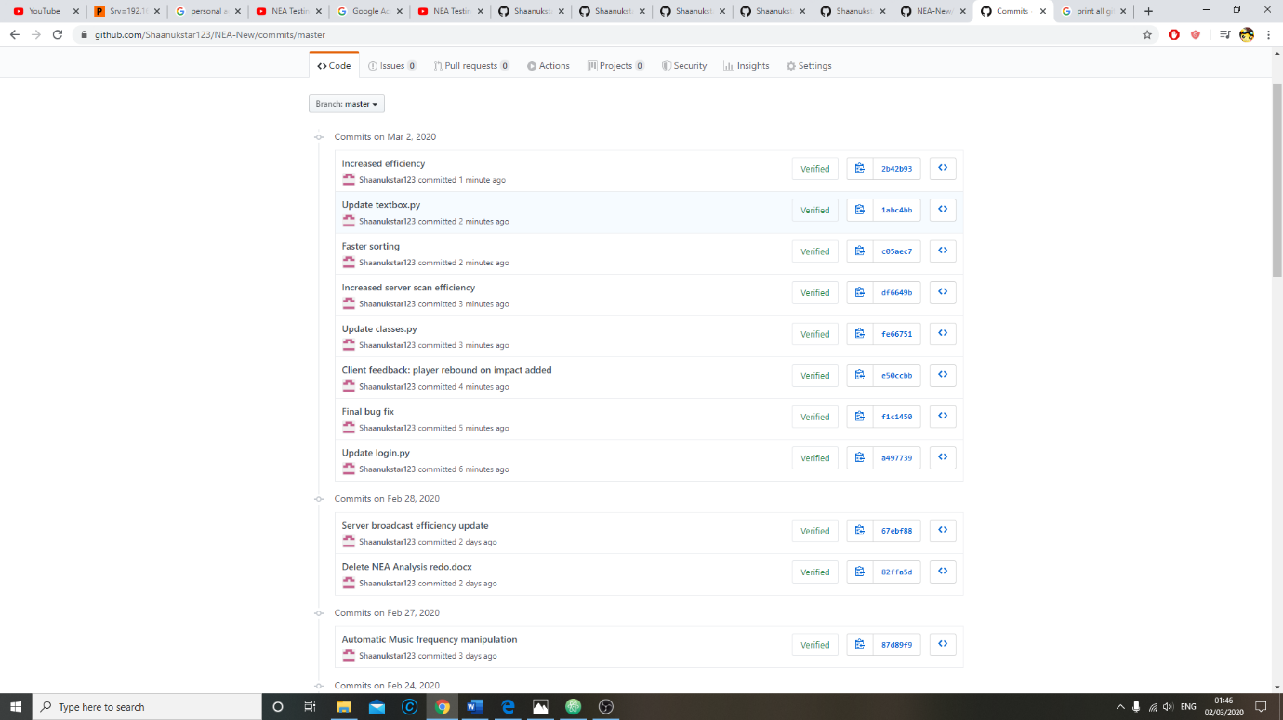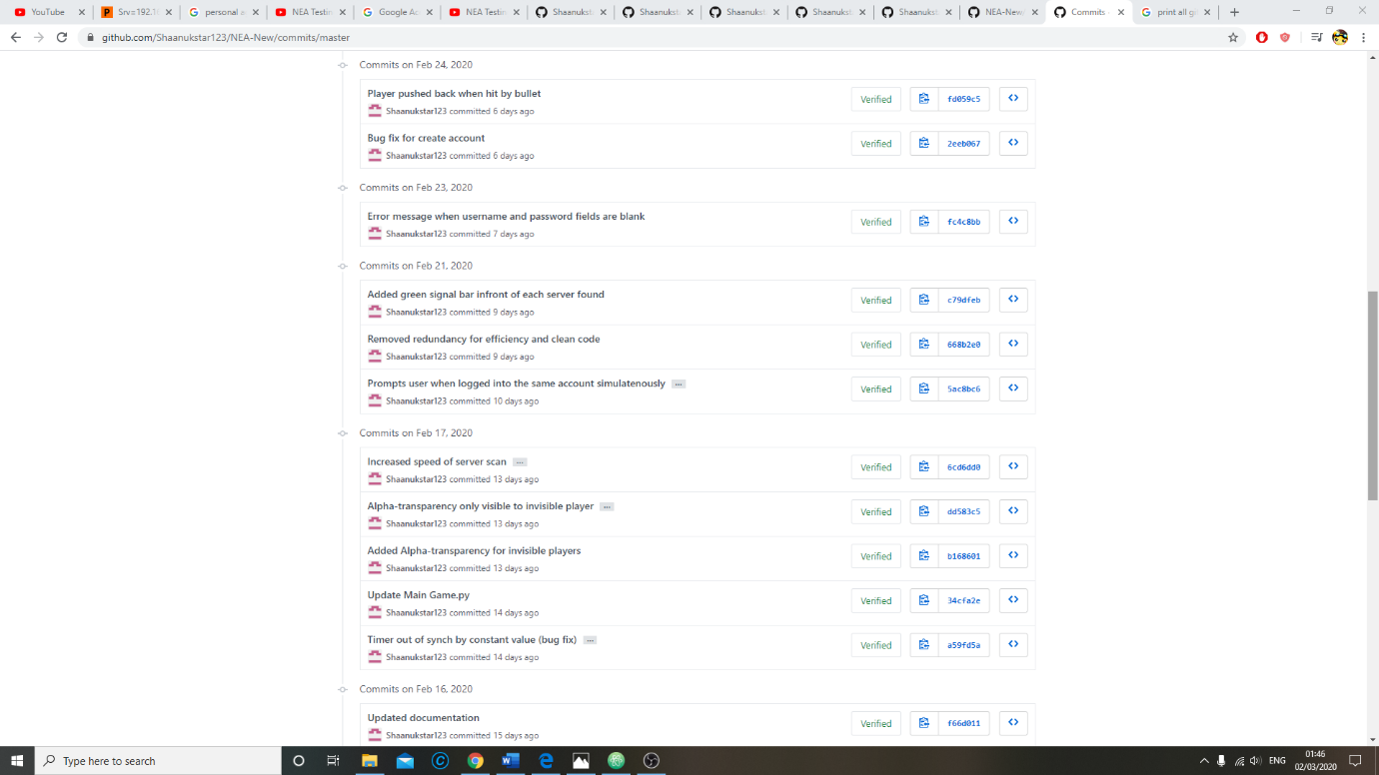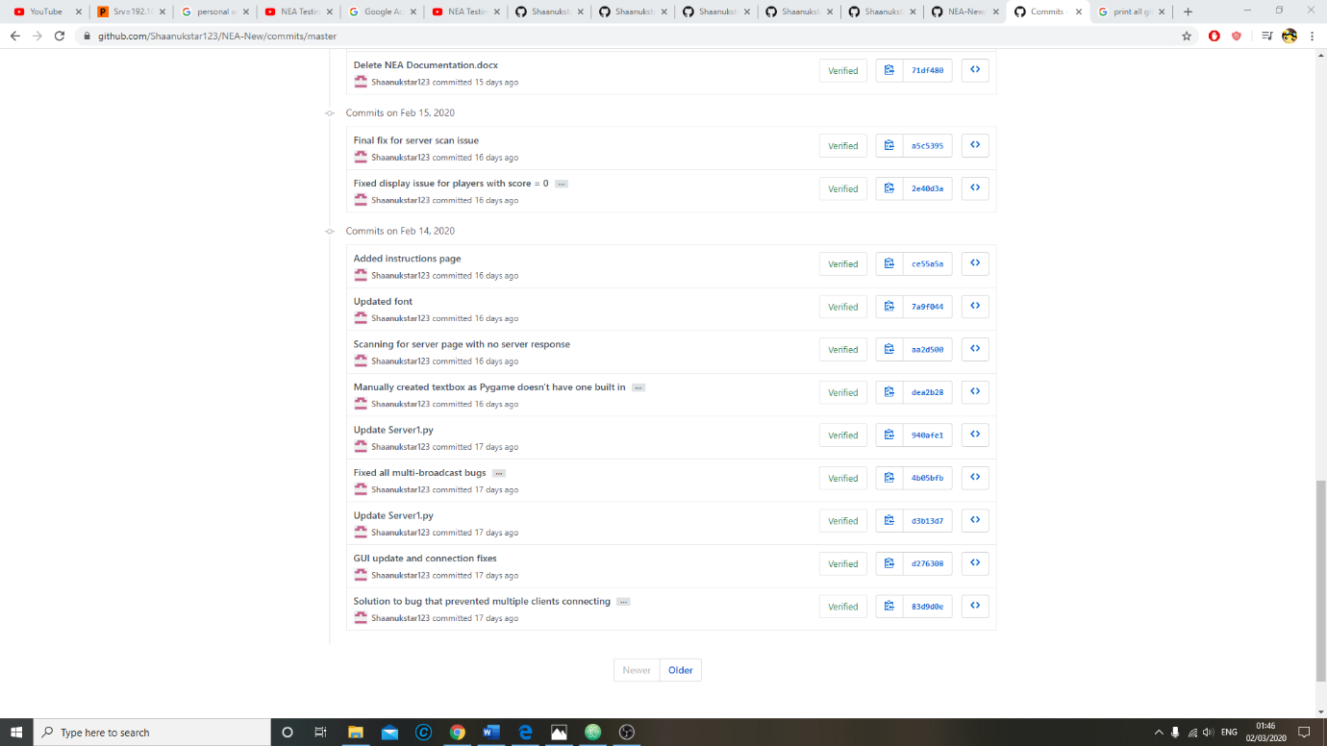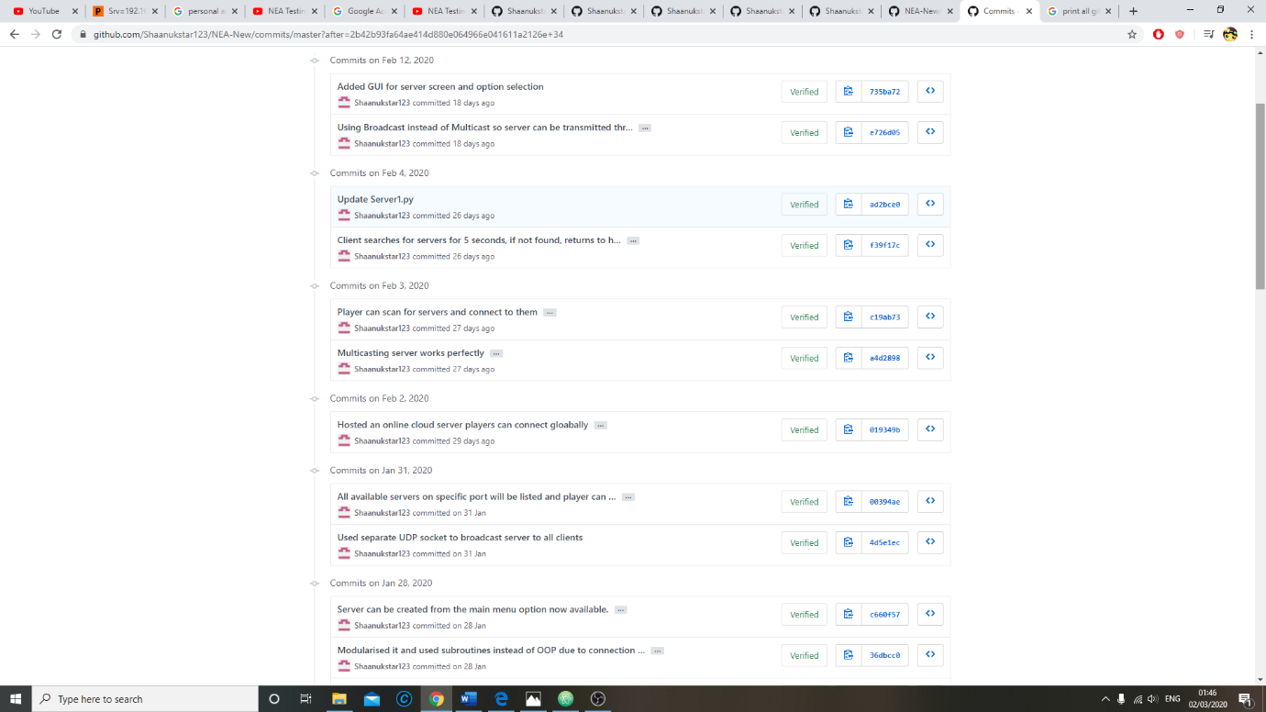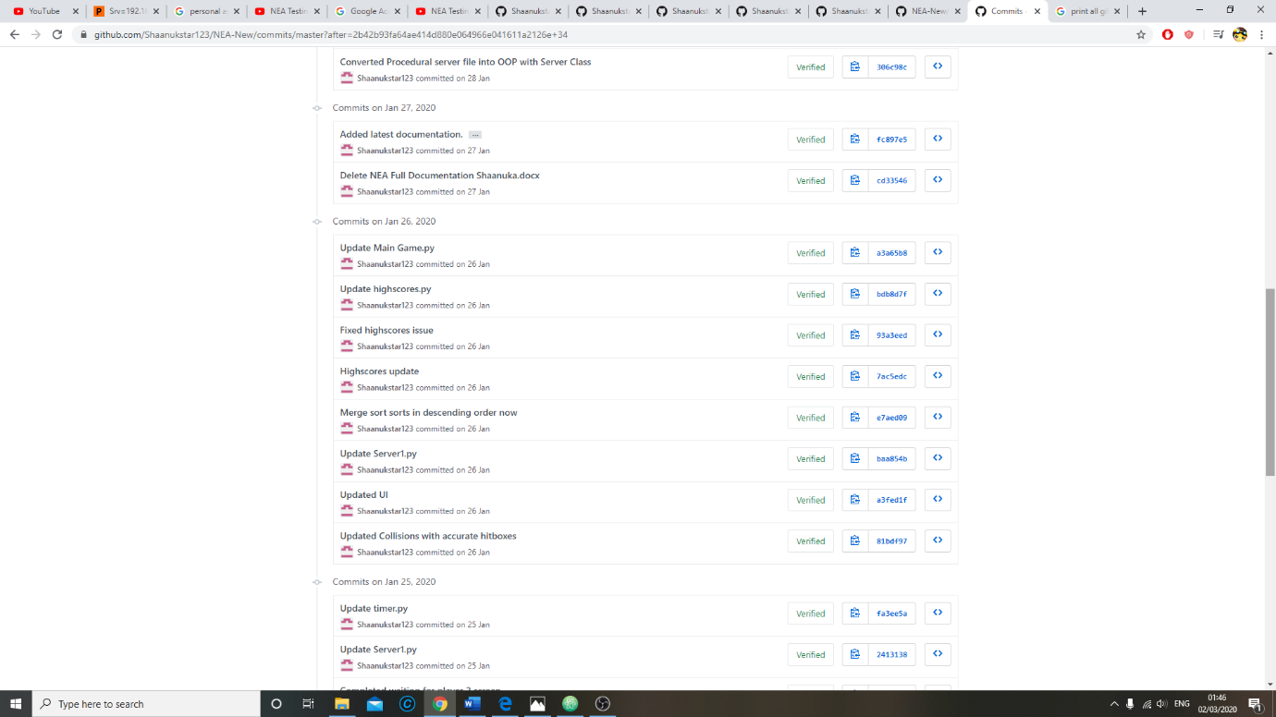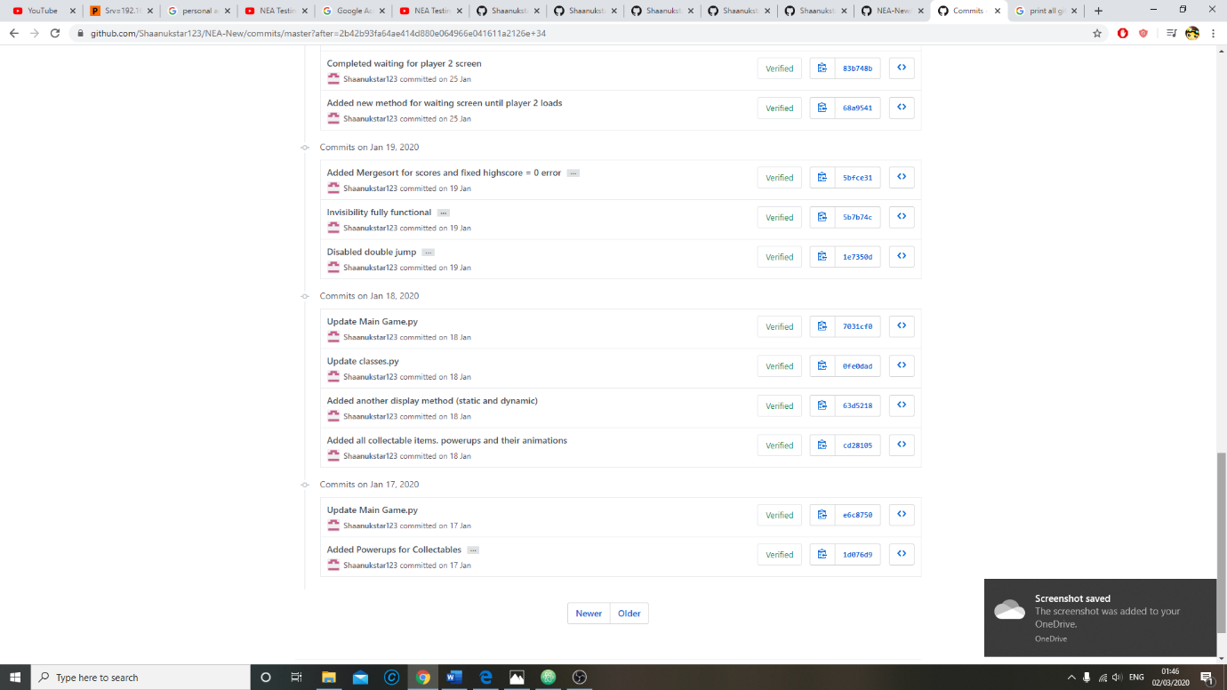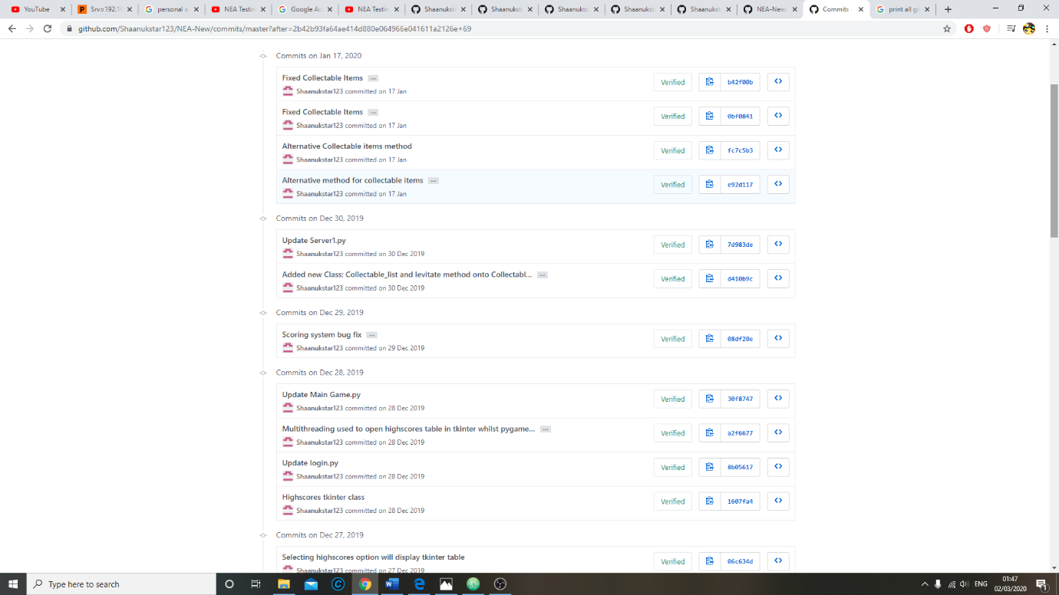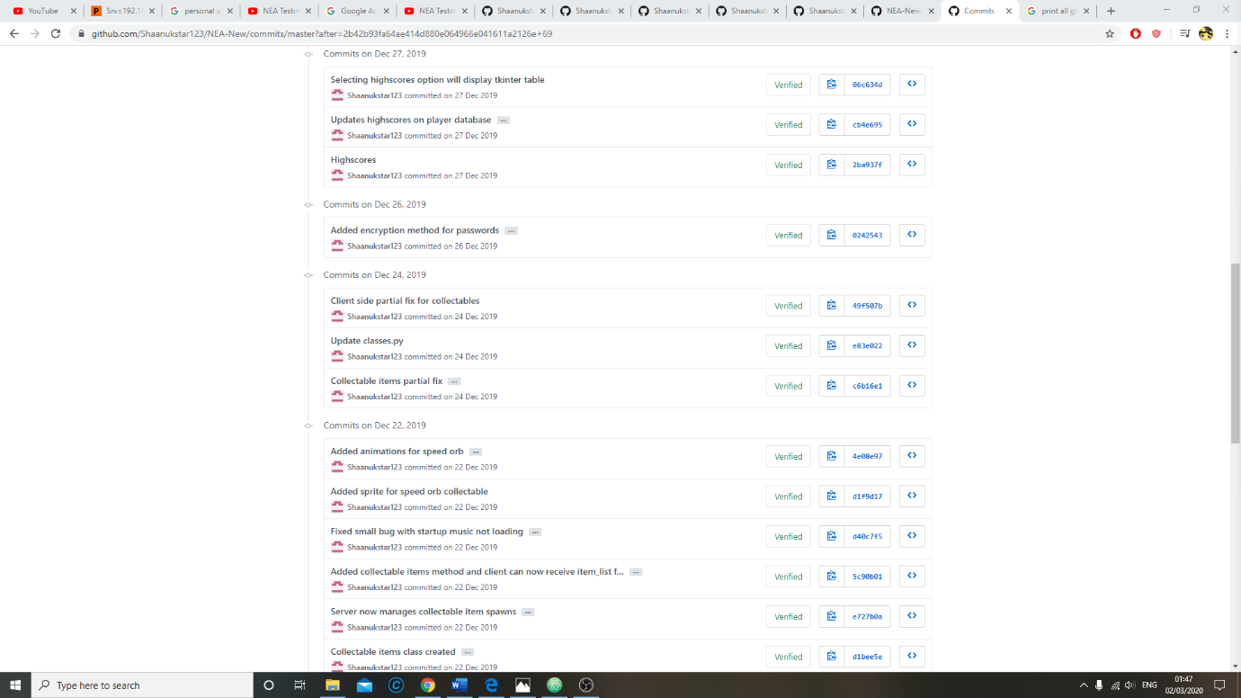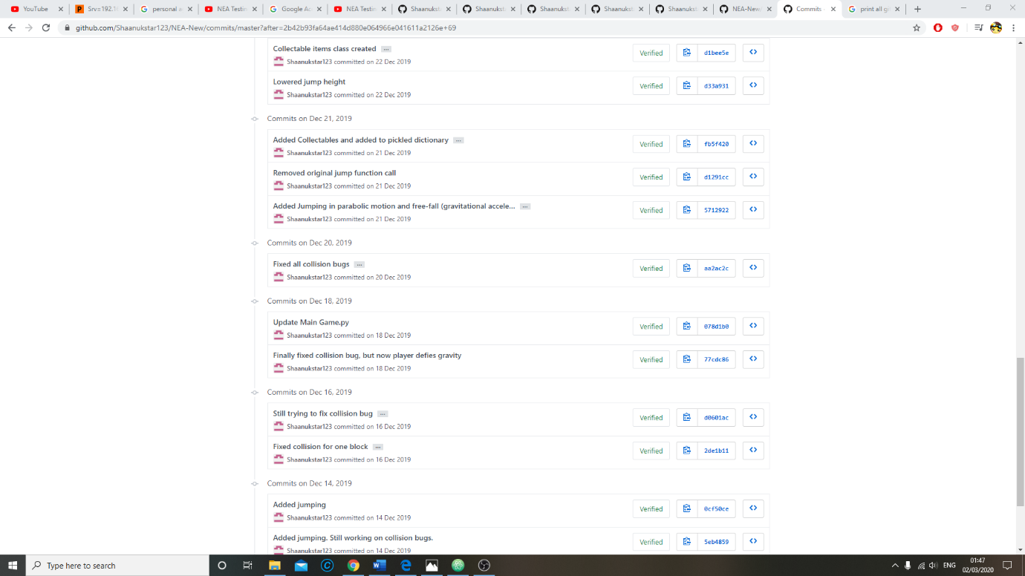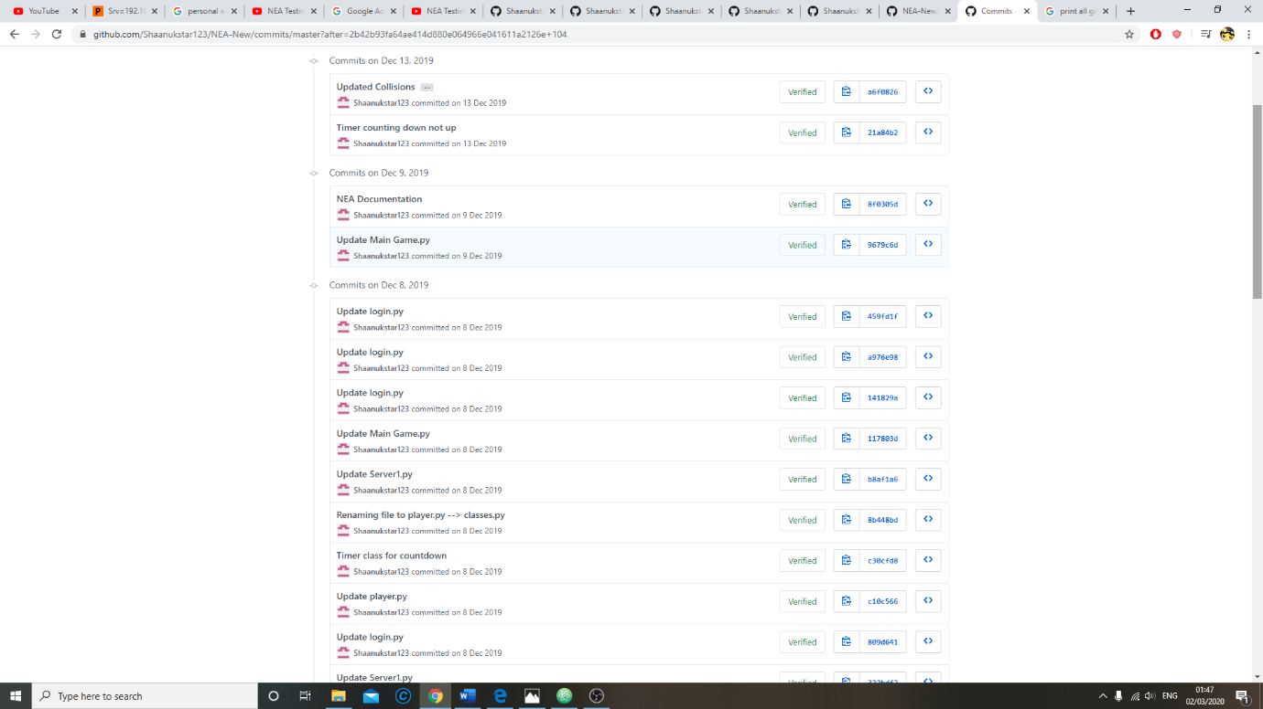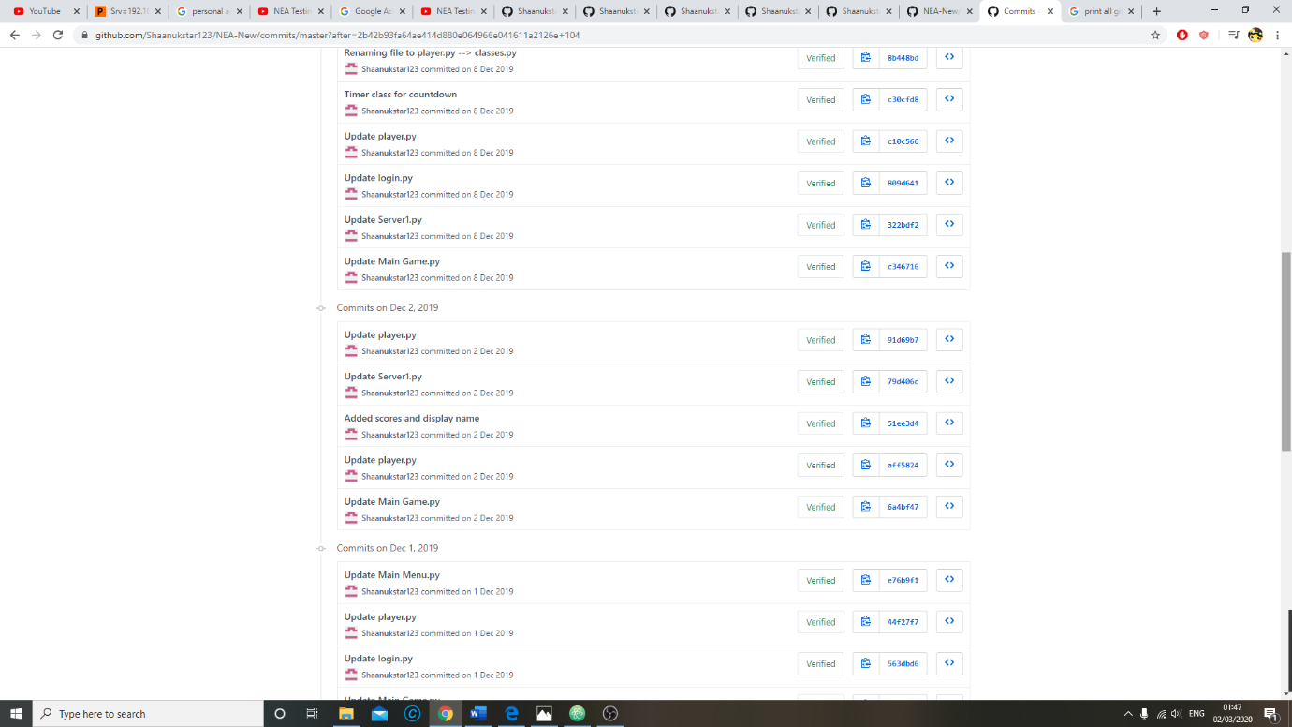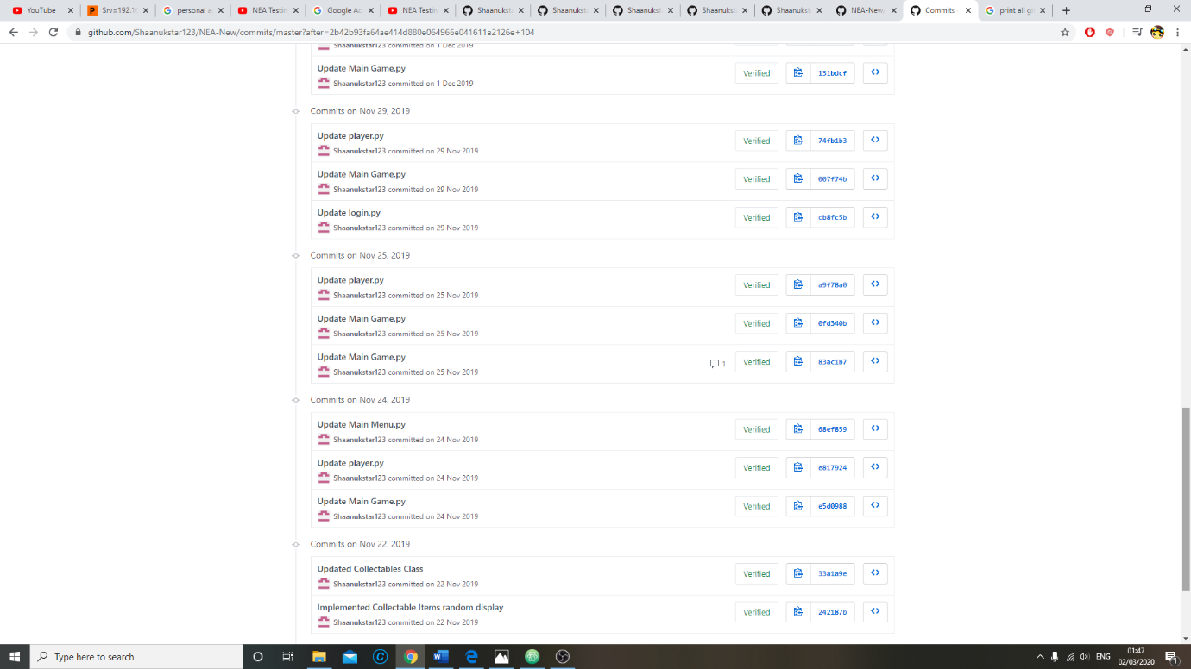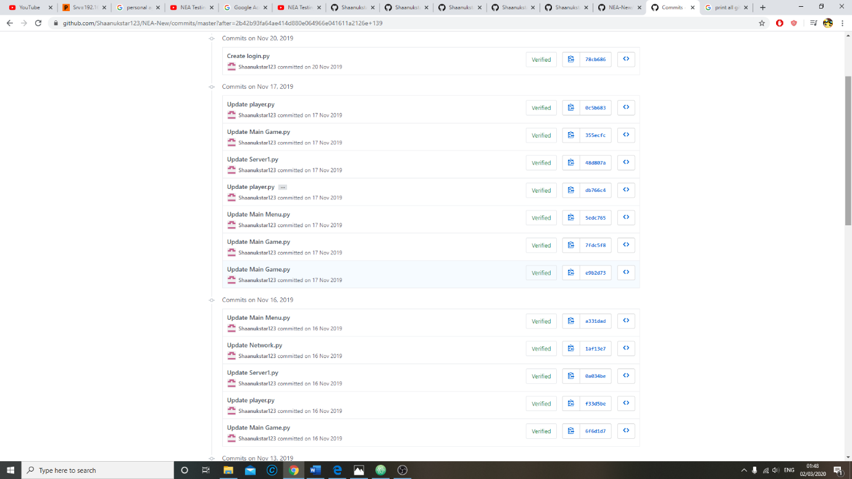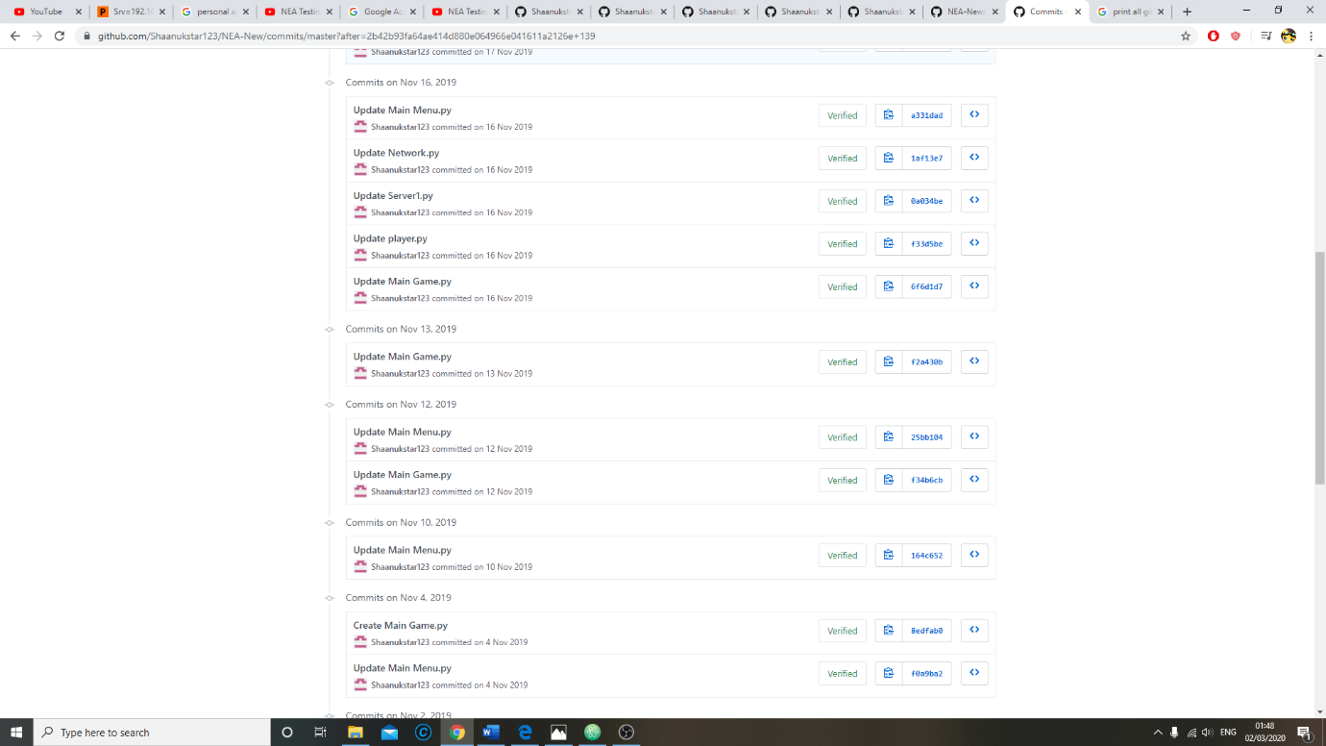

**\*Add alpha red routine**

**\*Critical Path Analysis**

**\*CPA evaluation**

# Evaluation

## General Objectives

1. The game should allow 2 players on the same LAN network to connect to a server and play a round of the game with each other.
2. The game should run smoothly with minimal stutter.
3. The server should act as an interface and handle all communications between clients.
4. The client should be able to host and join games without any knowledge of networks.
5. Users should be able to make an account which stores their high scores and be allowed to log in locally with their account details to view their high scores.

**Evidence for all objectives can be found in the testing section of the documentation**

### Objective 1

The main game tables and client server connection tests in the testing section are evidence of the game connecting the 2 players into a lobby where they engage in an battle against each other. Due to the success of all tests in this area, I conclude that this objective has strongly been met.

**Conclusion: Objective fully met**

### Objective 2

**Objective met.** There was minimal stutter throughout the running of the game.There was a slight bit of stutter during the testing video when the music changed This is due to the fact that the music was loaded in real-time whilst the game was running. However, the music is only loaded twice in the game and the stutter only occurred once throughout all tests. This allows to me conclude that the objective has been met.

**Improvements:** If there was more time available, I would try to find a method to pre-load the different music frequencies so that they don’t have to be loaded in the middle of the game.

**Conclusion: Objective fully met**

### Objective 3

The game server uses several methods to make sure the client’s are synchronised and acts as an interface to exchange data between them. This is proven by the evidence in the testing section. The server successfully allows the players to play a game with each other. It ensures that the game is synchronised for both clients.It also detects and handles errors such as 2 users connecting on the same account. This makes opening and running the game simple because the maintains the game with minimal user interaction.

The only test case that failed during gameplay was when the server didn’t process a response when one client force closed their game. Although the game wasn’t stopped, the server stored the client’s statistics before they disconnected, therefore the outcome of the game was decided by the values taken when the player disconnected, so the other player could not change the outcome of the match afterwards. This can be seen in the video where the disconnected player’s health and points remain the same after they disconnect even when the second player is shooting at them. This proves that although the server didn’t stop the game, it still managed to contain the error and prevent further problems and exploitations occuring as a result.

**Improvements:** The algorithm that detects client disconnection should be debugged to and fixed so that it terminates the game if one player disconnects from the server.

**Conclusion: Objective mostly met**

### Objective 4

The server broadcast and detect routines allow for clients to host their own games and connect with each other without manually connecting to a specific IP address. This feature allows for ease of use since no knowledge of networks or the other user’s network details are needed when playing the game.

**Conclusion: Objective fully met**

### Objective 5

The login and high score system works very well. As seen in the testing section, users can login, create a new account and view their highscores. Extensive testing was done to make sure every aspect of this system works. There was only one failed test, which was allowing users to have the same password given that their usernames are different. This is not a major problem however as it’s the username not the password that’s used to differentaite players within the game and during calculations within the database and highscore class.

**Conclusion: Objective fully met**

## Specific Objectives

### Login system

**Allows user to login or create an account**

Fully met: Login and creating accounts successful during testing. The database can also handle many accounts as seen in test 64.

**Rejects invalid inputs**

Fully met:Tests 1-14 proved that invalid inputs include identical accounts when creating an account and non-identical accounts when logging in, and that they are all rejected. This makes the login system very reliable.

### Main Menu

**Should have the options: Join Game, Host Game, Instructions, High scores, Quit:**

Fully met:Game loads main menu and the following options are selectable.

**Host game should take user input, then launch and broadcast a server:**

Fully met:Host game successfully takes input for name and time limit, then launches a server and broadcasts it to all devices on the network (tests 21-30).

### Server Menu

**All broadcasting servers should be listed and be available to select:**

Fully met: Clients successfully detected all available servers and displayed them in a vertical list. The user could scroll through the list using keyboard input.

**Connect to correct server when selected, then game loaded:**

Fully met: Clients can connect to the server and it loads the game (test 30).

### Main Game

**Waiting screen displayed until second player connects:**

Fully met: The first player to join the server is shown ‘Waiting for Player 2’ until the second player joins (test 31)

**Player should be able to move at a constant speed in the horizontal plane via keyboard input:**

Fully met: Holding the left and right arrow keys moves the player left and right at a constant speed (test 33)

**Gravitational acceleration and parabolic motion when jumping:**

Fully met: The movement when jumping is smooth and traces a parabola when moving horizontally in mid-air (test 34) Gravitational acceleration is also present and pulls the player down at a variable rate (test 32)

**Floating platforms are present and are tangible:**

Fully met: Player can jump onto platforms or get rebounded from them. Projectiles are also stopped when colliding with platforms.

**Live background animation throughout the game:**

Ful**l**y met: Background animations run throughout the runtime of the game (see gameplay at the end of the testing video)

**Music playing and pace of music changing with time:**

Fully met but with performance issues: Music is outputted and the frequency changes with time, however the change in music causes frame drops as mentioned previously under general objectives.

**Projectiles that collide and deal damage:**

Fully met: Projectiles do collide with players and cause damage. They successfully disappeared when also colliding with platforms and the arena boundary (tests 37 and 38)

**Synchronised countdown timer that starts at the beginning of a match:**

Fully met: The server host can choose the time limit. The timer value was synchronised with a +- 0.5 second uncertainty throughout the gameplay tests (see gameplay at the end of testing video)

**Working health, damage and scoring system:**

Fully met: Players take damage when hit by projectiles and the scoring system calculates the player’s final score depending on the health difference between the player and the opponent, the number of powerups used, and the time taken to defeat an enemy if the player wins.

**Collectable items spawn randomly and provide powerups. They should in synch with the clients and each one should be accessible to both players whilst connected to the server.**

Fully met: The items spawn at the same time and can be collected to provide the player powerups. The server generates them, and they are then instantiated on the client side.

The items although generated on the client-side, they are kept in completely in synch by the game timer which runs on the server side. Using an attribute such as the game timer instead of sending item data between server and clients negates any networking problems such as latency that can occur. Owing to this, I can conclude this objective has been fully met.

**A system that calculates the outcome of the game if time runs out and displays the outcome at the end of the game.**

Fully met: This calculation to find if there’s a winner for a round is fully functional, and the endgame screen either displays the winner or a message saying the game is a tie. This can be seen in tests 45 and 46.

**High score calculator that compares player’s score to their high score on the database and updates it when appropriate:**

Fully met: This feature works as seen in tests 18, 63 and 64.

### Game Server

**Broadcasts server to all devices on the network:**

Fully met: The broadcast works as it can be detected by all clients (test 27)

**Use an open UDP port and listens for connections:**

Fully met: The server allows accepts connections from the first 2 clients to join as seen in the gameplay at the end of the testing video.

**Uses separate threads and sends data each client simultaneously:**

Fully met: My game runs in real-time and both clients receive and send data to the server simultaneously. This is seen in the gameplay video where both clients interact with each other and the server acts as an interface for data interchange and it also handles several functions such as the timer, the collectable items and error handling.

**Code optimised to make it easier to add features:**

Fully met: I’ve made it easier to add support for more players per game by sending player data in a dictionary format within a list. Lists are mutable so there’s and the dictionary makes it easy to assign data to each player object. I used the object-oriented programming paradigm for all features such as the timer, collectable items, map platforms and player objects. The pickle library is used to serialise object data before being transmitted, so new classes and objects can easily be pickled and sent to the client.

**Command line interface that provides feedback on the status of the server:**

Fully met: The server prints statements such as ‘Server Started’, ‘Timer Started’, ‘Connection Established’ and ‘Client Disconnected’ onto its console.

**Acts as an interface and manages communication between clients:**

**Fully met:** The server successfully handles incoming data from a client, processes them and transmits them to the next client. I’ve expanded this when discussing general objective 3 above.

**Server terminates when match ends:**

Fully met: Server closes and a new match can be hosted on a new server afterwards if the user wishes to. This is seen in test 58.

### Images and sprites

**Obtain character models and sprites for player 1, player 2 and projectiles:**

Fully met: Character and projectile sprites were edited using Photoshop CC 2019.

**Split animated gif images into static images for animations:**

Fully met: I used the online application Ezgif to separate gif files into separate png files.

**Create an instructions page and convert it to an image format:**

Fully met: I used Photoshop CC 2019 to design my own instructions page and saved it as a png file.

## Additional objectives

Due to time restrictions, I was not able to complete the additional objectives.

**Adding 3 player support for each game:**

Not met, but I managed to optimise the server so that this feature can be implemented.

**Adding more animations such as walking and death animations:**

Not met, but I created a method of making the death animations for player with the use of queues in my documented design. However, I could not implement it due to time restrictions.

## User feedback

I ask one of my peers that who was a part of the target audience to test my program. He tested the different parts of the program as seen in client testing table in the testing section. I implemented the improvements that were suggested. Now that I’ve completed the project, I asked another member of my target audience to play my game and give me some final feedback.

**Login System:**

‘Login system works well in creating an account and letting me log in’

**Improvements: ‘**The data could be stored in an online database instead of a local one so that players can create a permanent accounts and save their scores on one device and be able to load it on another one.’

**User Interface:**

‘It was very colourful and the animations made it really immersieve’.

**Improvements: ‘**There can be more options such as customisable key bindings and clickable buttons rather than keyboard only input’

**Hosting and joining local games:**

‘It was easy to host a game and join it instantly. I was also able to quickly scan for any nearby servers’.

**Improvements: ‘**Keep the server running after each game and reset it so it runs a new game when the players re-connect to it.’

**Performance:**

‘The game ran smoothly and I didn’t notice many frame drops at all. However, there was a small delay in in my game compared to the other player’s when comparing our screens’

**Improvements: ‘**Automatically change frame rate of both games depending on the highest latency between one of the clients and the server.’

## Analysis

In conclusion, I think my project was very successful in completing all its main objectives and functioning as a localhost multiplayer shooter game. It allows clients to host their own game and broadcast it to the network so that it’s discoverable by other local players. They can then connect and play a session in real time. The player’s data is stored locally in a database and they can view their high scores or the scores of the players that they’ve played with, adding to the competitive aspect of the game.

The biggest challenge when programming this game was the real-time multiplayer battle system that I had to develop where I had to find efficient ways communication between clients and server to reduce lag. There were many problems that occurred, and I had to fix or find new methods which I documented in the documented design section.

I received positive feedback from my target audience meaning that the project was successful in accomplishing its main goal of entertainment. There were some improvements that were suggested and they have been recorded above.

In hindsight If I were to re-attempt this project, I would put less focus on the login and scoreboard system and more focus on the client server communications and making the server seamlessly integrate with the game as a whole. Improvements for this would be possible if there was more time available.

## Bibliography

These are the resources that I’ve used in my project.

Textbox for user input: <https://stackoverflow.com/questions/46390231/how-to-create-a-text-input-box-with-pygame>

UDP broadcasting : <https://gist.github.com/ninedraft/7c47282f8b53ac015c1e326fffb664b5>

Introduction to sockets: <https://realpython.com/python-sockets/>

Sqlite3 interface: <https://docs.python.org/3/library/sqlite3.html>

1. <https://www.usgamer.net/articles/top-10-biggest-grossing-arcade-games-of-all-time>
2. https://upload.wikimedia.org/wikipedia/en/a/a0/Digdug.png
3. <https://store.steampowered.com/app/403400/ARCADE_GAME_SERIES_DIG_DUG/>
4. https://i.ytimg.com/vi/5em8leAa8Po/hqdefault.jpg
5. <https://www.youtube.com/watch?v=QTPy4iO-9Do>
6. https://cdn3.dualshockers.com/wp-content/uploads/2019/05/Multiplayer-Abraham-Lincoln.jpg
7. <https://www.howtogeek.com/241285/why-video-games-make-you-feel-sick-and-what-you-can-do-about-it/>
8. <https://techsore.com/best-programming-language/>
9. <https://excelwithbusiness.com/blog/say-hello-world-in-28-different-programming-languages/>
10. <https://opensource.com/sites/default/files/styles/image-full-size/public/lead-images/python3-game.png?itok=jG9UdwC3>
11. <https://www.pubnub.com/blog/socket-programming-in-python-client-server-p2p/>
12. <https://btbusiness.custhelp.com/app/answers/detail/a_id/7629/~/how-do-i-find-my-ip-address%3F/c/5099/>
13. <https://wiki.python.org/moin/GlobalInterpreterLock>
14. <https://www.sciencelearn.org.nz/resources/573-measuring-sound>
15. <https://en.wikipedia.org/wiki/Alpha_compositing>
16. <https://ezgif.com/>